Purchase of Service (POS)
Purchase of Service (POS) requests for clients can be created, viewed, printed and authorized within the POS screens in SANDIS7.
The POS screen can be accessed a number of ways –  Right-clicking on an individual in the welcome screen and selecting POS. | 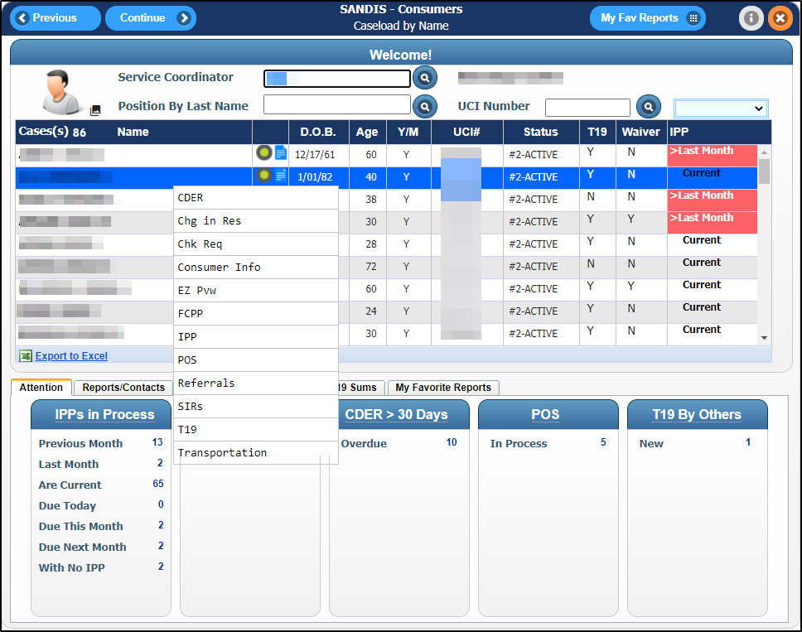
Selecting POS on the drop-down menu after entering a client’s UCI in the on-call lookup field. | 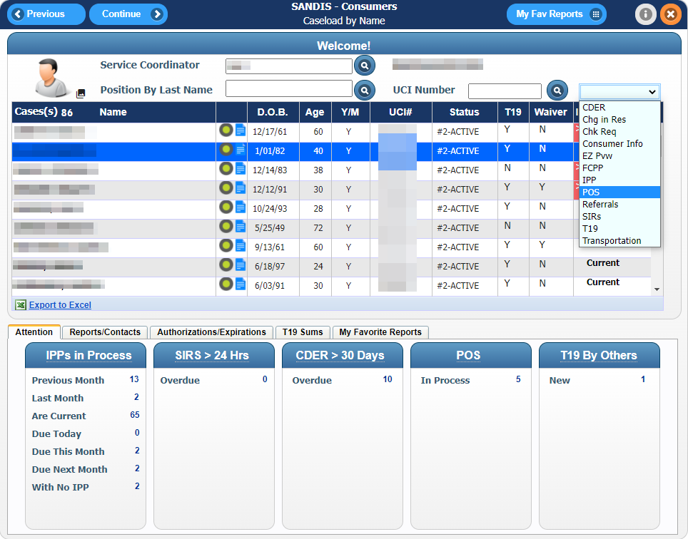
Or by clicking POS Requests under the group POS/Fiscal – SC Level using the navigation menu. | 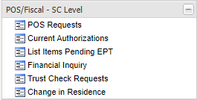
The POS History Screen will display information about the individual’s POS Requests in a table with columns that can be right-clicked and then Sorted or Filtered.  Clicking or the will close the POS History screen. | 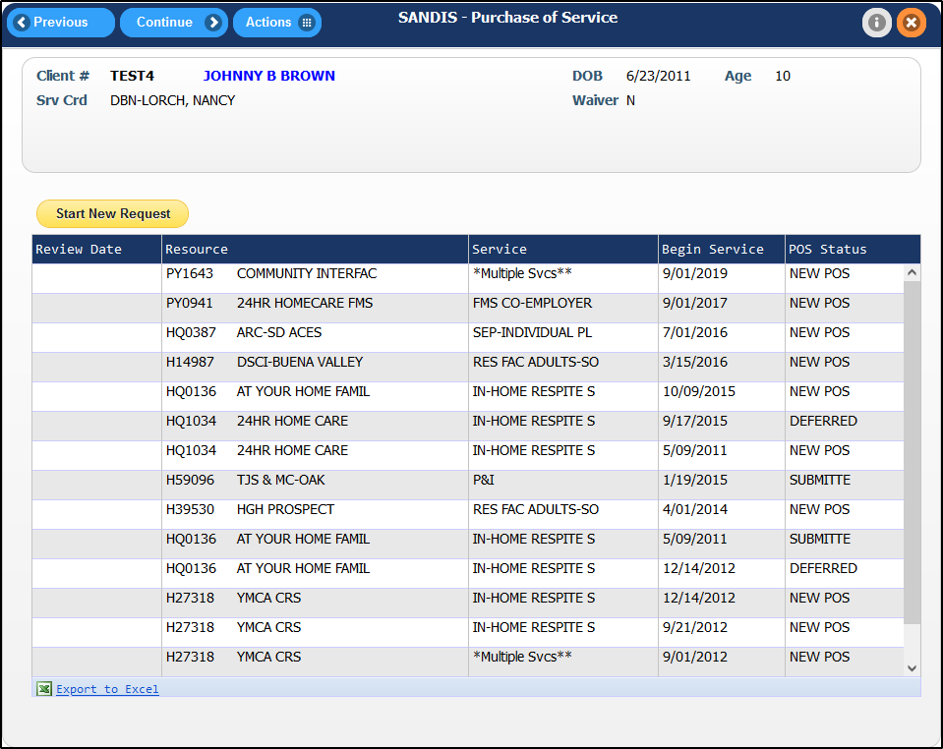
Placing your mouse cursor over the menu will display a submenu with options for deleted POS Requests or the individual’s Current Authorizations. | 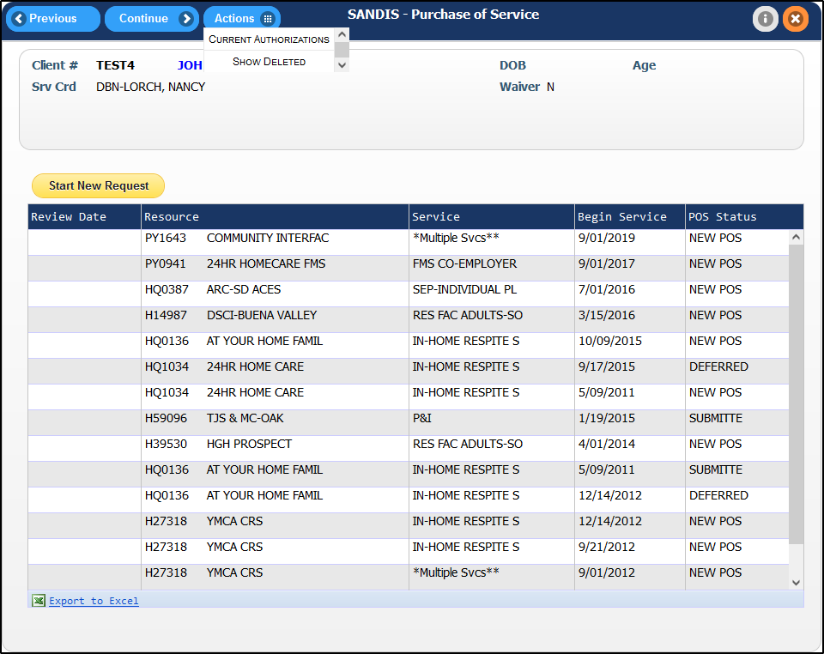
Create a new POS request

To create a new POS Request, click on the button.

Enter the desired Resource number for which this POS is being requested or click to find a Vendor using the Resource by Name search feature.  Click to advance to the Resource’s Rate Table to select the Service and Sub-Code desired. | 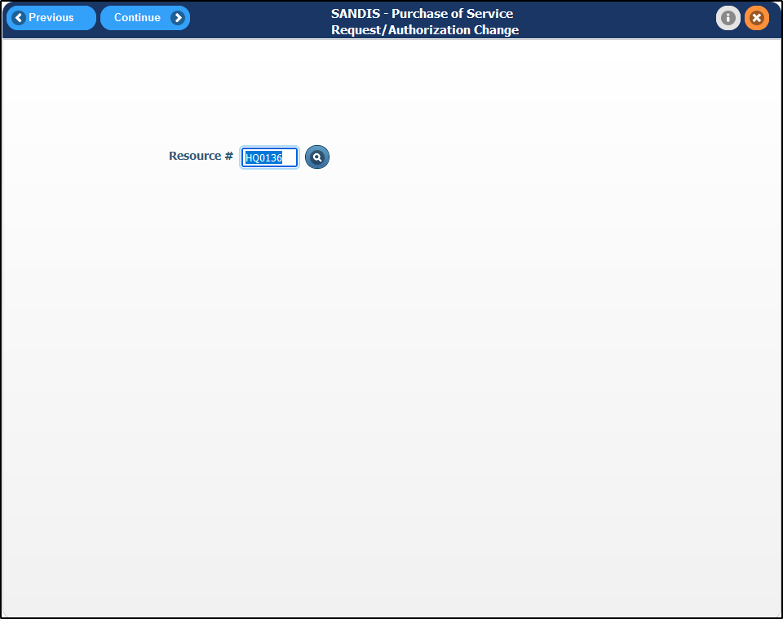
The selected Resource’s Rate Table provides information related to the various rates associated with the vendor. The columns in the table are sortable and can also be searched after being right-clicked and the option being taken. Find the desired Service Code and Sub-code from within the table, right-click the record and choose “Select” to advance. | 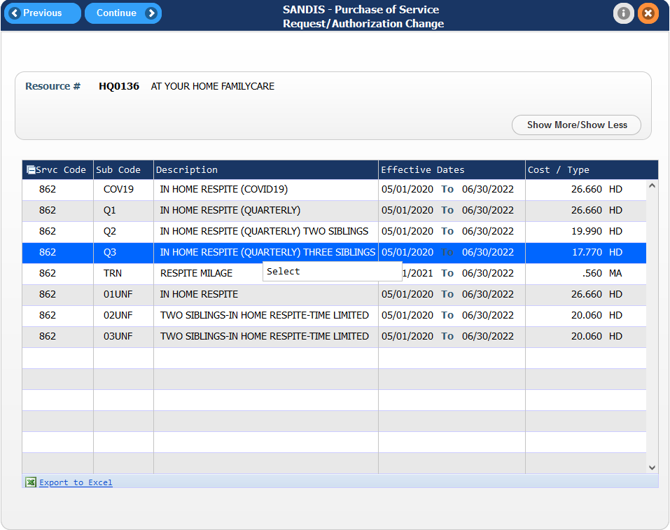

Clicking or the will return to the POS History screen without creating a POS Request. | 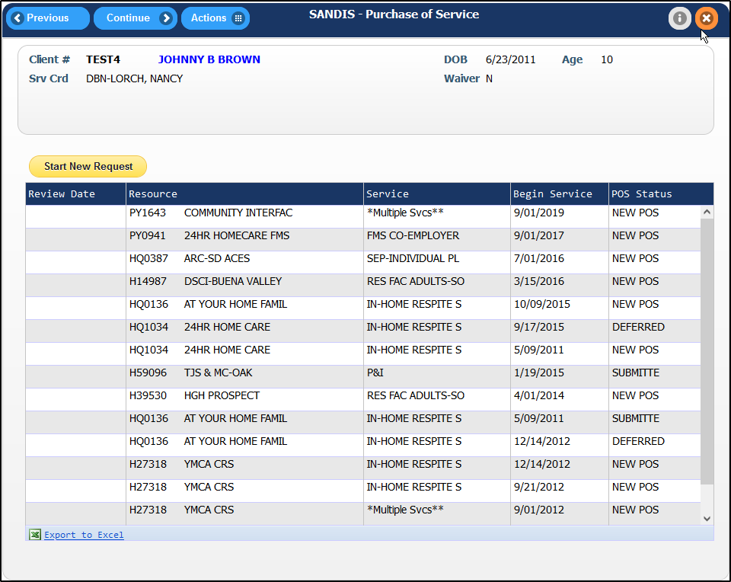
Once a Service and Sub-Code have been selected from the Resource’s Rate Table, the Main page of the POS Request will load. Enter the necessary information into the different fields as necessary on the Main tab. | 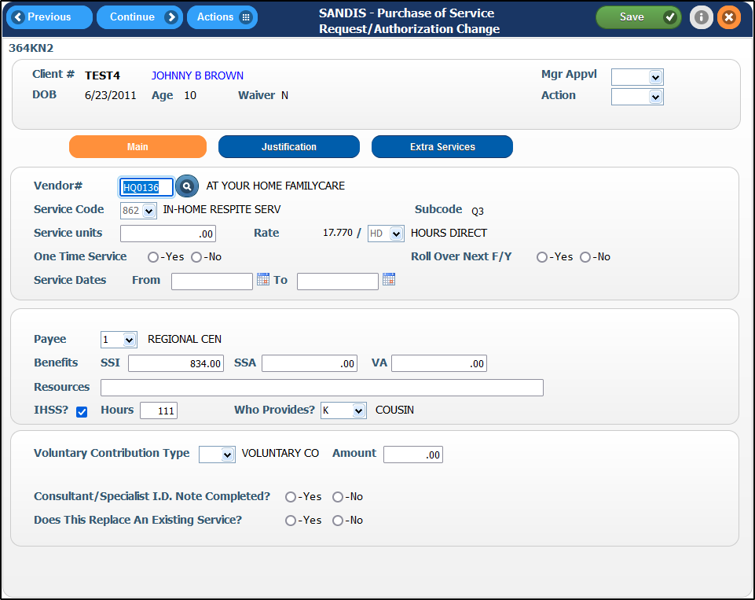
Click to use the Resource by Name search to change the Vendor#.  To change the Service Code and/or Sub-code, mouse over and select Rate Table to return to the vendor’s rate table and change the selection. The Start (From) and End (To) Dates can be entered manually or by using . | 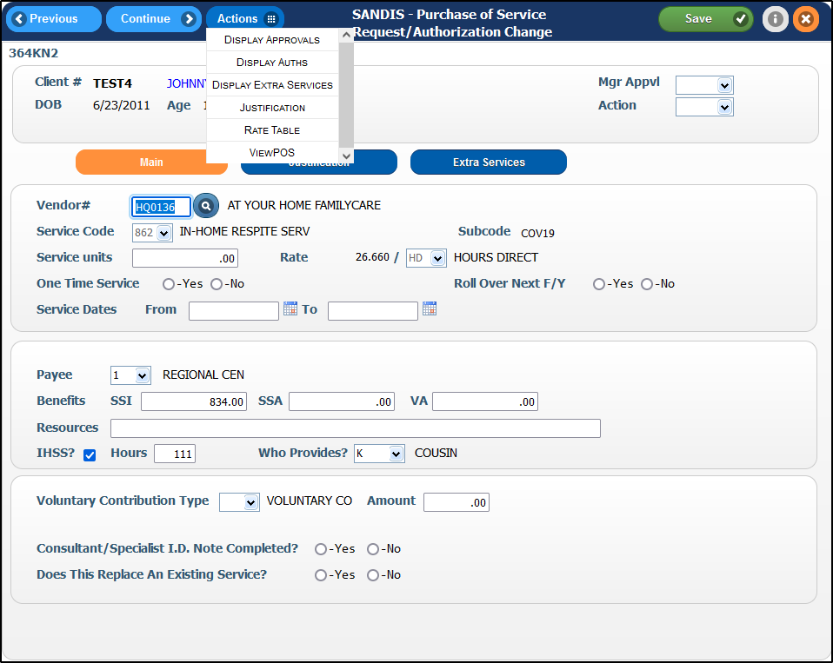

Justifications Tab  Clicking on the icon, icon or the icon will save any entered information and advance to the Justification tab. | 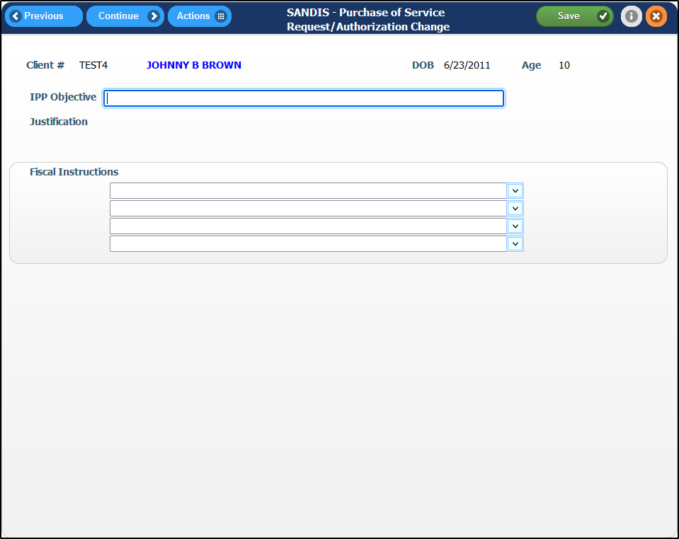
Enter the required information on the Justifications Screen. Each of the fields in the Fiscal Instructions section can be manually entered or a template can be selected from the corresponding drop-down menu and then modified as necessary.  Clicking will save any entered information and remain on the page. Clicking will return the page to the main tab. | 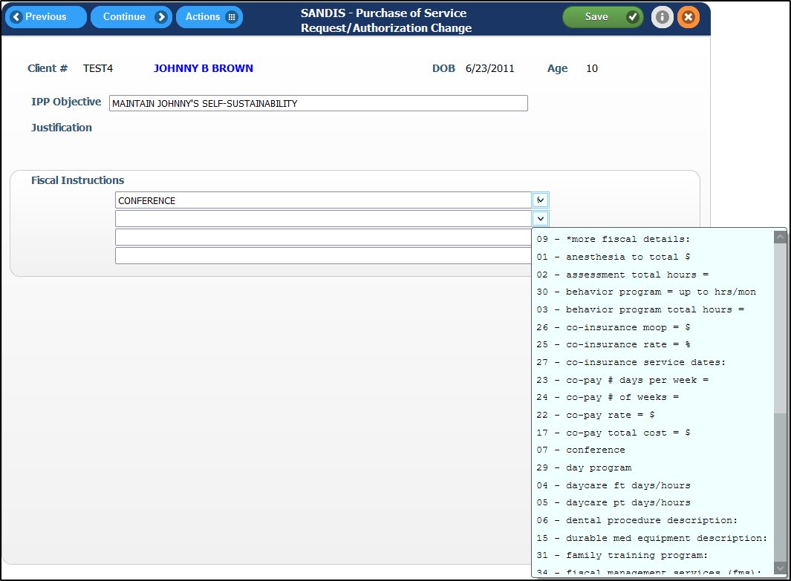
Click to be save your work and redirect to the Extra Comments section.  The Extra Comments screen contains a character limited text area where any additional information can be entered. | 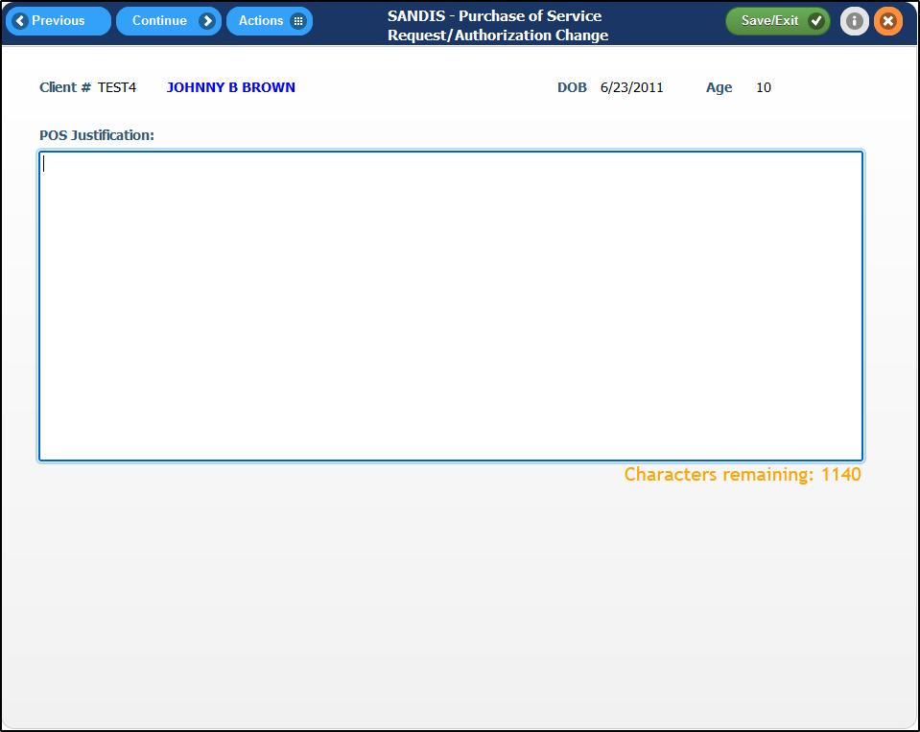

Clicking or will save any entered information and return to the POS Request History Screen where the request can be further worked with as needed.  If needed, you can exit the screen without saving changes by clicking on the icon. | 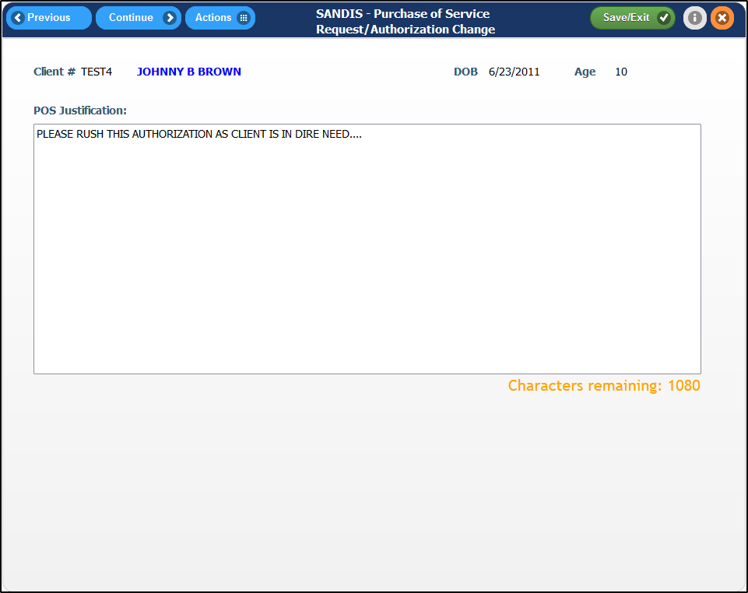
Extra Services Tab  To add additional services offered by the same vendor to the POS Request, click and enter desired service and subcodes as needed by clicking on the  icon. | 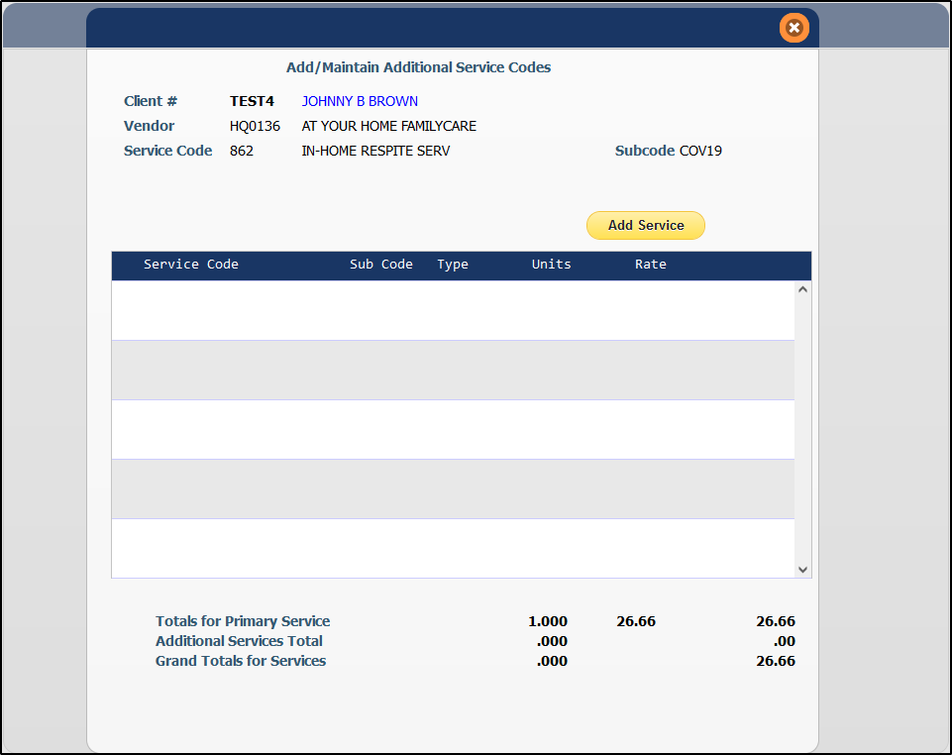
A window will prompt to select the units for the desired service code and will also display the rate of the service. Enter the units and any comments as necessary and press to continue.  Once all services have been added, clicking on the Add/Maintain Additional Service Code window will return the screen to the main tab of POS Request workflow. | 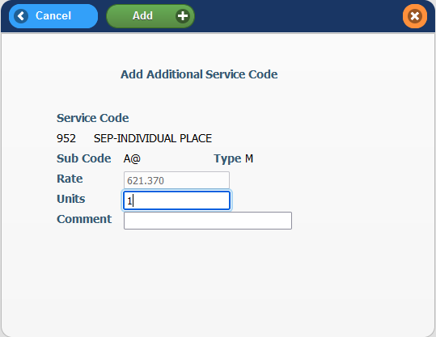

Change a POS request  To make any edits or updates to an existing POS Request, return to the POS History Screen, right-click the desired request and select Change.  Once back in the POS Request, changes can then be made to any necessary fields, the same process as when entering a new POS Request. | 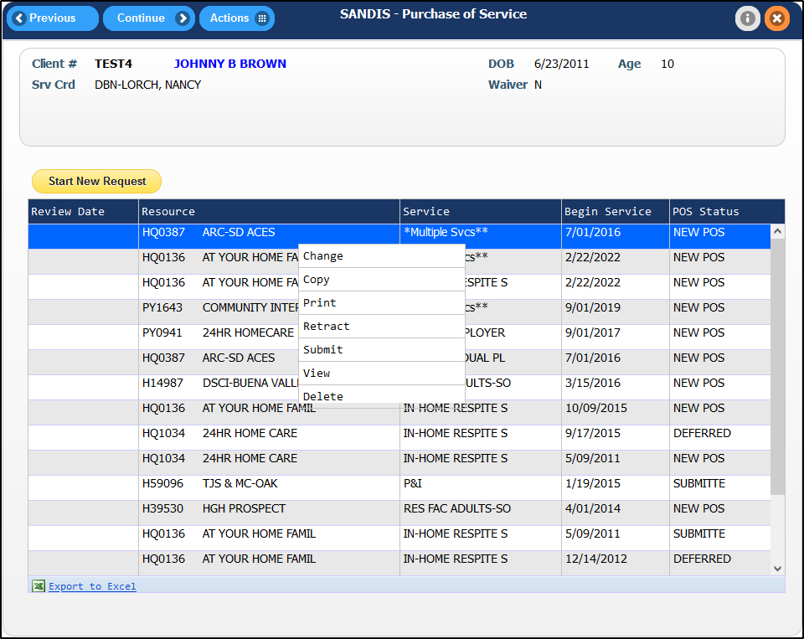
Only records in with a NEW POS status can be Changed, Submitted or Deleted. | 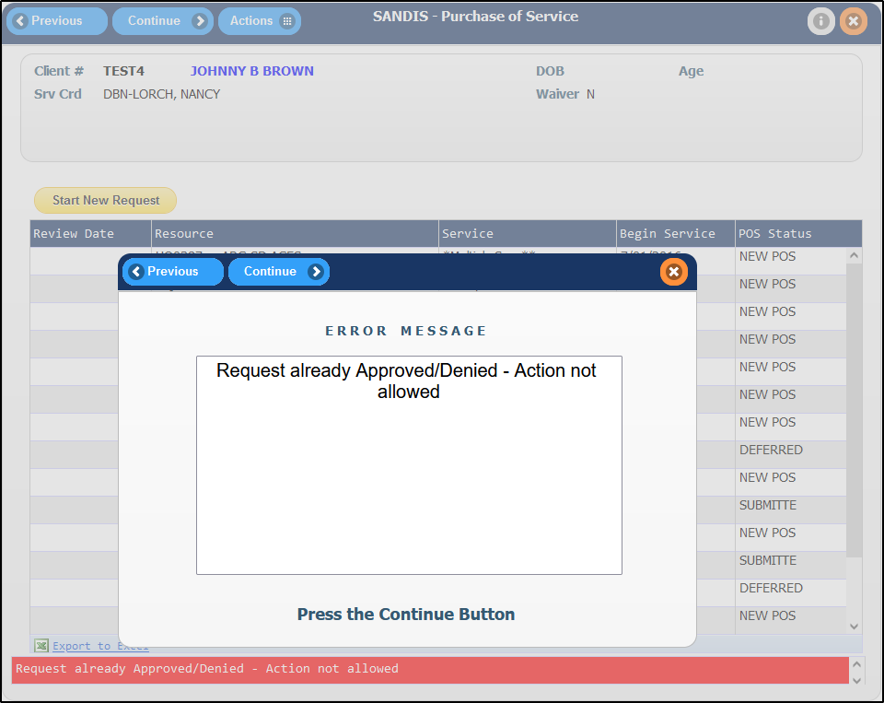
Submit a POS request  Once all the information is entered correctly for the POS Request, it can be directed to a manager for approval by right-clicking and selecting Submit. The Status will change to Submitted and the POS Request can no longer be modified. | 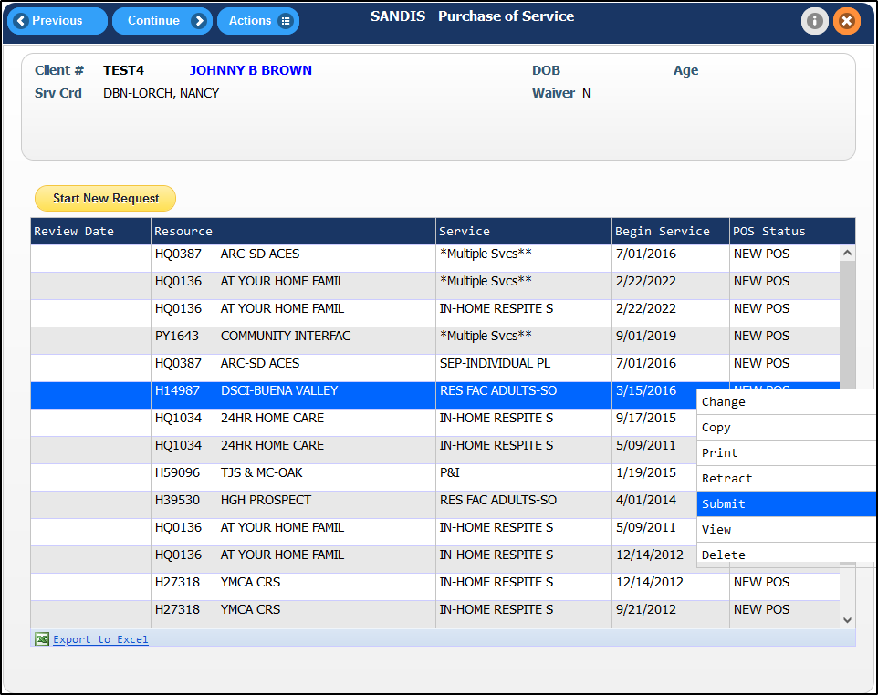

Retract a POS request  A note that has been submitted can be edited once more by retracting it. Simply right-click the submitted record, select Retract and the list will refresh with the request converted back to New POS. | 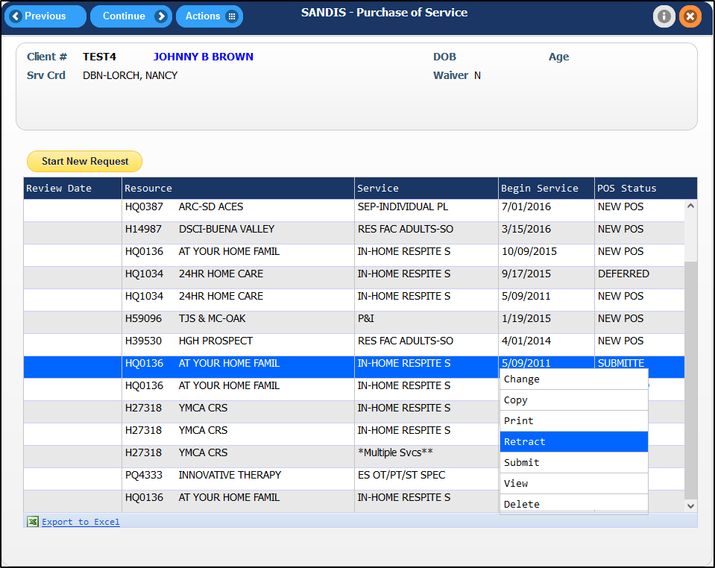
Delete a POS request  If a POS Request needs to be deleted, right-clicking and selecting Delete will mark the POS Request for deletion and remove it from the POS History screen.  Only POS Requests in NEW POS status can be deleted. | 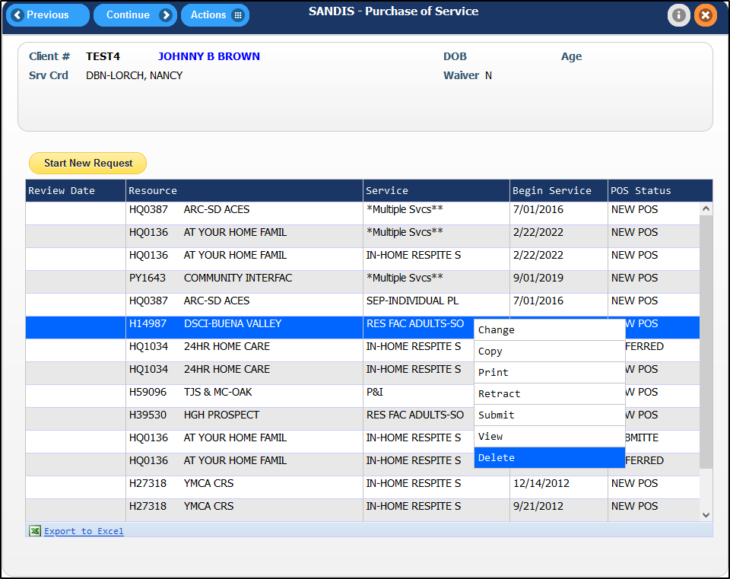
Copy a POS request  To copy a previous POS Request, right-click the desired POS Request and select Copy to begin a NEW POS Request, will all of the targeted Request’s information. | 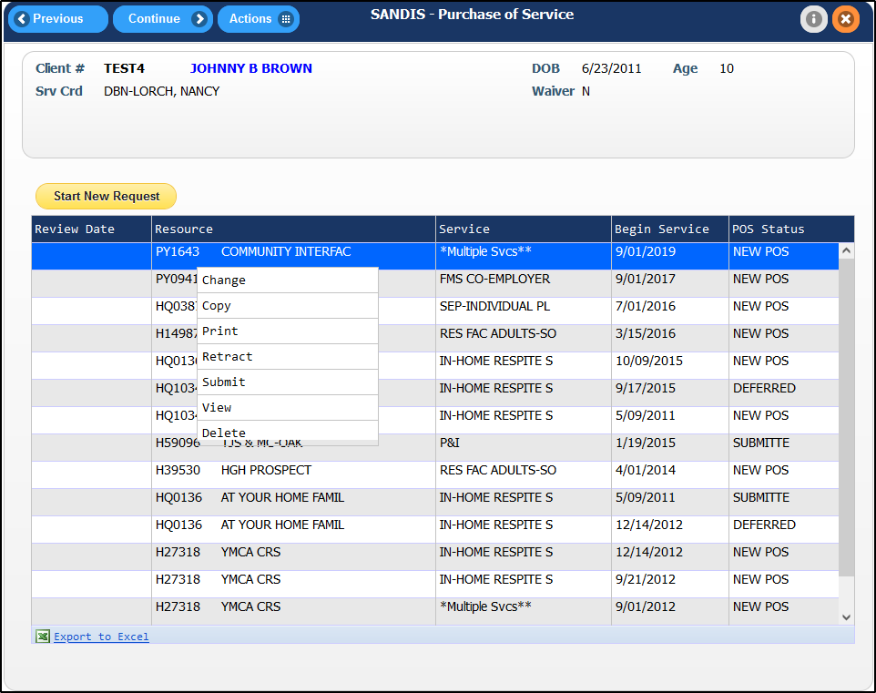

The new request will load the copied request’s information and have all sections pre-filled. Select all the required information and press to advance through the POS workflow.  The process to complete a copied request will be the same as a new request. | 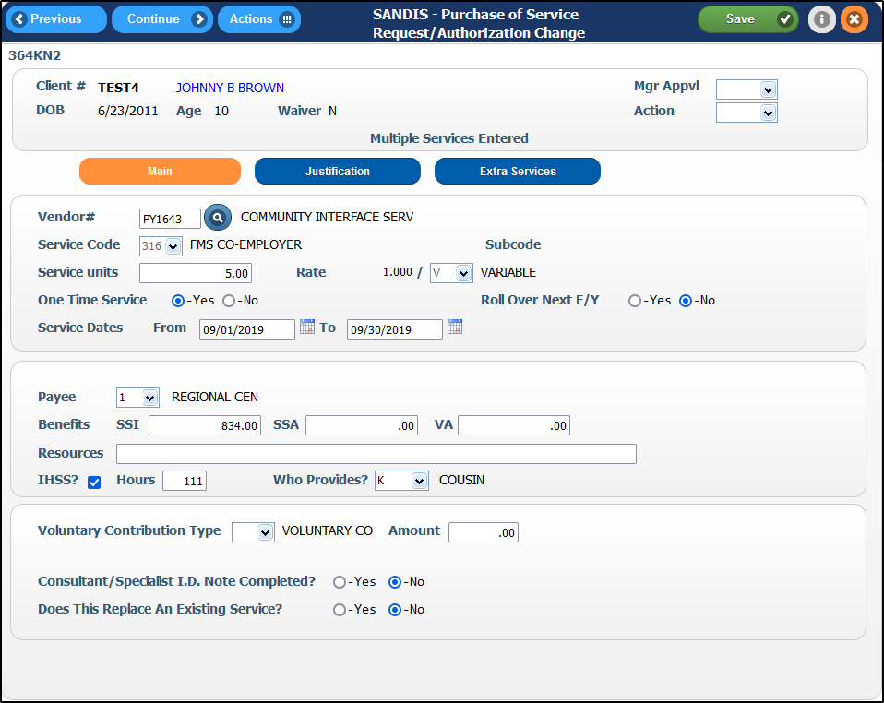
Viewing a POS request

Right-clicking and selecting View will load the contents of the POS Request in the POS Interface but in View Only mode
Printing a POS request  Right-clicking and selecting Print will load the contents of the POS Request in a report format | 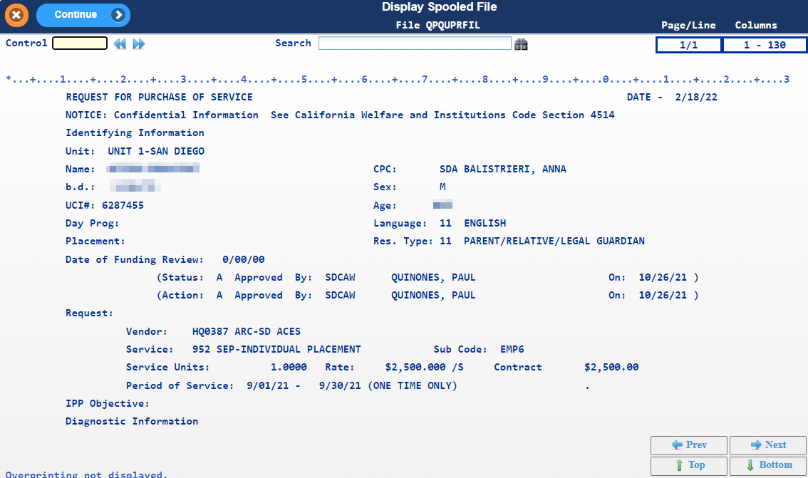
Click after selecting to print the report or email the report to yourself as a PDF. Clicking will exit without performing any action. | 