Client Development Evaluation Report
The Client Development Evaluation Report (CDER) program was created to assist users by creating an automated process to capture Client information and share it with the Department of Development Services (DDS). The CDER is used as an assessment tool by DDS to:
- Collect data on Client diagnostic characteristics.
- Measure and evaluate on an ongoing basis a Client’s adaptive skills and challenging behavior.
- Evaluate personal outcomes and quality of life of those individuals with developmental disabilities who receives services in the California Developmental Disabilities Services system.

There are various ways to access the CDER screen in SANDIS7:  - Welcome Screen shortcut  - Welcome Screen Caseload Overview  - Atrium Navigation Menu  - Atrium Search bar | 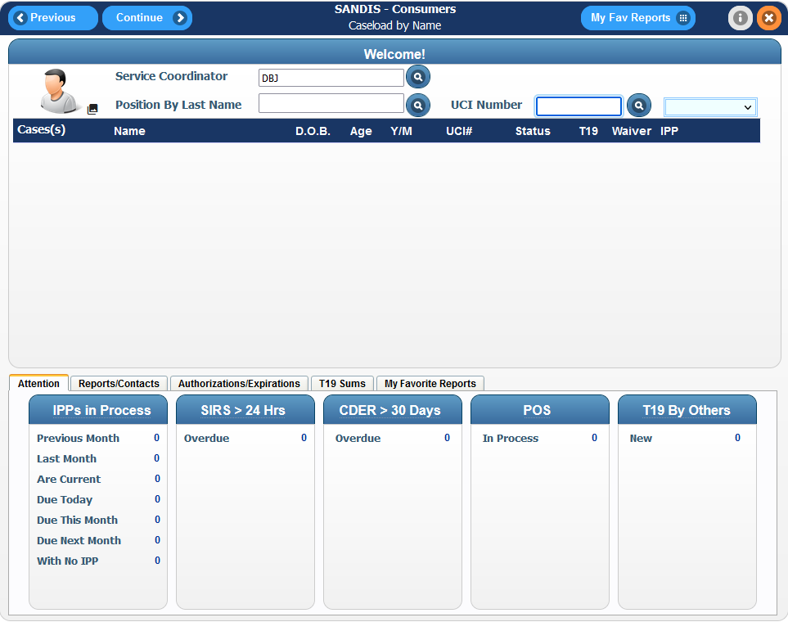
Start by entering the UCI number in the welcome screen. Click on the drop-down menu to the right of the icon and select CDER. This will take you directly to the CDER program. | 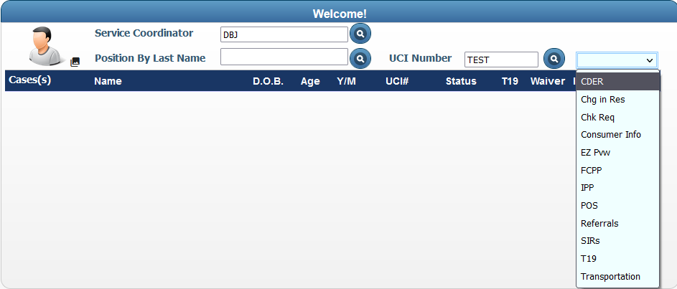

A CDER record is also directly accessible by right clicking on a Client from the welcome screen caseload view and selecting CDER. | 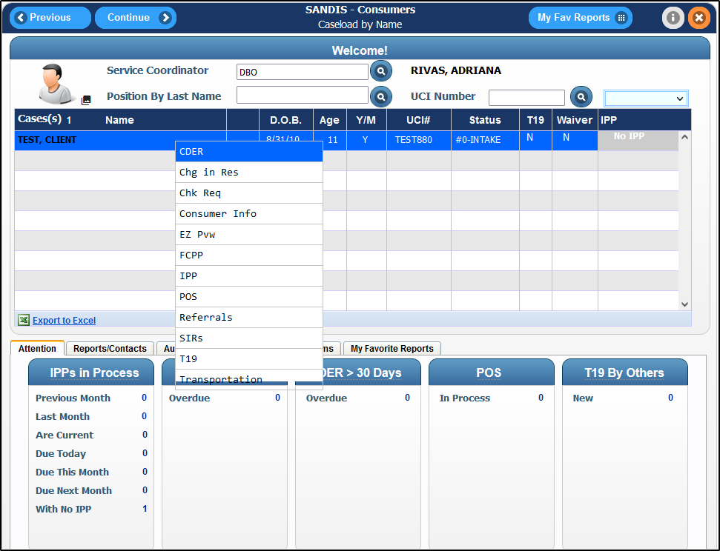
Lastly, you can access the CDER program from the Navigation tab. Under Clients/CDERs – UPP, select Update CDER Info. | 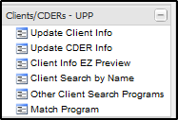

Searching for a Client  If you accessed the CDER program from the Navigation menu, a screen will prompt you for the Client’s UCI#. Enter the UCI# and click . | 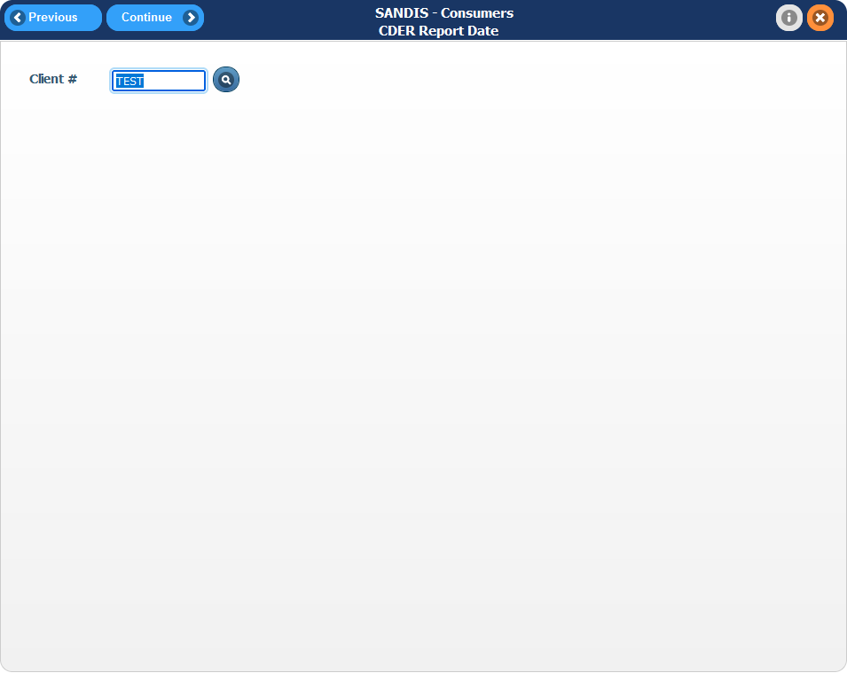
You can also search for a Client using the icon. Click on the icon to search for the client by first name, last name, or partial name.  This screen allows users to conduct a wildcard search of any Clients with the entries that are inputted. A minimum of 1 letter in any field is required prior to conducting any search. Hit the button to proceed. | 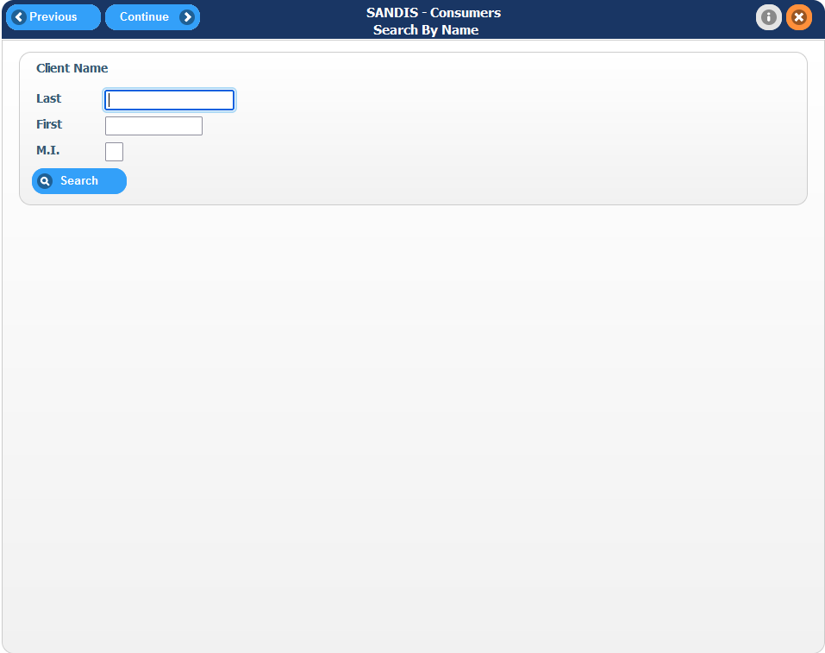

A list of clients will appear that match the specified search criteria. Double click the name or right click the name and choose Select to continue. | 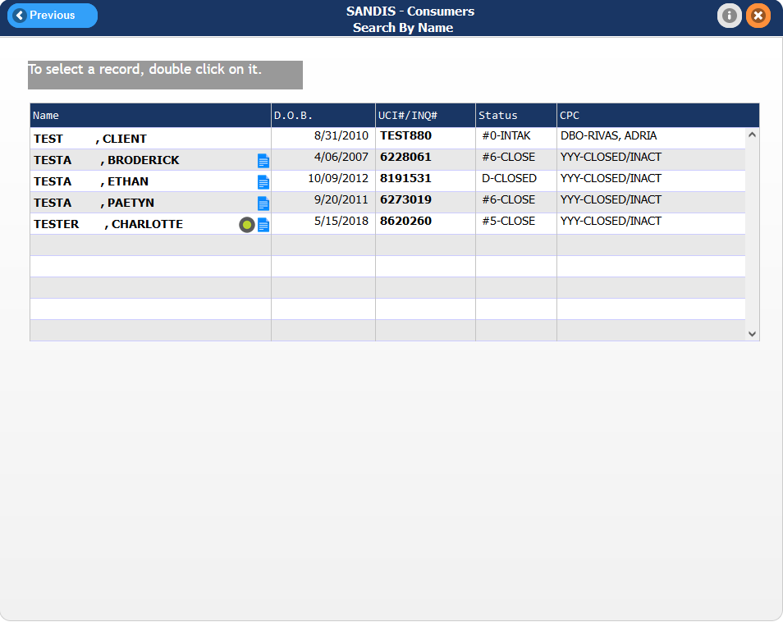
Whichever method is chosen, once the customer is selected, you will be directed to the main screen of the CDER program, the CDER Report Date screen. | 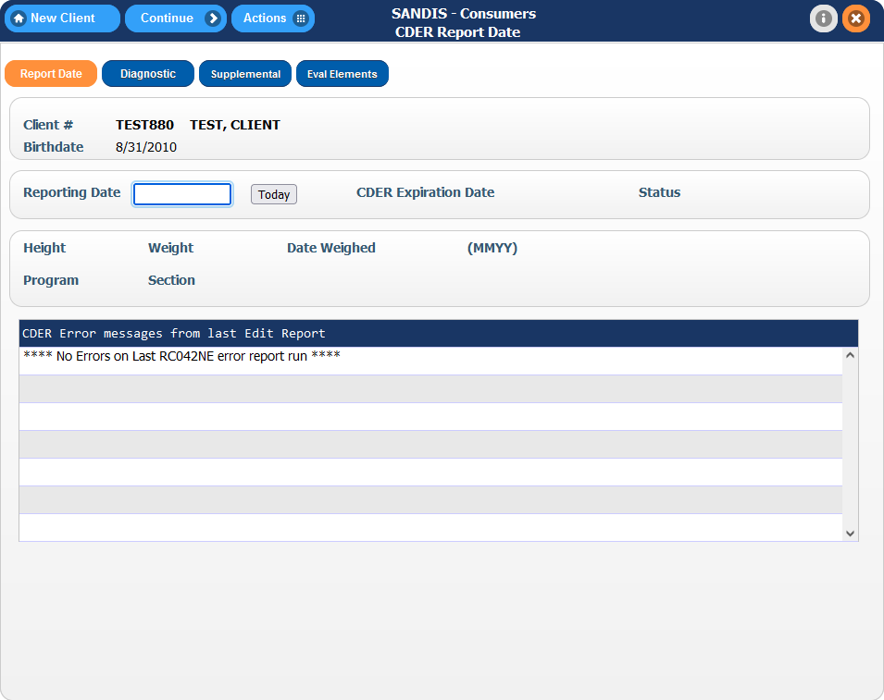
There are four tabs to go through in the CDER program:  Please note that clicking on these icons will take you to the specific tab but will not save your work. To save your work, press the button. | 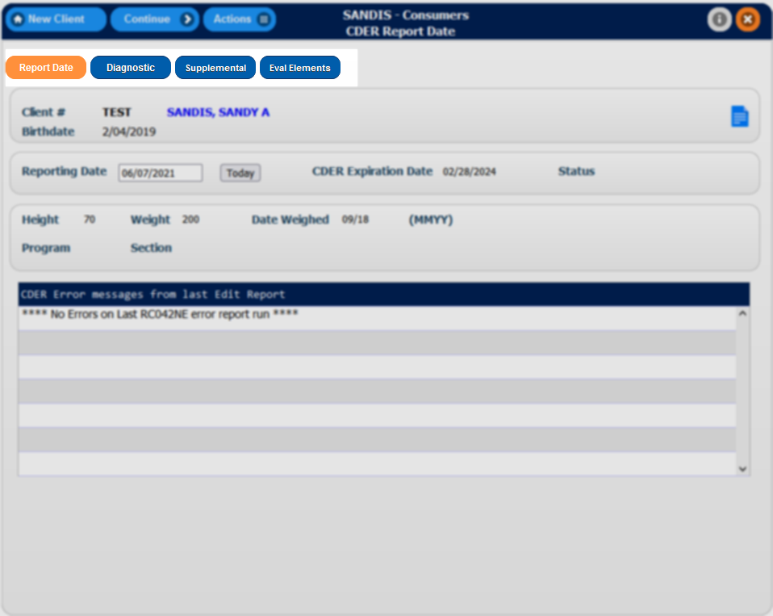

Navigating the CDER menu

Add Report Date  A client’s CDER begins at the Report Date screen.  If you are modifying an existing record, ensure that the Height, Weight, Date Weighed, Program and Section entries are accurate and press the button. | 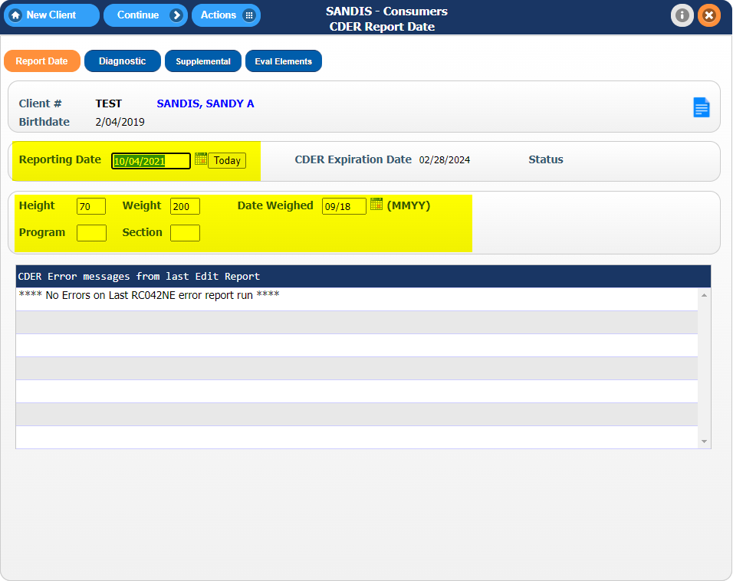
If a new entry is being created, fill in the blank entries, including the Reporting Date, and press the button to begin the workflow. | 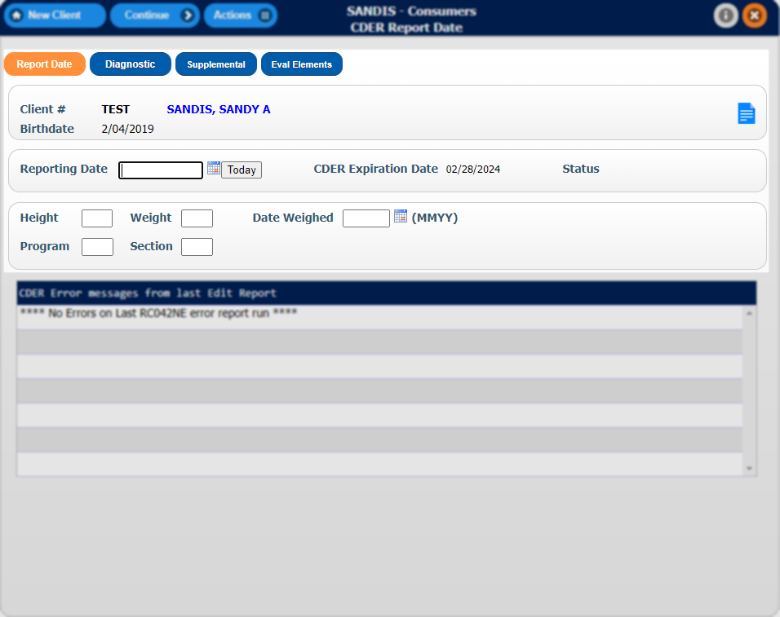
Add Diagnostic Information  In the Diagnostic screen, click on the button to add a new entry. You can View, Modify or Delete an existing entry by right clicking the record and choosing the requested action.  Please note that only clinicians will be able to update the Diagnostic tab. This is VIEW ONLY for Service Coordinators. | 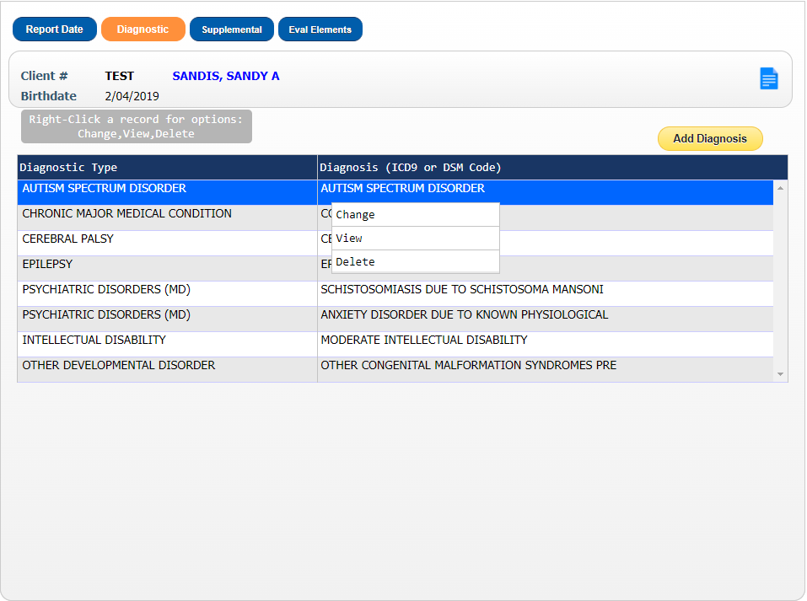
This window allows the ability to sort and filter by Diagnosis and Diagnostic Type. You can do so by right clicking the dark blue bar and choosing either Sort, Filter or Find. | 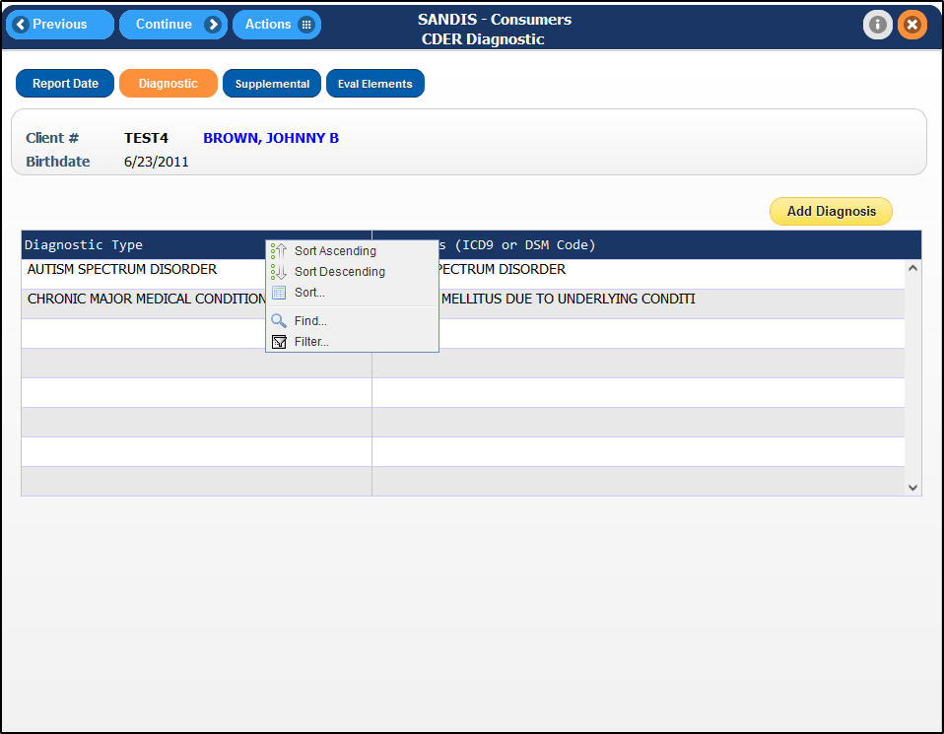
A list of Diagnoses will be displayed. Double click on a Diagnosis to be directed to the CDER Diagnostic Screen | 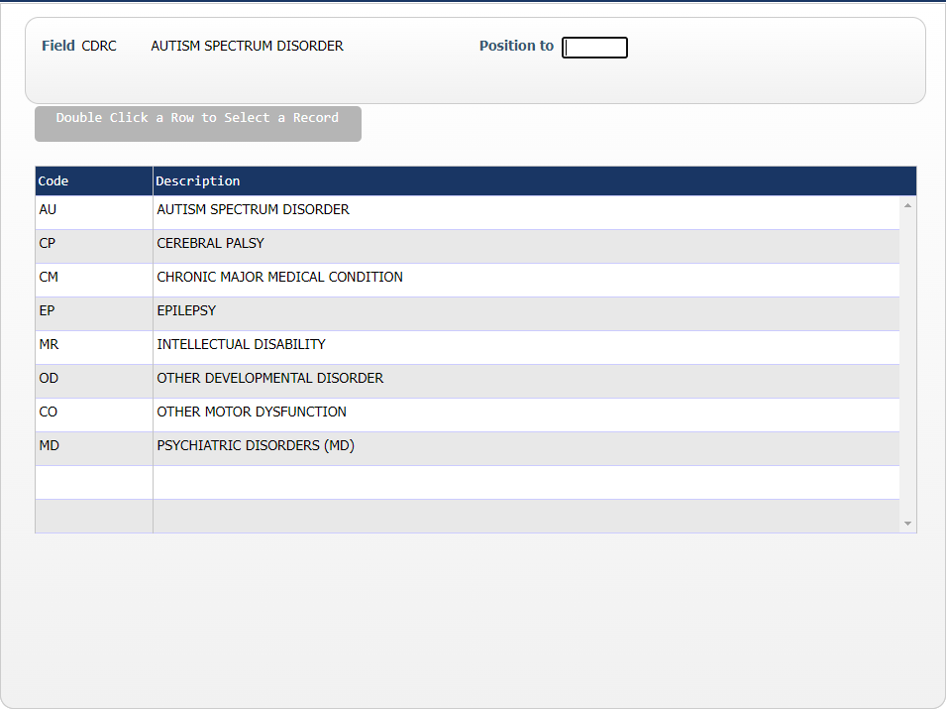

At the CDER Diagnostic screen, each CDER category will display different fields depending on the category that is chosen. Complete all open fields to continue.  Click on the icon next to ICD10 to be presented with a list of available options. | 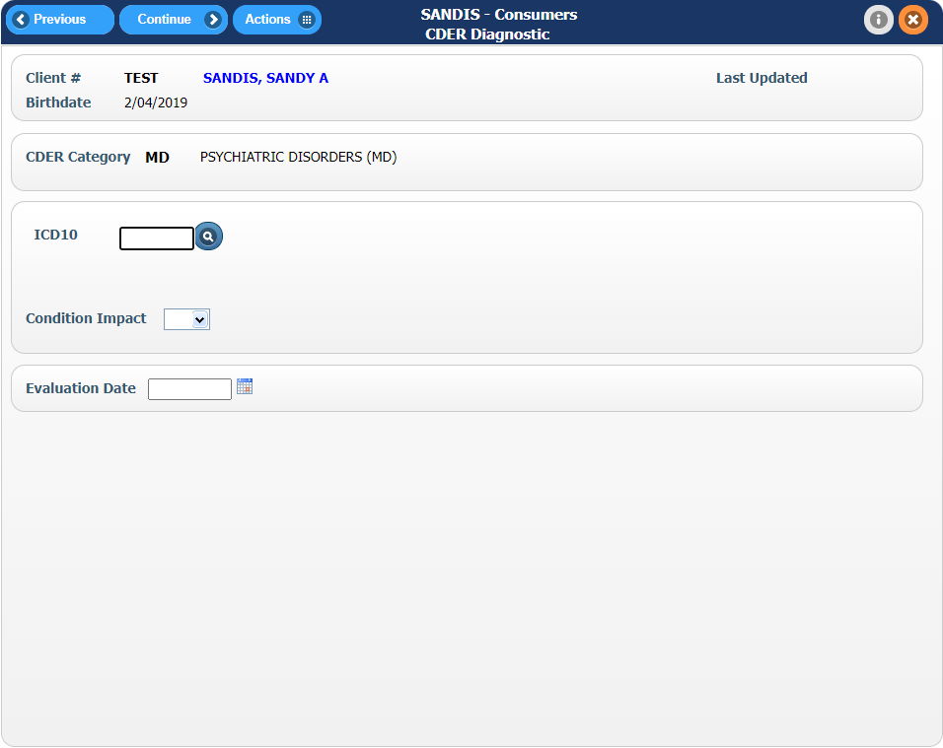
If you know the ICD10 code, you can enter it directly to jump to the ICD10 Diagnostic code or you can enter the name of the description. | 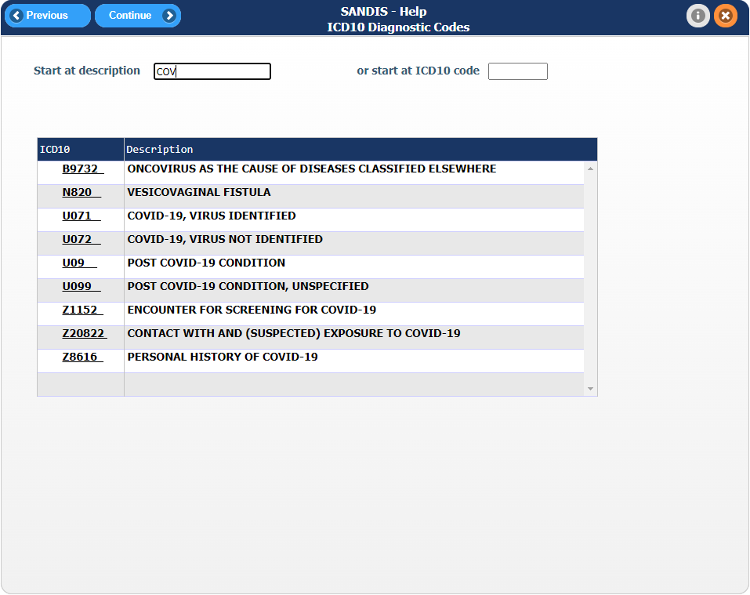
After finding the ICD10 code, click the ICD10 code to select it and press the button to add it to CDER Diagnostic record.

Add Supplemental Information  Once the Diagnostic window has been completed, press the button to be directed to the Supplemental Information screen.  The Supplemental screen is divided into two sections, Supplemental Types and the Supplemental Information records that already exist in the client’s record. You can scroll up or down to view a list of all available options. | 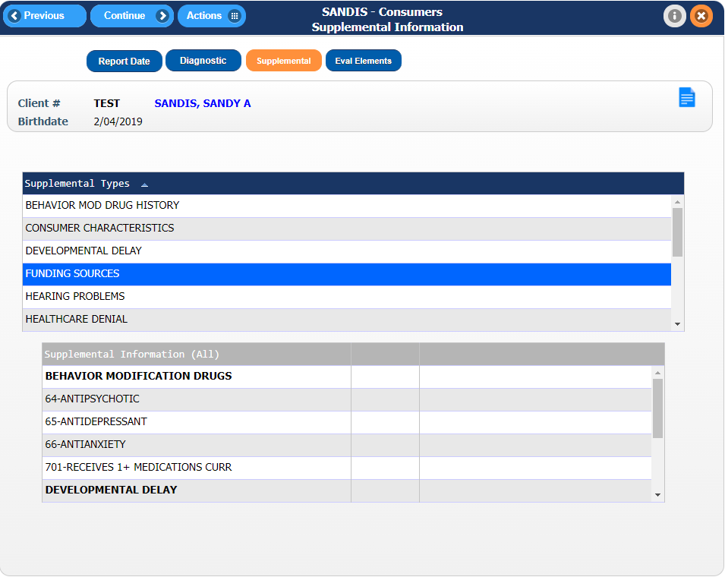
The following information can be found in this screen:  - Risk Factors  - Hearing Problems  - Vision Problems  - Behavior Mod Drug History  - Consumer Characteristics  - Developmental Delay  - Funding Sources  - Hearing Problems | 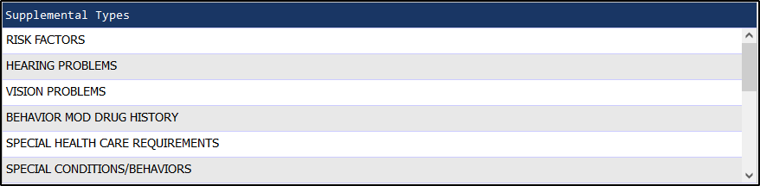
Cont…  - Healthcare Denial  - Intake Procedures  - Abnormal Involuntary Movement  - Medi-Cal Keeper  - Consumer Medications  - OBRA Eligibility  - Risk Factors | 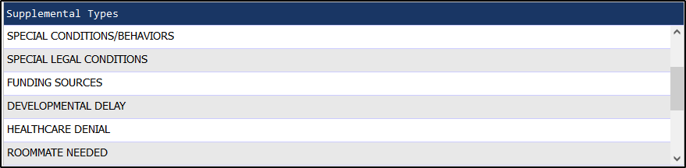
Right-Click on the Supplemental Types record you wish to add a new record for and choose Add. Existing records can be changed or viewed by choosing Change or View on the pop-up menu. | 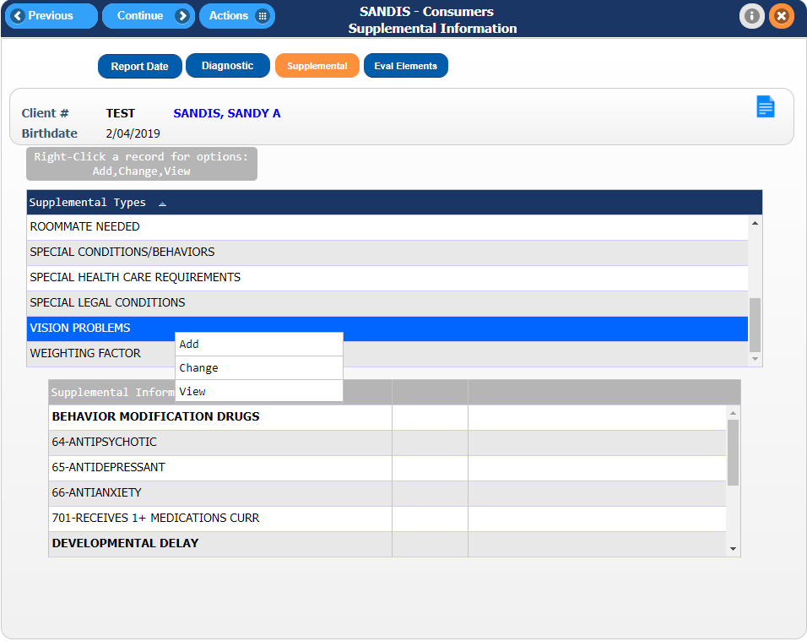

Add Evaluation Element  After reviewing the Supplemental screen, select the Eval Element tab to proceed. | 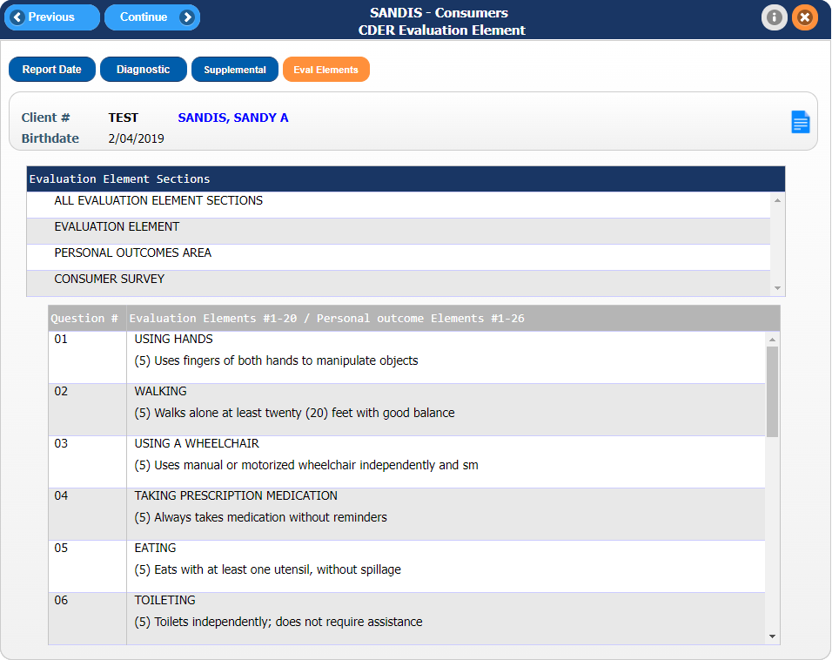
The screen is separated into two sections, the Evaluation Element and the questions pertaining to that element.  Each Evaluation Element Section has a number of questions pertaining to that Element. By right-clicking the Section, you can Change or View the responses. | 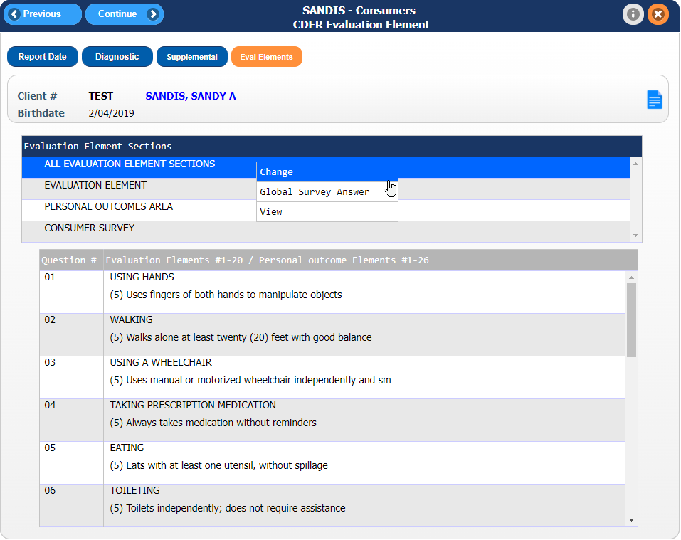
If Change is selected from the menu, you will be directed to a screen containing the questions relevant to that Element. You can use the icon to review a list of available options for that question.  Once complete, finalize all changes and exit the CDER program by clicking on to save your work. | 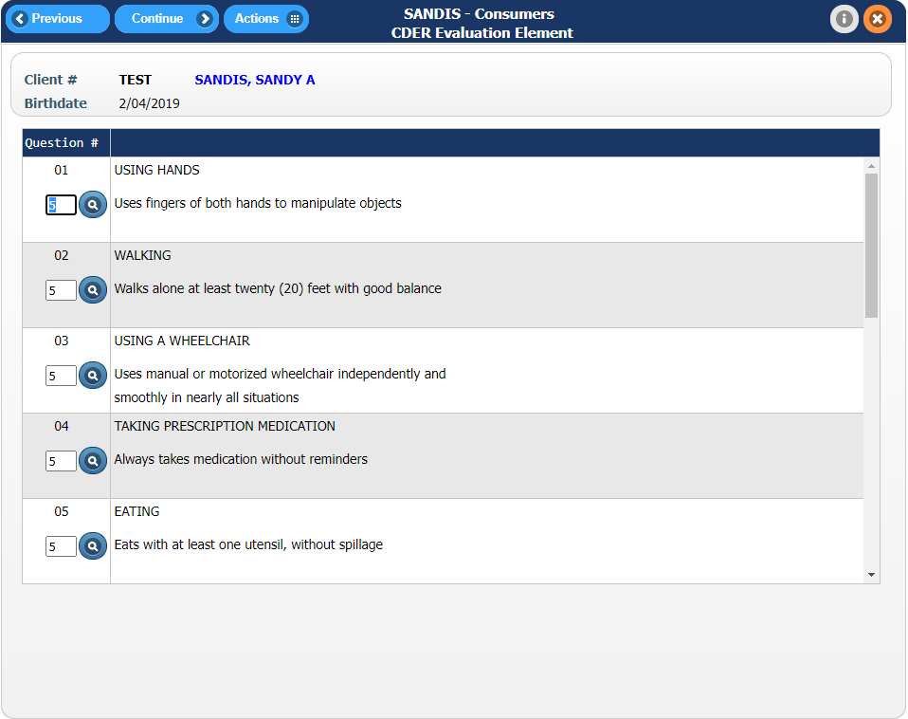
Viewing Overdue CDER

SANDIS7 provides various tools to review deadlines for upcoming or overdue CDER’s.

In the main welcome screen, the bottom portion of the screen displays a general default list of reports with due dates. A snapshot of CDERS that are due and over 30 days is set up by default.  Click on the CDER > 30 Days text to open up a detailed window with a list of clients due that have a CDER due over 30 days. | 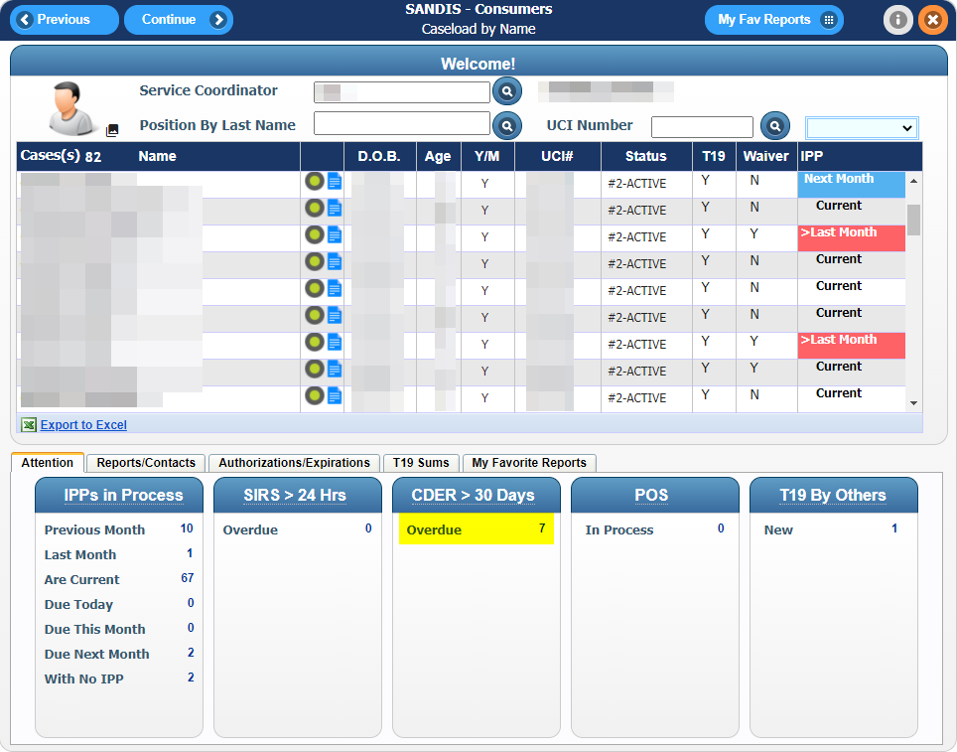
Double-clicking on the on a client will redirect your screen and open the client’s CDER record.  Please note that an Export to Excel feature has been implemented for convenience. | 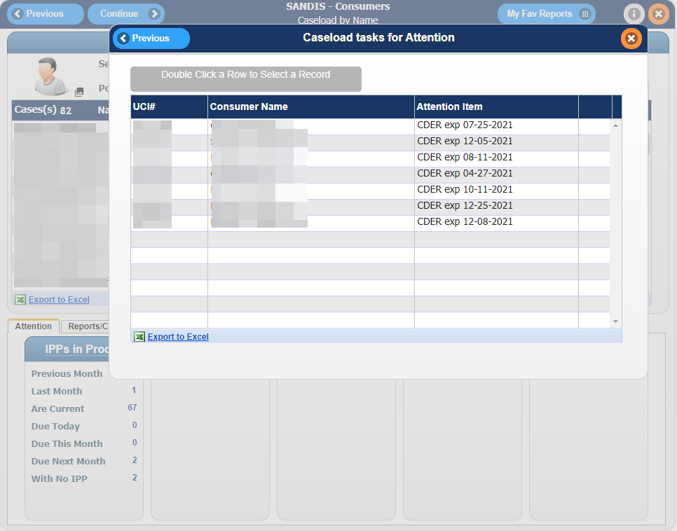

Using the Navigation menu located in the left side of the page, use the vertical scroll bar to find a category  Printing/Tracking. Click on icon to reveal the drop-down list of options and select Report Tracking | 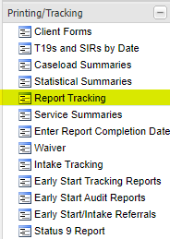
Select the CDER Over Due Reports option by clicking on the button next to the requested selection and press the button to proceed. This will lead to the CDER Due Reports screen as pictured above. | 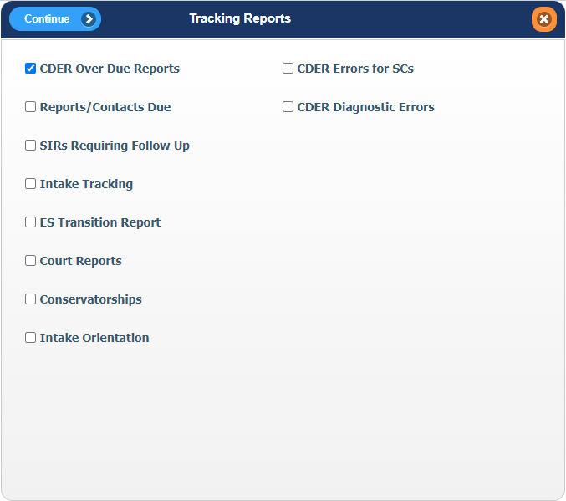
Three options are available to choose from:  - CDERs Overdue/Expired  - CDERs Over 12 Months Old  - Consumers without Revised CDER  Select one of the check boxes to make your selection and click when ready. | 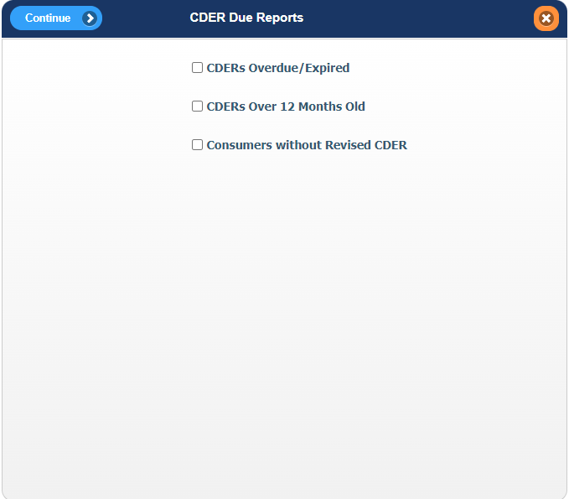
A prompt will appear to enter the caseload. A 3-character caseload code can be entered to search by Service Coordinator or a 2-character unit code can be entered to search by Unit.  If a caseload code is not found, clicking on the icon will direct the window to a list of available caseload codes that can be searched. | 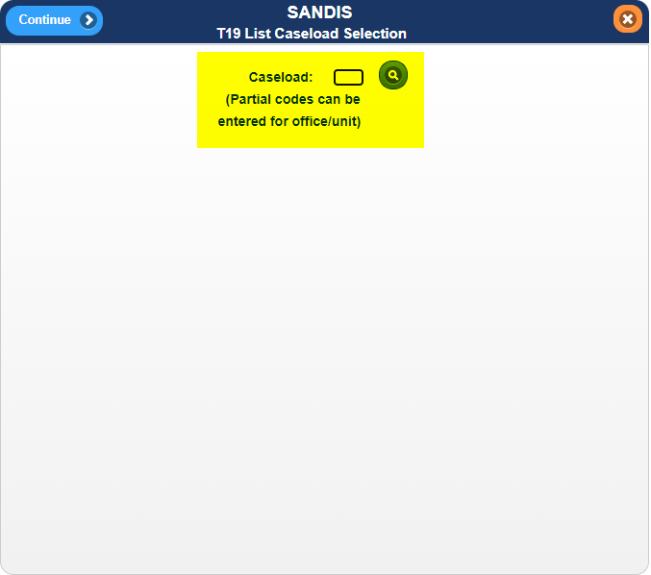
Please note, if selecting the following options:  •CDERs Over 12 Months Old  •Consumers without Revised CDER  A prompt will ask where the report will be output to. Select Display and press the icon to generate your report. | 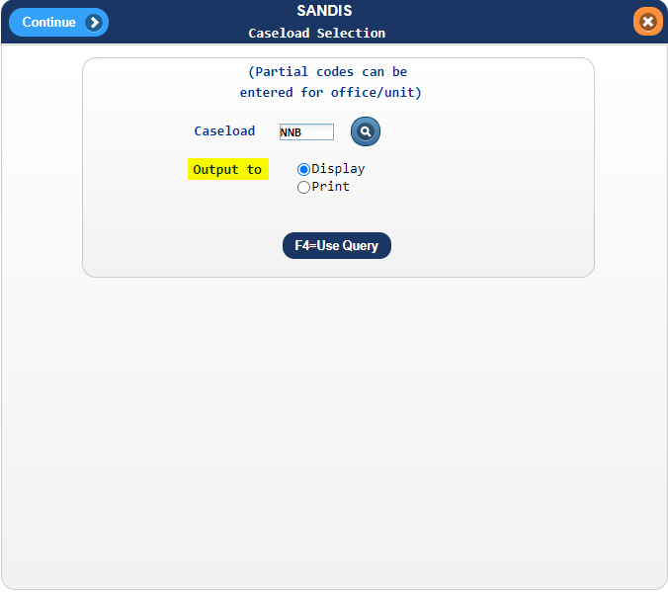
The generated report will display containing all UCI records with CDERS matching the criteria of the selected menu option. Click the button to proceed. | 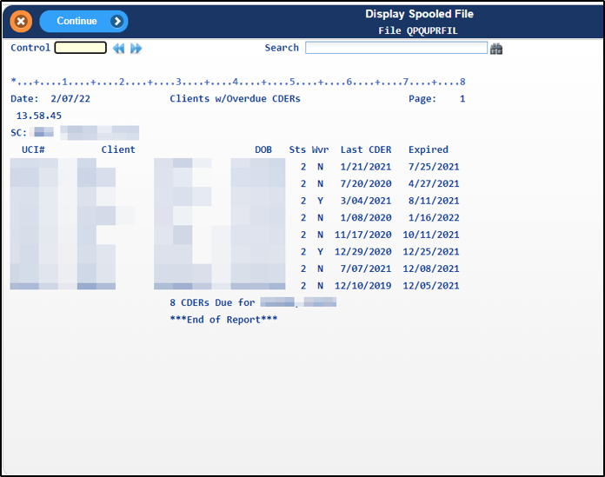

A prompt will generate to select how to receive your report. Select the desired option or press continue without selecting an option to exit the screen. | 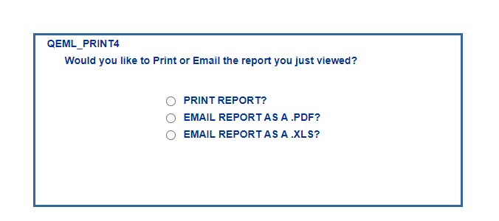
Printing a CDER  To print a CDER, use the navigation menu to find the Printing/Tracking category, click on icon to reveal the drop-down list of options and select Client Forms to be redirected to the Case Mgmt Printing menu. | 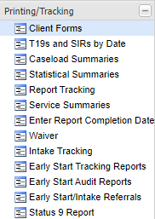
Continue by clicking the button next to the CDER Printouts. | 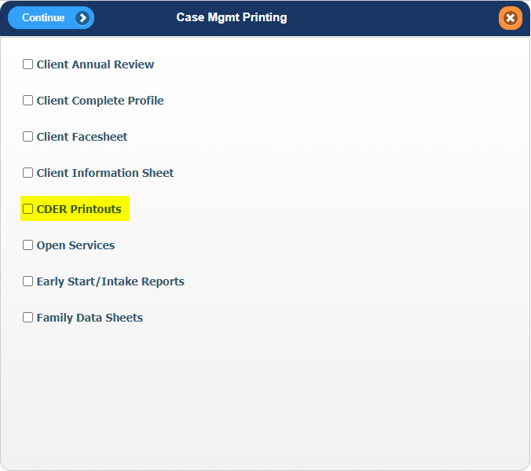

Enter the UCI# (Consumer #) and select the type of report that is requested by clicking on the button next to the selection.  Click on the button to proceed. | 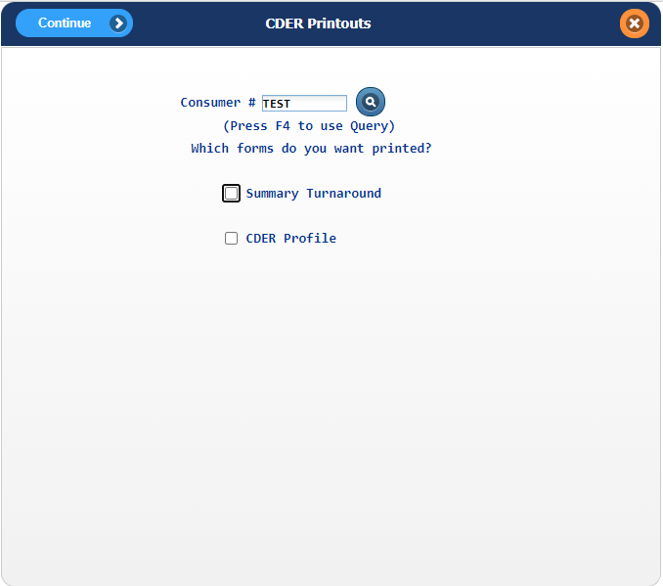
The report will display on the screen. Use the navigation buttons on the bottom right of the screen to navigate the report.  Click on the button to proceed. | 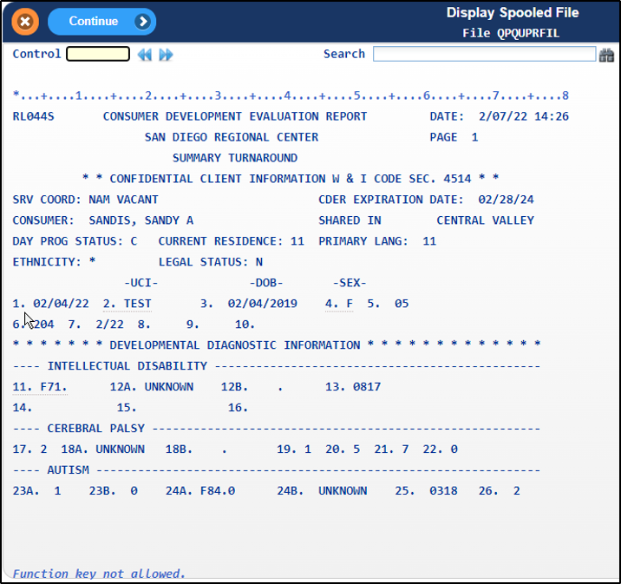
A prompt will display to print the report. If you would like to print the report, select Yes and press button to have the report printed to the default printer assigned to your account. | 