Contents
Consumer Information Program 2
Primary Tab 7
Additional Info sub-tab 9
Client Contacts sub-tab 10
Shortcuts 1 11
Shortcuts 2 12
Consumer Address 13
Consumer Relationship tab 18
Consumer History Tab 21
Consumer Supplemental Tab 27
Consumer Comments tab 32
Consumer Financial tab 37
Consumer Health tab 42
Consumer Legal tab 47

Consumer Information Program

In SANDIS7, the Primary Consumer sheet provides an overview of all information recorded for a client being served by the Regional Center. It displays the client’s demographics, address, legal status, relationships, contact information, financial, medical and guardianship history. The Primary Consumer Sheet also contains various shortcuts to different features of SANDIS7 in order to provide an easy way to update a client’s information when needed.

There are various ways to access the Primary Consumer Sheet record in SANDIS7:  - On-Call Search  - Welcome Screen Caseload View  - Atrium Navigation Menu | 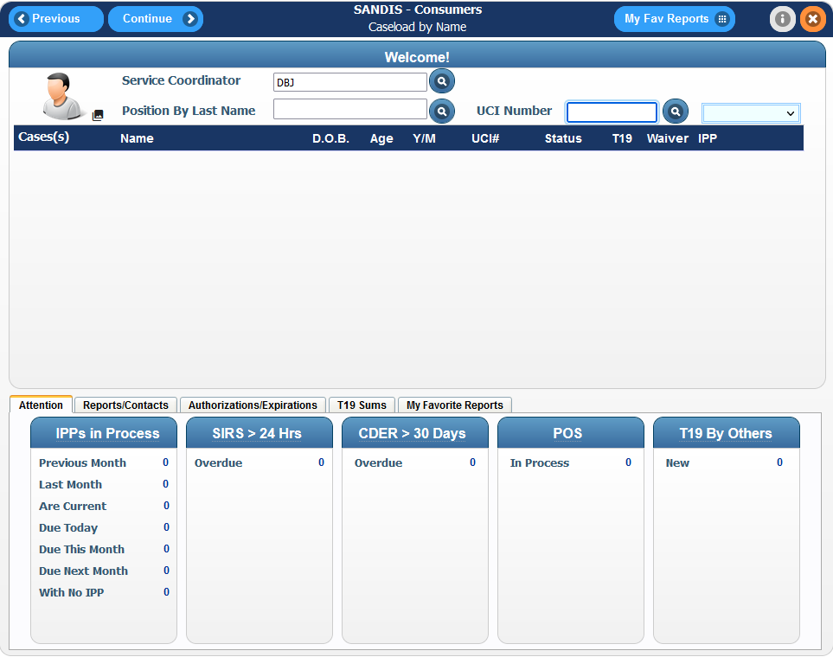
Enter the UCI number in the welcome screen. Click on the drop-down menu to the right of the icon and select Consumer Info. Additionally, pressing Enter after typing the UCI # will display the Consumer Information Sheet of the client. | 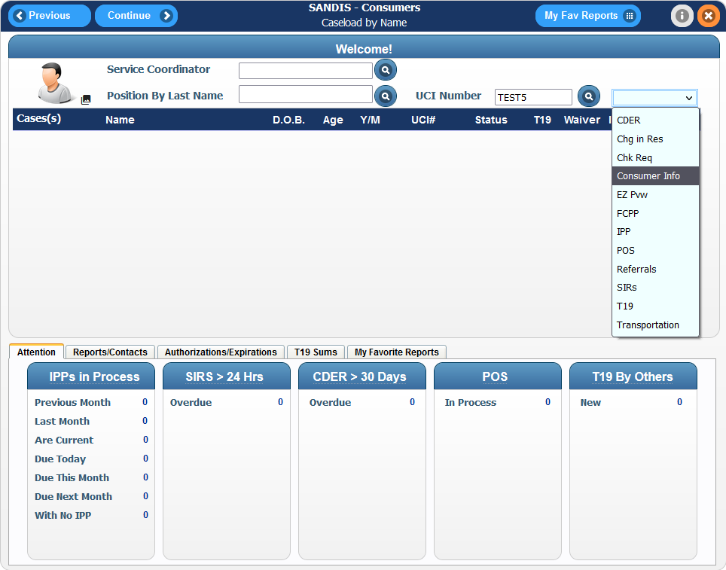
A Consumer Information record is also directly accessible by right clicking on a UCI in the current caseload and then selecting Consumer Info.  By default, double clicking on a client’s record in the Welcome Screen Cases section will redirect the user to the Consumer Information record. | 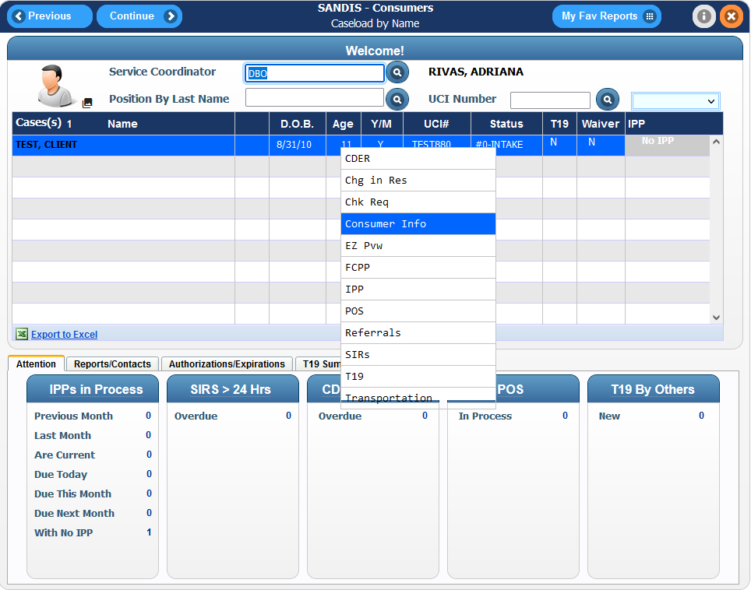
Located on the left side of the screen, the Atrium (the menu that contains all options related to the position the current account being used is coded for) has a search feature at the top. It is possible to search for the Consumer Information program by searching the name of the shortcut – “Enter/Update Client Info” and pressing Enter on the keyboard.  It is not necessary to enter the full name of the shortcut, typing in “Update” will also bring up a list of links containing the name Update. | 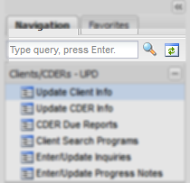
Using the scroll bar located on the right side of the Atrium menu, navigate to the Clients/CDERs – UPD group and click on the + sign. Click on the Enter/Update Client Info to enter the Consumer Information program.  Please note that the name of the menus may vary slightly. | 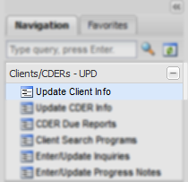
If accessing the Consumer menu via the Navigation atrium, a screen will prompt to enter the Client’s UCI#. Enter the UCI and click on the button.
SANDIS7 also provides the ability to search for a client using the icon. Click on the icon to be redirected to the Search by Name screen.  This screen allows the user to conduct a wildcard search of any Clients. A minimum of 1 letter in any field is required prior to conducting any search. Click the button to continue. | 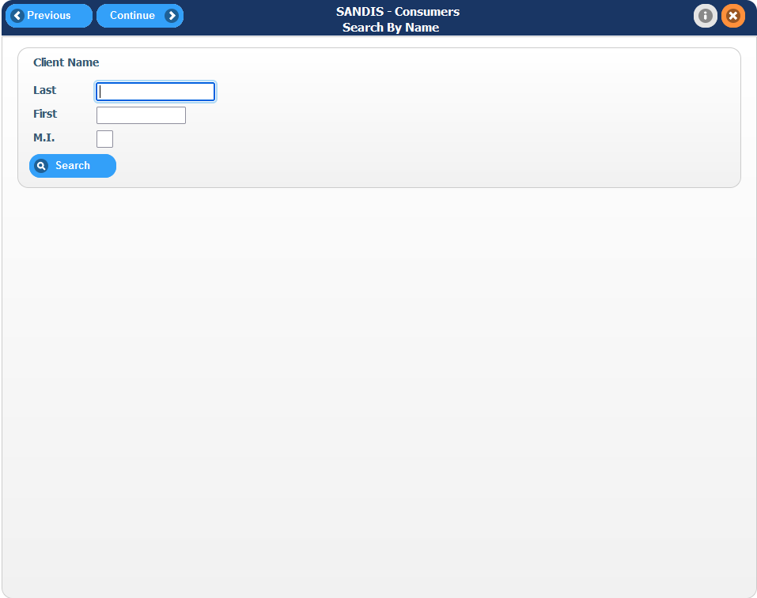
A list of clients will appear that match the specified search criteria. Double click the name or right click the name and choose Select to continue. | 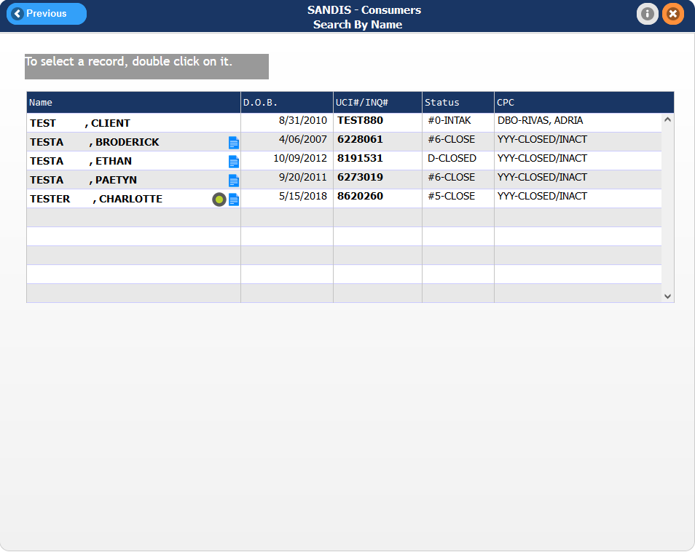
By default, only clients within the current active caseload or unit will appear as editable when accessing the record.  The record will display in view mode if the client is outside of the Service Coordinator’s unit. | 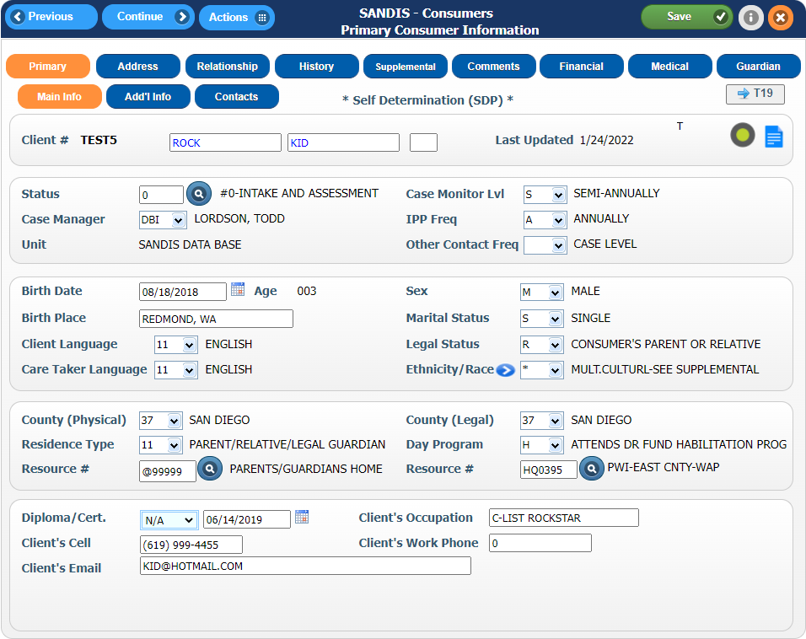
Navigation Breakdown  Upon entering the consumer record, it will display 9 tabs:  - Primary  - Address  - Relationship  - History  - Supplemental  - Comments  - Financial  - Medical  - Guardian | 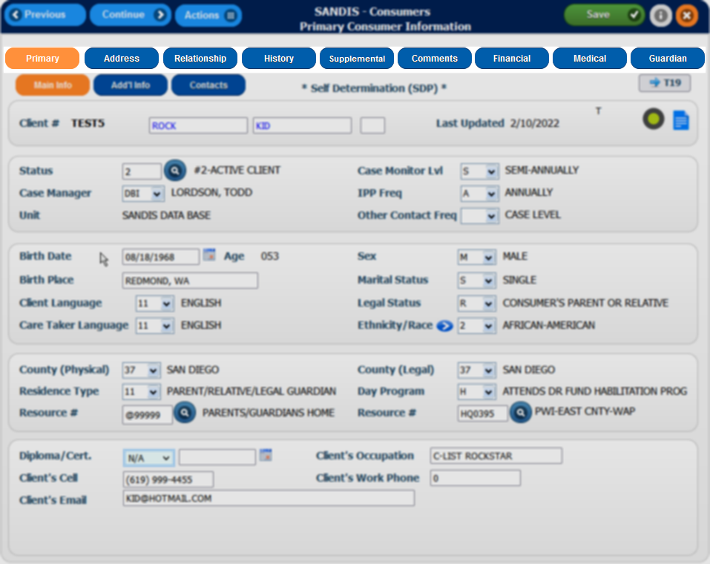
Advancing through the Consumer record workflow  Note the Previous, Continue, Save and Actions Menu Icons at the top of the menu.  - : Go back one tab  - : Go forward one tab  - : Provide a list of shortcuts based on active window  - : Save any changes made to the active record | 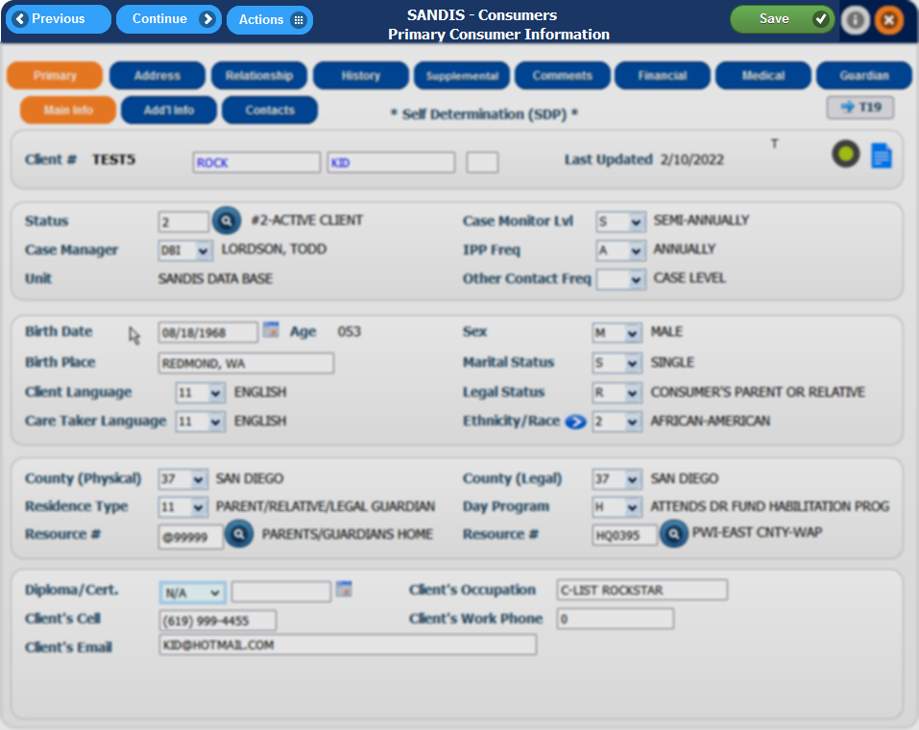
Primary Tab  In the Primary Tab of the Consumer’s record, it will display the following information:  - Case Status, Assignment and Report Frequency  - Client’s Demographics data  - Legal Residence and Resource Information  - Client’s Contact information  There are also two sub-tabs which contain additional information: | 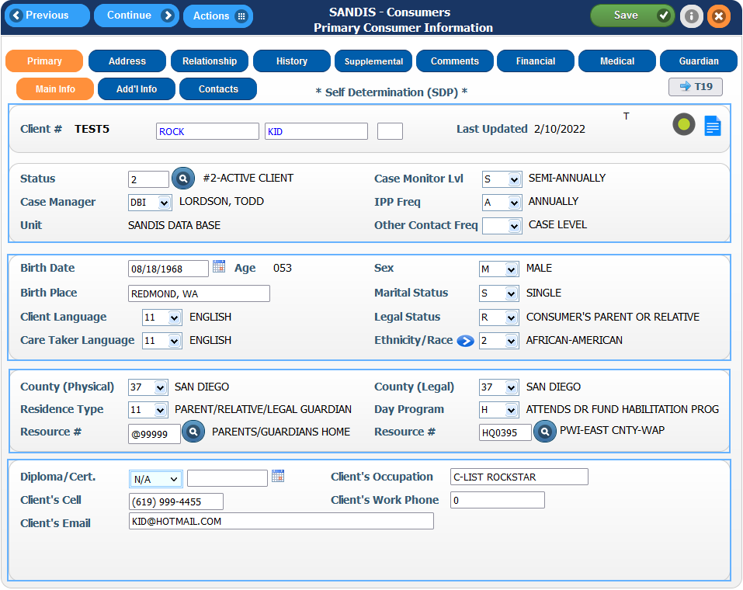
This portion of the consumer record displays  - Client’s Name and UCI#  - Case Status  - Assigned Case Manager  - Assigned Unit  - Case Monitor Level  - IPP Frequency | 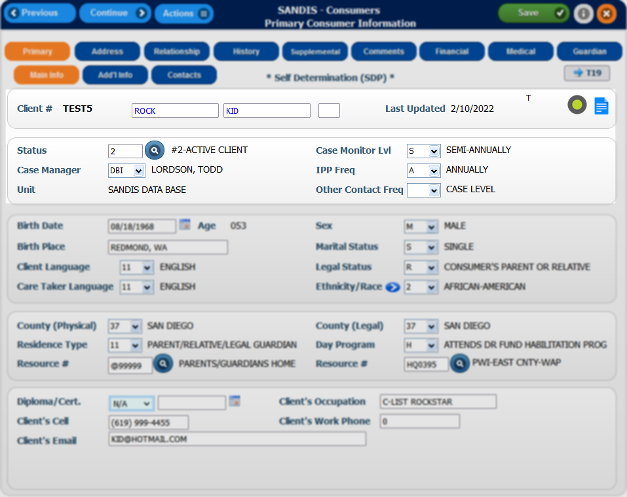
This portion displays  - Client’s birth date and current age  - Birth Place  - Language  - Caretaker Language  - Gender  - Marital Status  - Legal Status  - Ethnicity/Race | 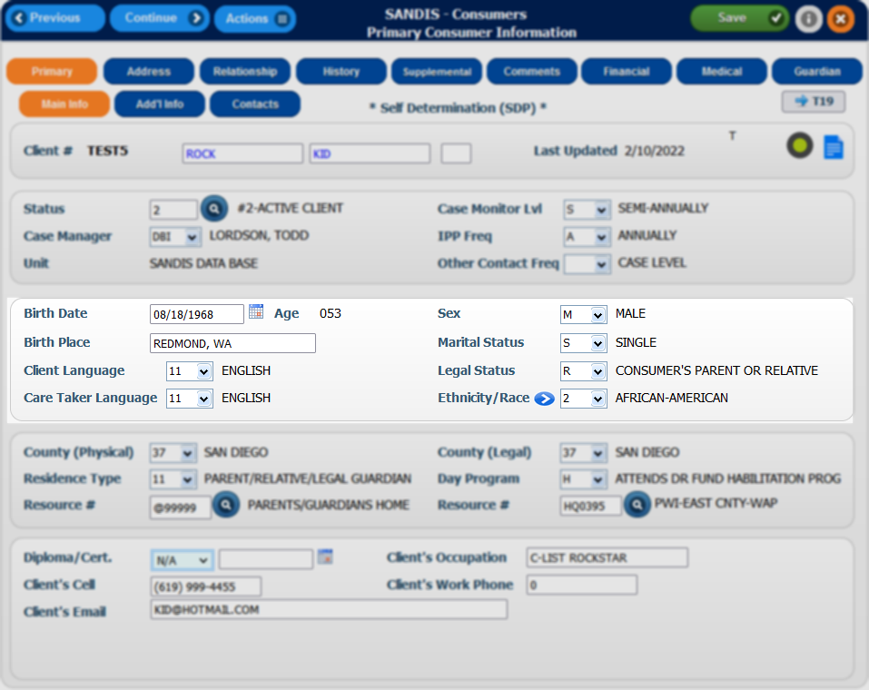
This portion displays  - Assigned County Code  - Legal County Code  - Residence Type  - Resource# assigned to the customer (if any)  - Day Program Record | 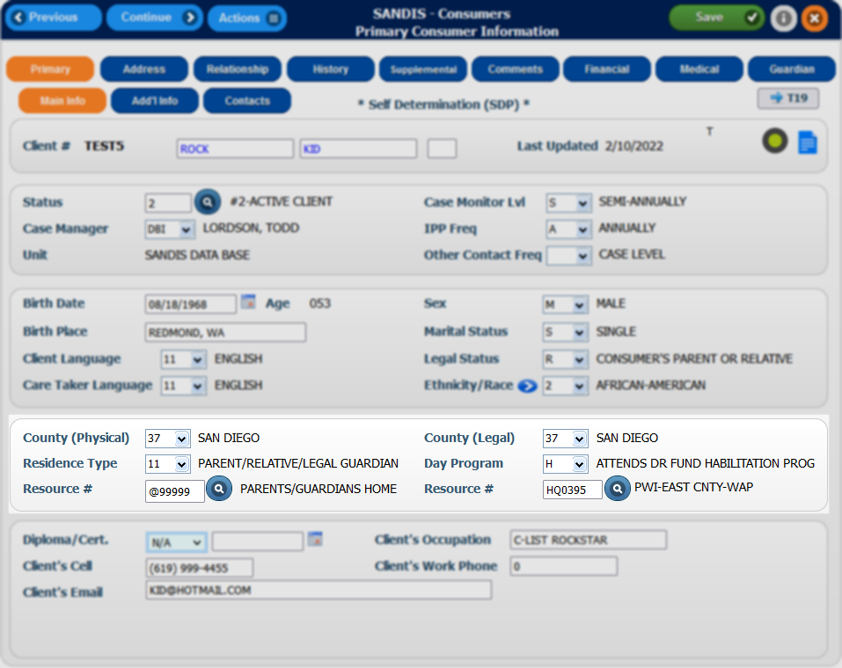
The bottom portion displays  - Diploma/Certificate information  - Phone number and Email  - Occupation and Work Phone | 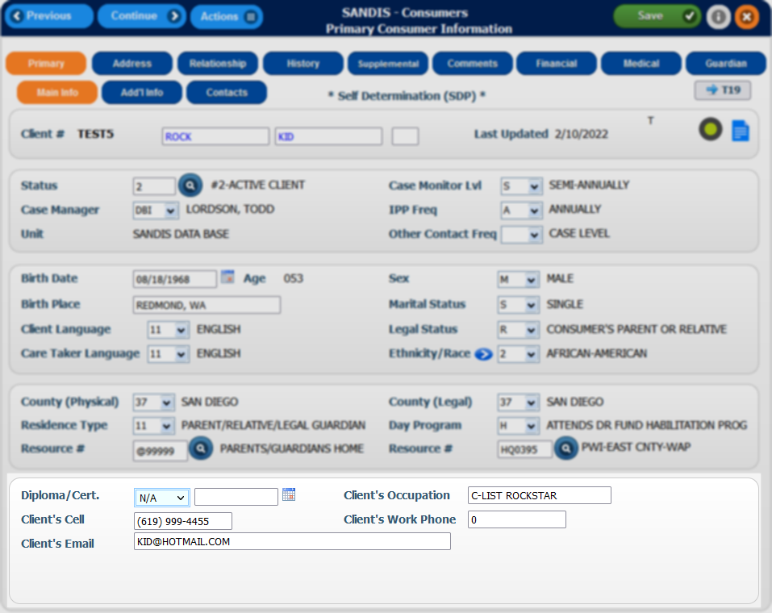
Additional Info sub-tab  Clicking on the tab will direct the user to an extra tab of information contain the customer’s  - Medicaid Waiver eligibility  - Health District  - Case Management Type indicator  - Assessment Level  - Referral Source  - Maiden name for self and mother  - Religious preference  - Children for consumer indicator | 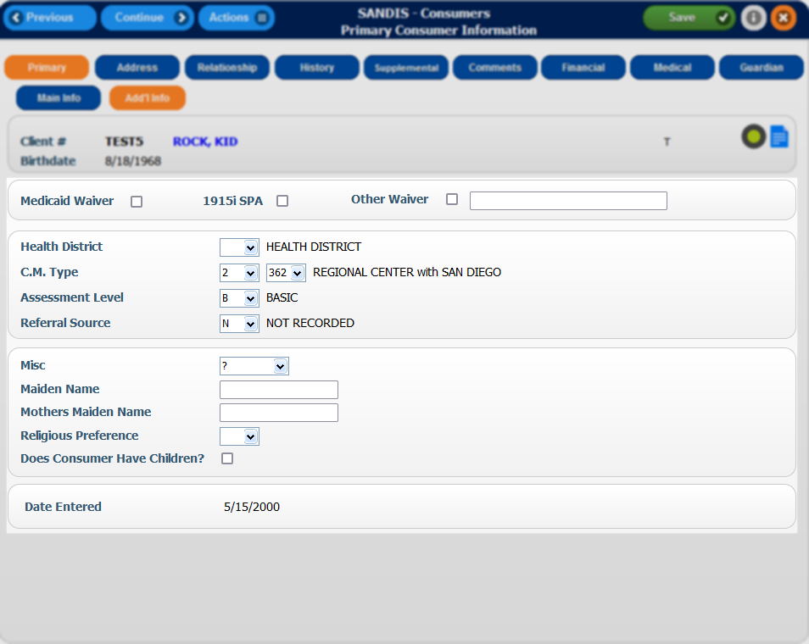
Clicking on from this screen will display the primary screen of the consumer file. The tab can be used to place additional contact information for the client. | 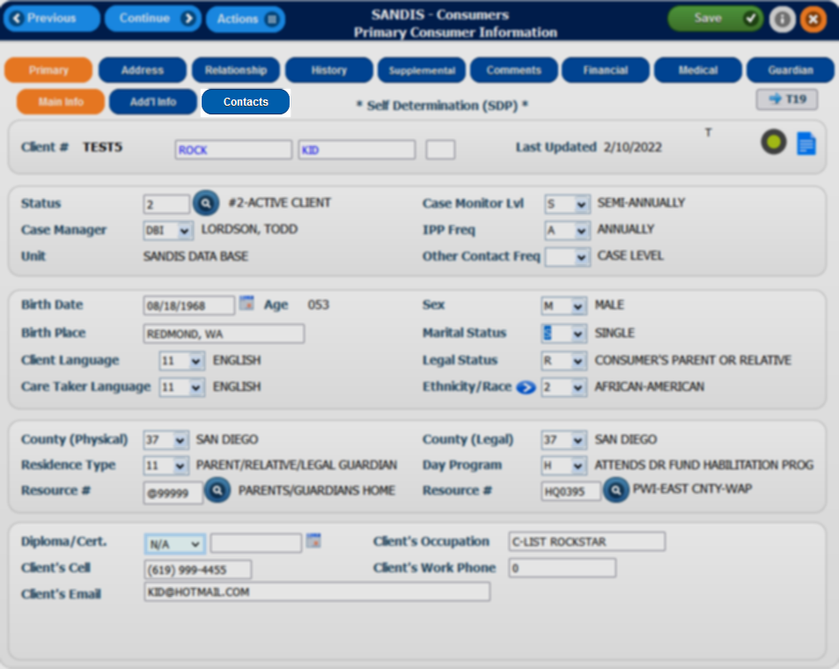
Client Contacts sub-tab  Clicking on 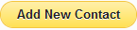 will bring up a list of options that can be used to add a new record. A Primary Legal Contact, a Primary Family Contact and an Emergency Contact can all be added if desired. Double click on an option to proceed. | 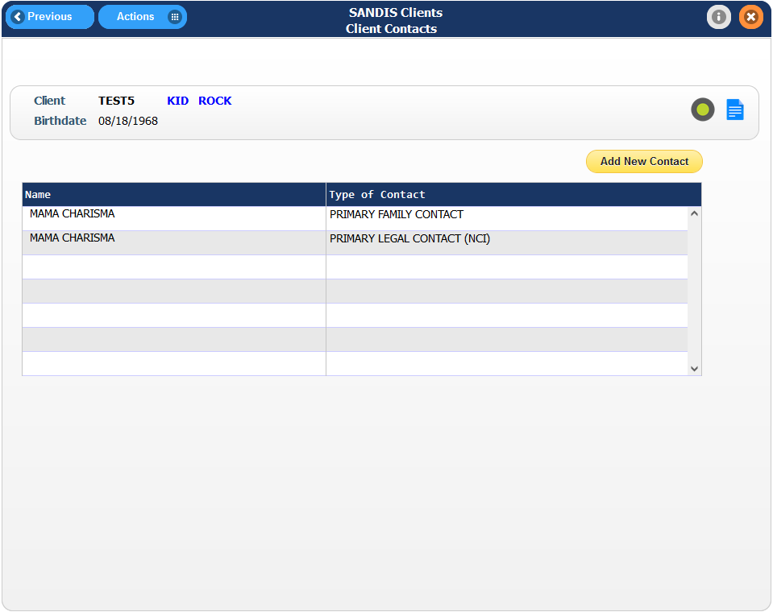
A list of available relatives that are in the Relationship will appear. If the relative is not present in this list, click on to add a new entry to the client’s contacts.  Double click on a record to continue. | 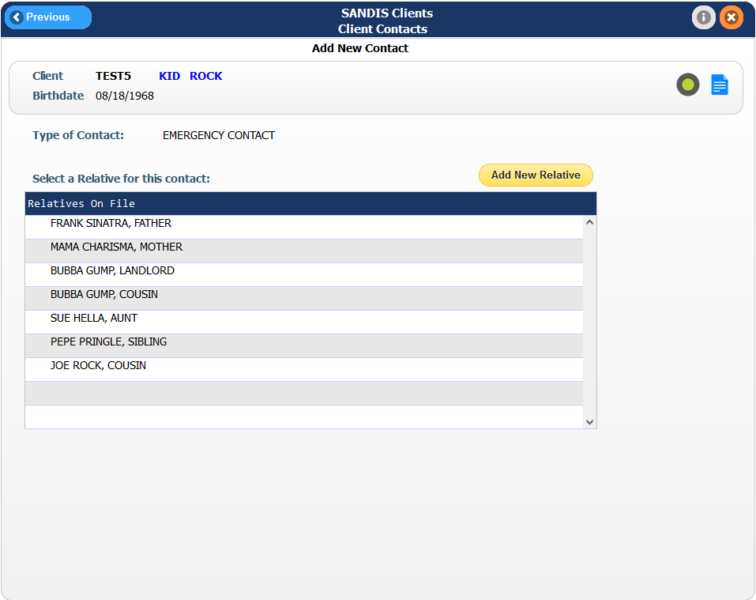
Select an address from those listed or click to create a new entry. Double click the desired address to proceed to the next screen.  Press when ready to finalize the change. | 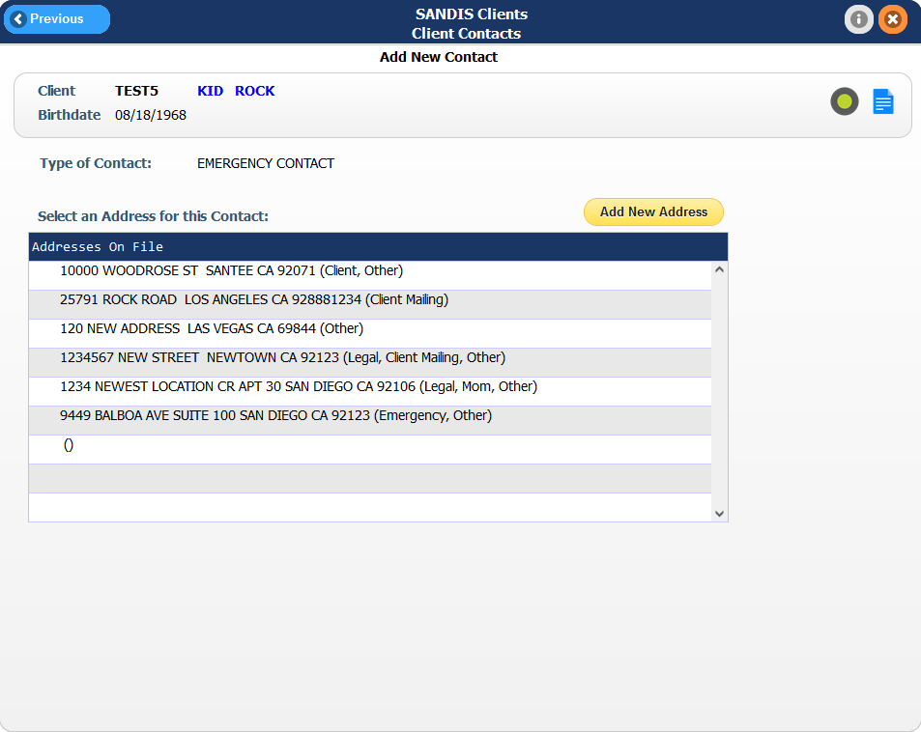
Shortcuts 1  Under the tab of the Consumer record, there are various shortcuts. Highlighted on the right are the following clickable shortcuts:  - Therefore document  - Legacy OnBase  - Title 19 Program | 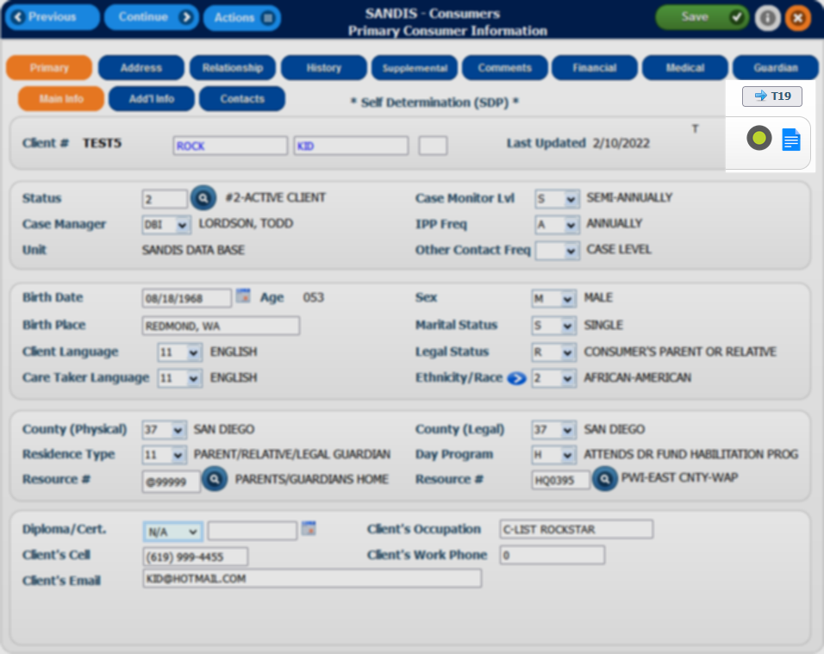
In addition to drop-down menus being available, these features are available:  The icon to assist with searching for status and resources  The to assist with entering the date  The icon to assist with selecting multiple ethnicities for a client | 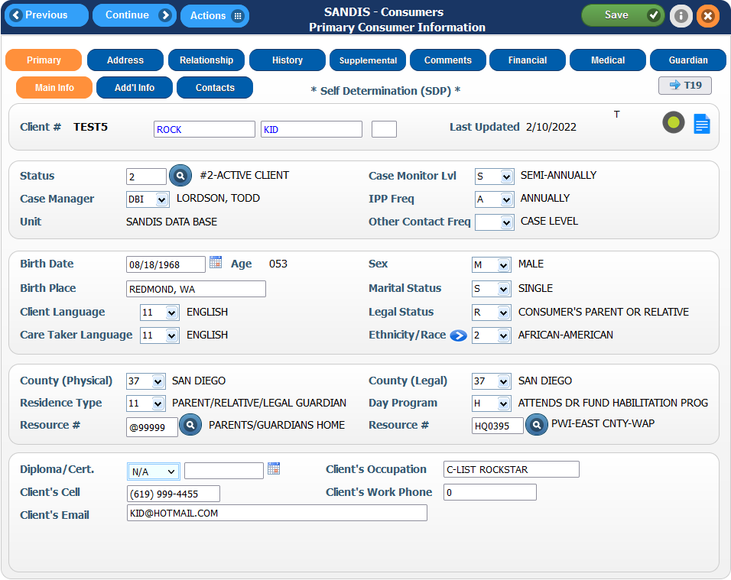
Shortcuts 2  Clicking on the Menu will bring up a list of the following shortcuts:  - Save changes to record  - Additional Info Tab  - Access the CDER record  - Comments Tab  - Financial/Medical Tab  - Guardian/Conservator tab  - History Tab  - UCI Search Tab | 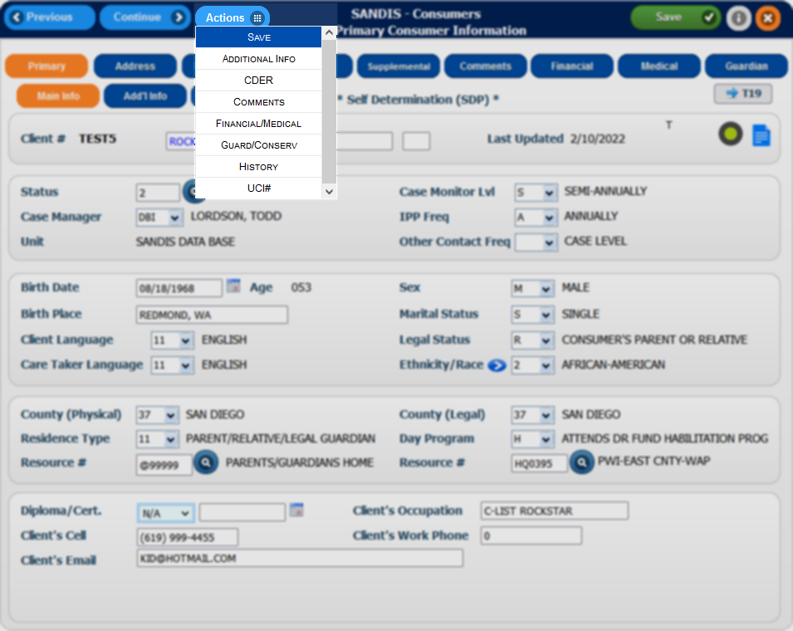

Consumer Address

To Access the Consumer Address screen, click on the icon found in the Primary tab of the Consumer record.

This tab displays the client’s address and addresses pertinent to the case such as legal address, mailing address, work address, residential facility, etc.  Please note that the record must contain at least and only one of the following:  - One Consumer record only  - One Mailing address only  If applicable, a client can have one address with a bus pass. An error will occur if there are multiple addresses with a Bus pass checkbox marked. | 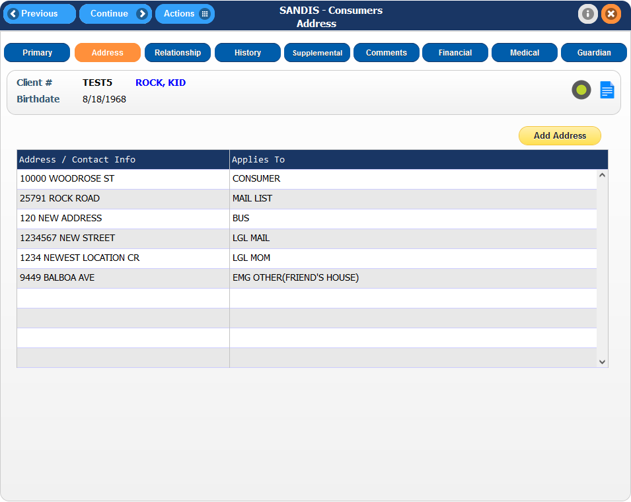
There can be multiple entries listed but there must only be one Consumer record and one Consumer Mailing Address per UCI record.  NOTE: Consumer does not have to be checked if they are marked as Status 90-Transient/Homeless under Residence Type in the primary tab of the Consumer File. | 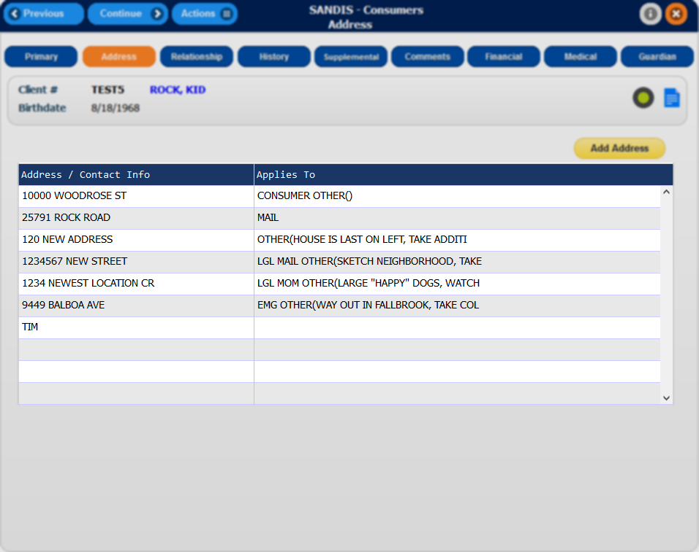
Additionally, If the client is eligible to a Bus Pass or Voucher, there can only be one entry for Bus Pass or Voucher on the client’s record.  Placing a checkmark for Bus Pass or Voucher for two addresses within the client’s record will cause an error. | 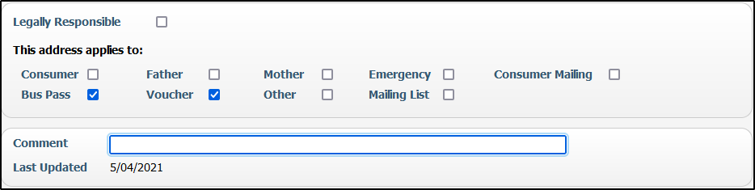
Viewing vs Editing  If accessing a record, double clicking on the record will take the user to the record in View-Only mode. To make an edit, right-click on the record and choose the Change option. | 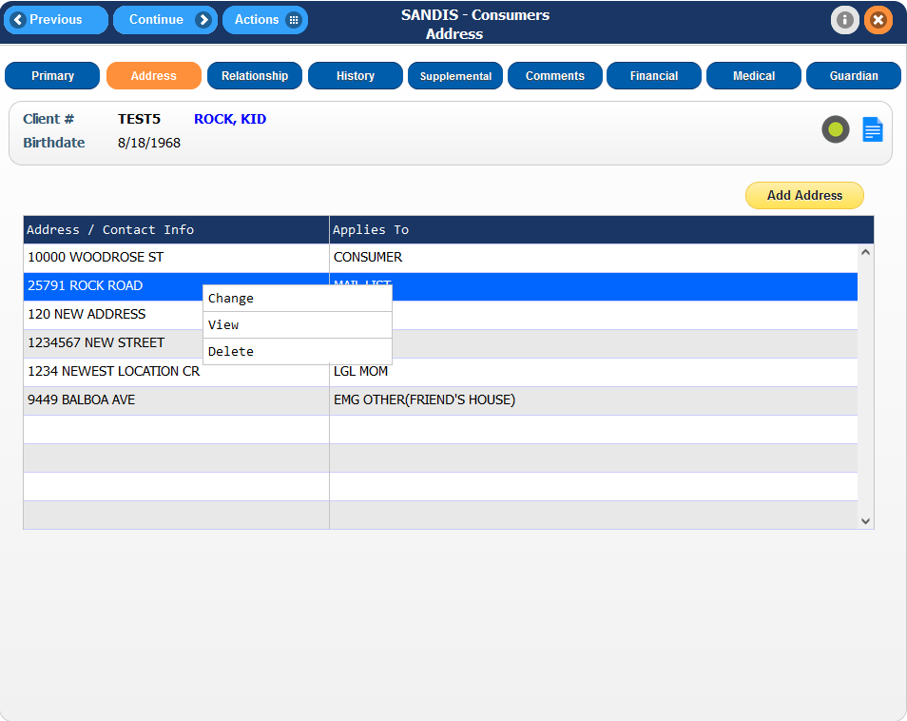
Adding a New Address  To add a new address, click on the  icon.  Enter all the pertinent fields for the new record that are being entered and press the button to save any changes or the button to save and exit the record. | 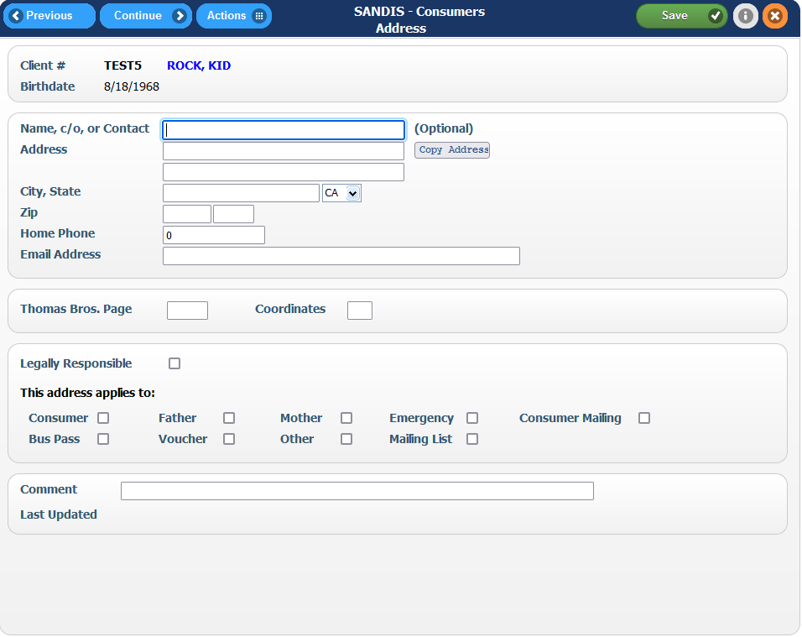
Completing an Address Change  In the event of a client moving to a different address, the current address would need to be modified to remove the Consumer checkbox from it and adding it to the new record.  e.g. A client is moving from 10000 Woodrose St to 25791 Rock Road. The Consumer option would be unchecked. An option needs to be chosen for the record to be saved so the previous address can be indicated as Other with a Comment. | 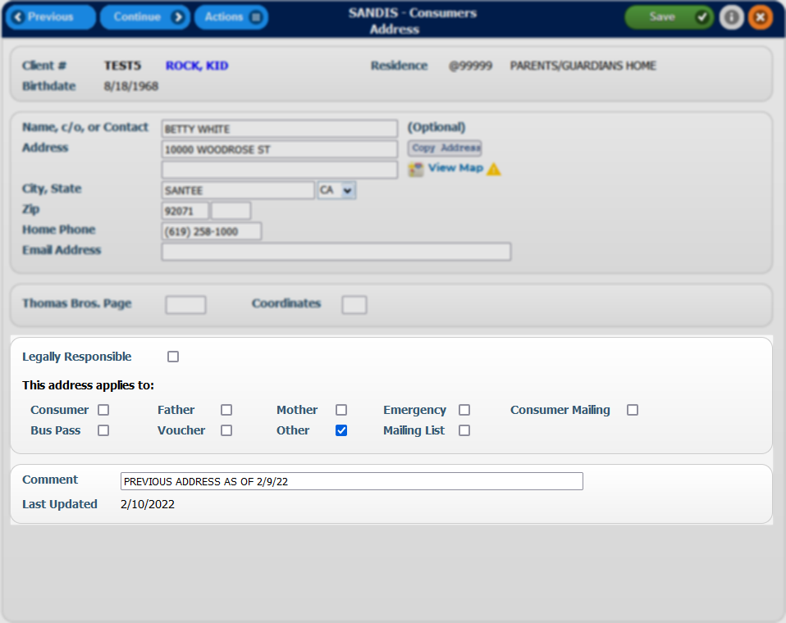
Adding an alternate mailing address  If there is a need to add a secondary or tertiary mailing address to the file, this can be done by clicking on Mailing List. Doing so will allow the user to maintain only one Consumer Mailing record and with unlimited Mailing List addresses. | 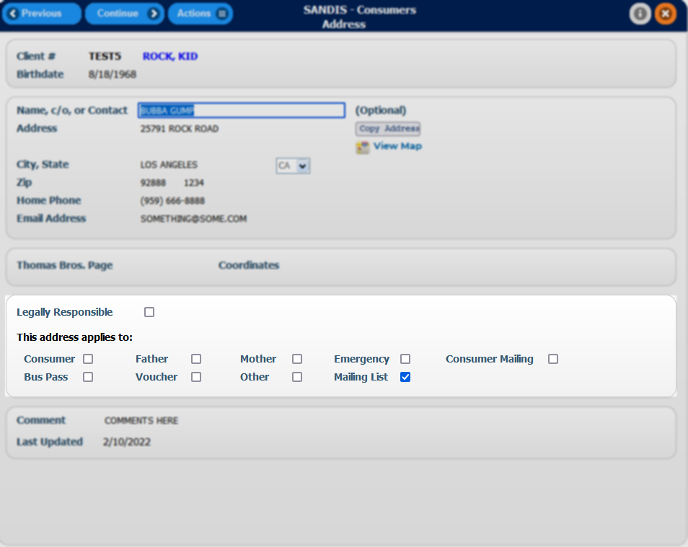
The new record would contain a Consumer checkmark and a Mail checkmark if the client receives their mail there (and there is no other address with Mail checked.)  Please note that an address must contain a zip code for the mail to be generated and sent | 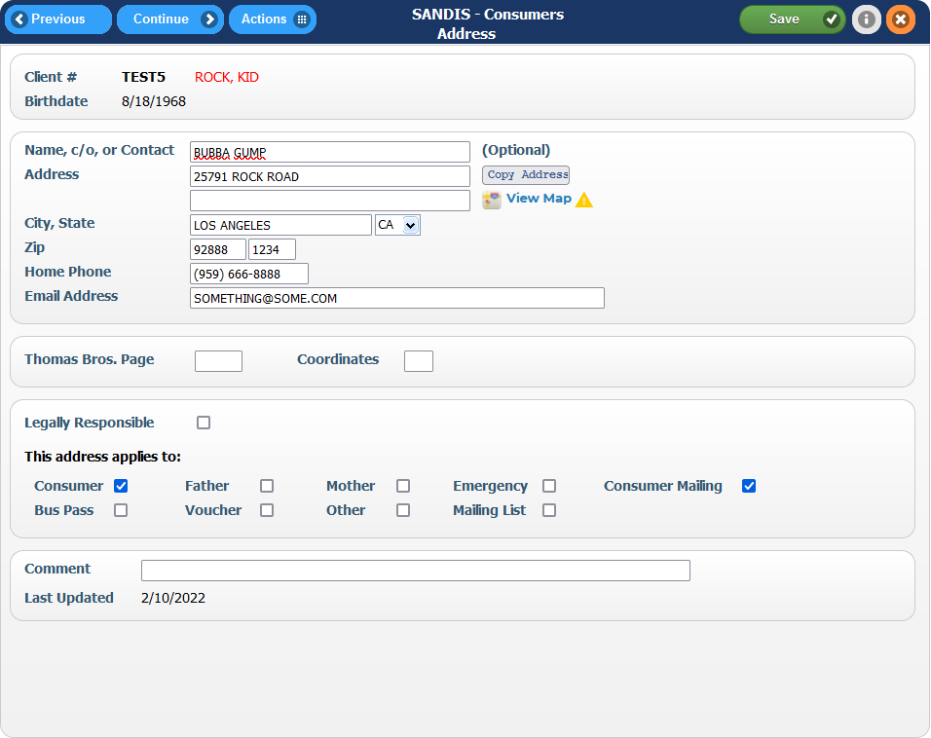
The new record would now be marked that it applies to the Consumer and the Consumer Mailing as applicable. Ensure that no other address records have the consumer listed on it and click to save and exit. | 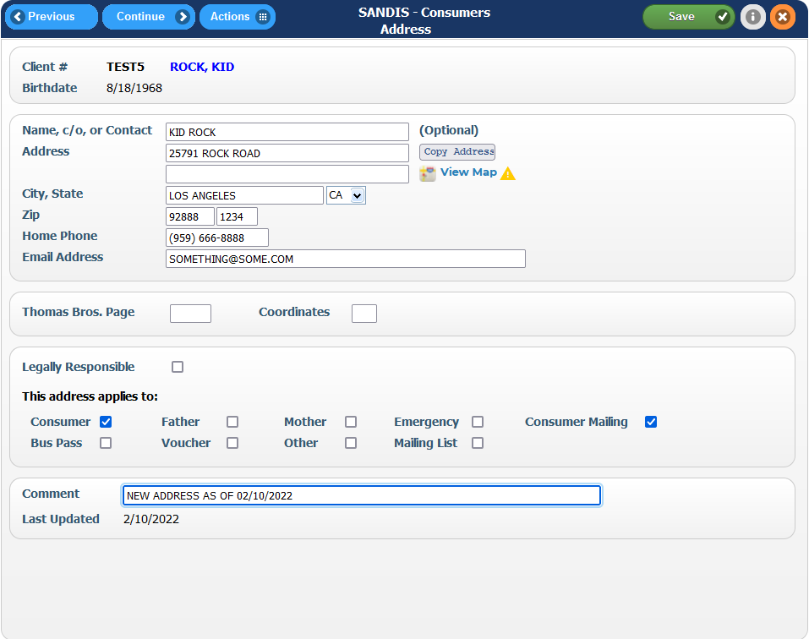
Display comments in Address tab  SANDIS7 provides the option to display comments in the main screen.  Example: Client needs to have an alternate address for a friend they stay with occasionally but does not want to receive mail there. The address can be displayed with the description as other and have no impact to the other records on file. | 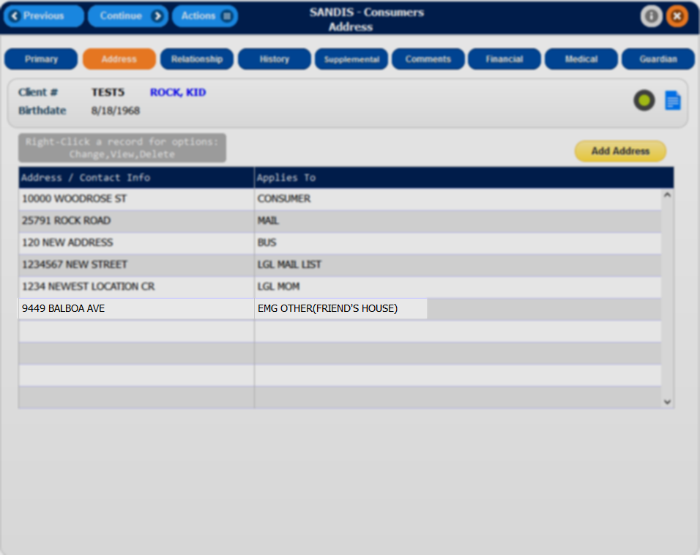

Access the record in edit mode and enter the required information. Click on the Other option and enter a note in the Comments line. The information entered into the Comments line will then appear in the Address tab after saving. | 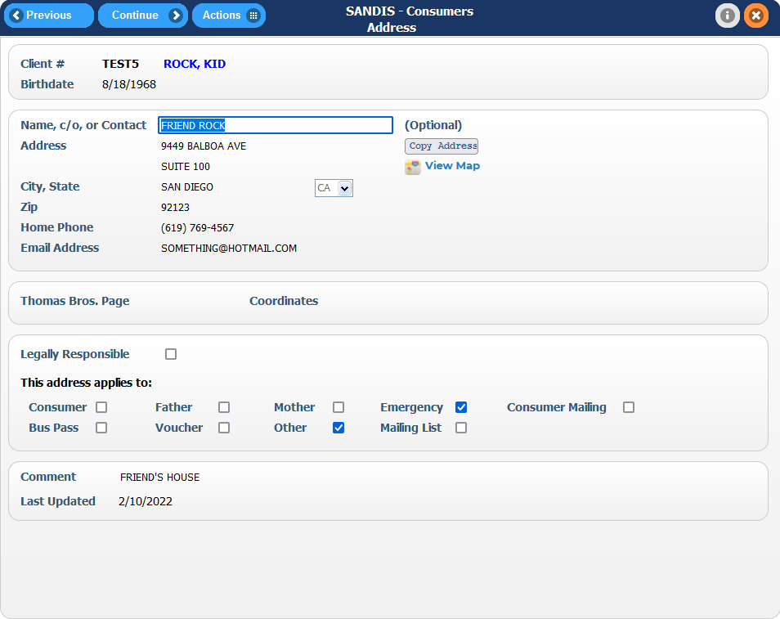
Deleted records  To access a deleted record, click on the Actions # icon in the Navigation bar and select Show Deleted. | 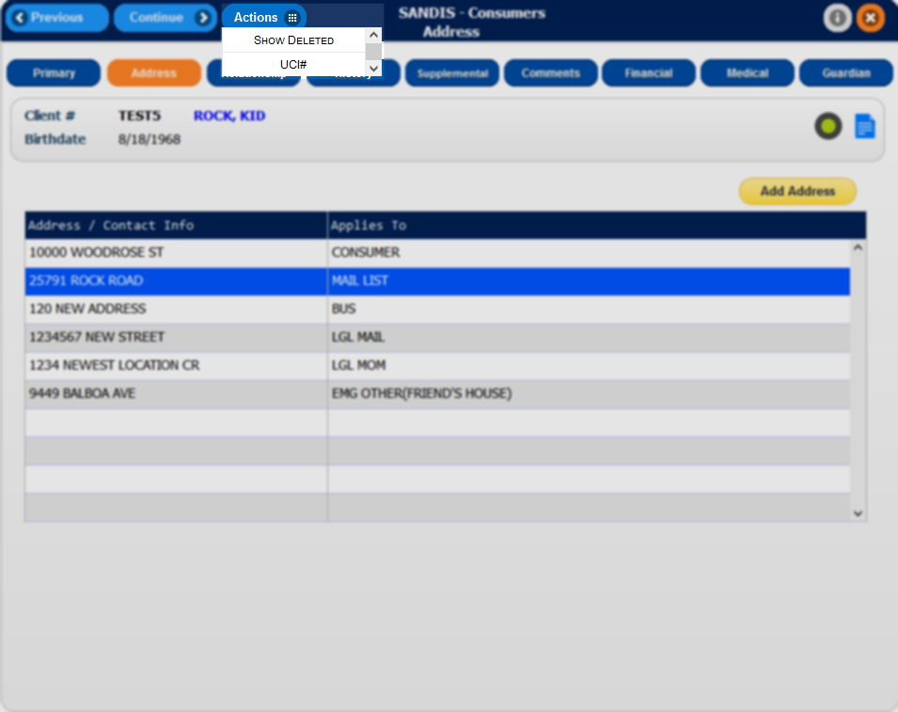
Re-activating a deleted record  In the deleted records screen, right-click on the deleted address and select Reactivate. | 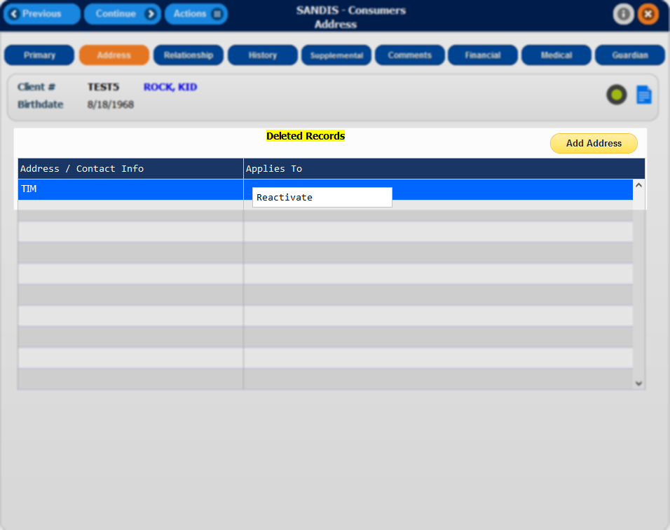

Consumer Relationship tab

To access the Consumer Relationship tab, click on the icon found in the Primary tab of the Consumer screen. The information in the relationship tab is typically entered during the Intake process.

The Relationship tab displays the client’s relationships such as parents, siblings, grandparents, attorneys, etc. The following column will be displayed in the screen:  - Last Name  - First Name  - relationship to the client  - UCI number (if applicable)  There are no limits to how many relatives can be added in SANDIS7. | 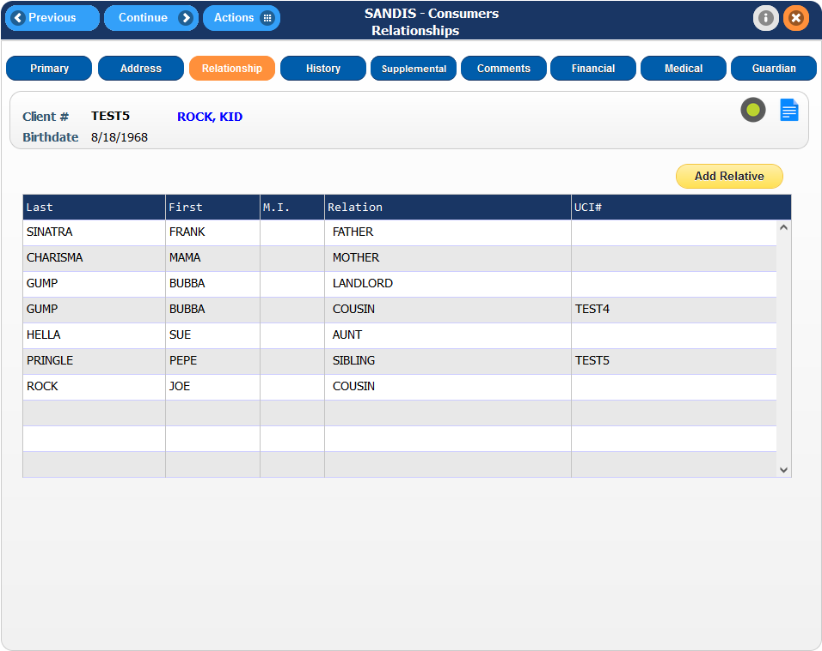
Viewing vs Editing  By default, double-clicking on an entry will display the record in View-Only mode.  To make an edit, right-click on the record and select the Change option. | 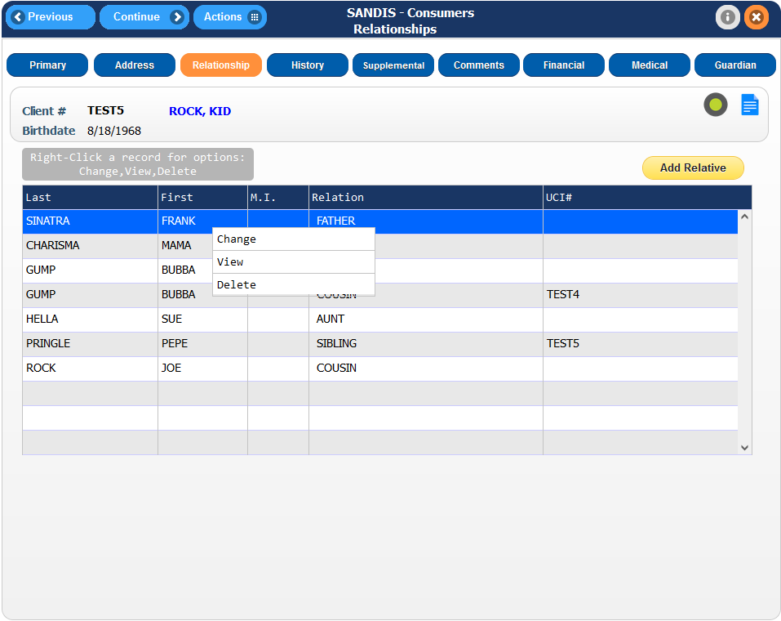
Deleting a record  If an entry was made in error, or is no longer applicable, the record can be deleted by right-clicking the record and selecting Delete from the pop-up menu. | 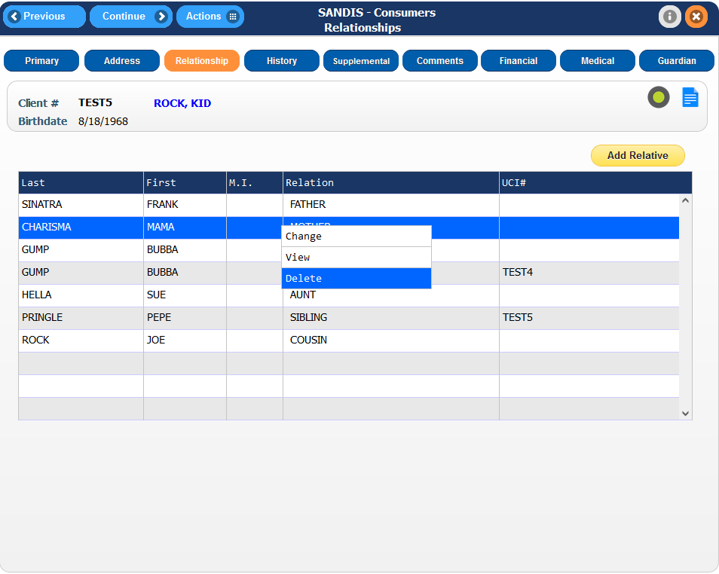
Viewing a deleted record  To access a deleted record, click on the Actions # icon in the Navigation bar and select Show Deleted. | 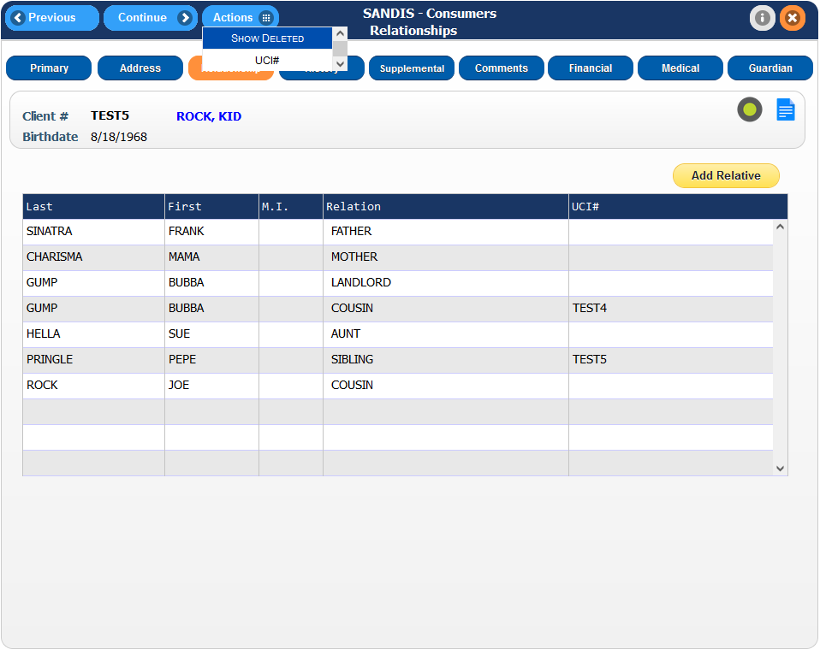
Re-activating a deleted record

In the deleted records screen, right-click on the deleted address and select Reactivate.
Adding a new relative  To add a new relative to this screen, click on the icon. | 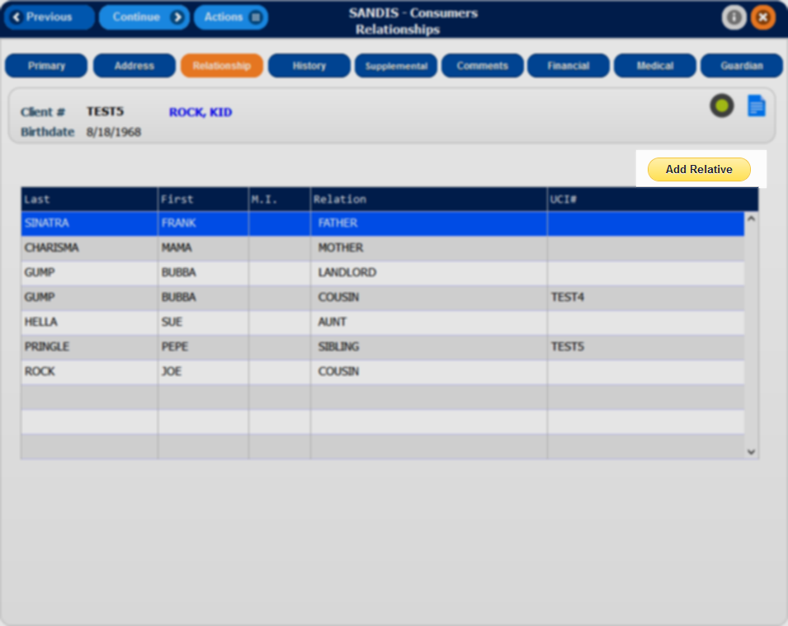
Enter the pertinent information in the available fields:  - Relationship to Client (required)  - Last and First name  - UCI# if applicable  - Occupation, Phone number and email  - Marital Status, SSN, Date of Birth and Place of Birth  - Age at consumers birth and number of children if applicable  - County of Residence and Primary Language  - Any Indicators located in the bottom section of the record | 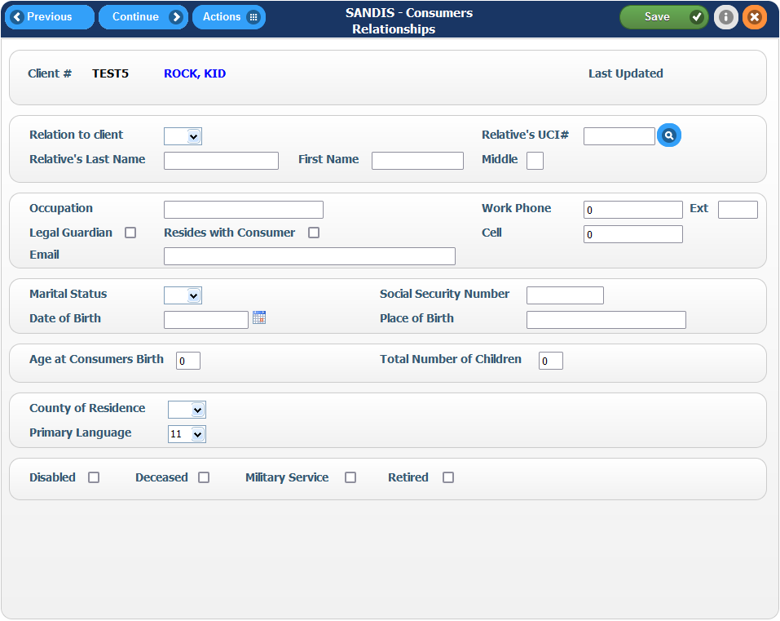
Please note that drop downs are available to determine the available options.

Click on the icon to save any changes and remain on the page. Click the button to save any changes and exit the screen.

Consumer History Tab

To access the Consumer History tab, click on the icon found in the Primary tab of the Consumer screen.¹

1: The History tab is view only for most staff
The History screen is broken down into two sections.  The top section contains the Historical Events categories and the bottom portion contains the Historical Information of those categories.  These sections also have a Sort, Filter & Find feature by right clicking the dark blue bar or the gray bar. | 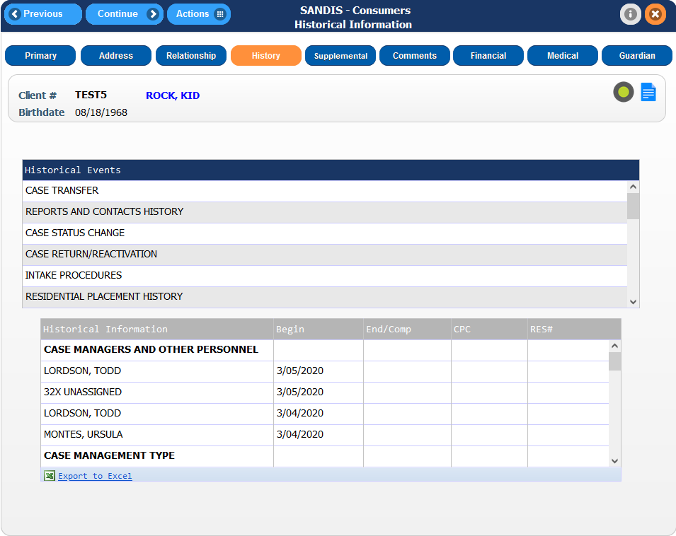
The top section contains the following Historical Events:  - Case Transfers  - Reports and Contacts History  - Case Status Changes  - Case Returns/Reactivations  - Intake Procedures  - Residential Placement History  - Day Program/Service History  - Special Incidents  - Court Orders  - Evaluations/Referrals  - Funding  - PRUCOL information  - Legal Status History  - Case Manager Assignment | 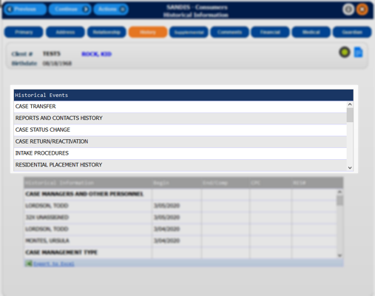
Continued...  - Case Management Type History  - Conservatorship Packet Tracking  - Surveys  - Genetics-Reasons for Service  - Services Provided  - Day Program Status  - ADA Certification  - Institutional Deeming  - Appeal History  - Open Case with Other Agencies  - Service Delivery Type  - AFPF Tracking  - Voter Registration Notification  - Med Waiver DS2200 | 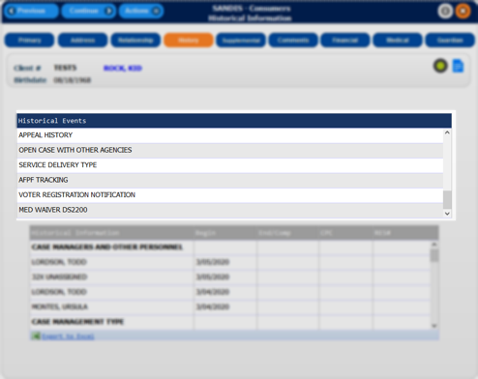
Depending on the type of profile the SANDIS account is set up for, there are options to Add, Change or View a record for each Historical Event category by right-clicking on the category. | 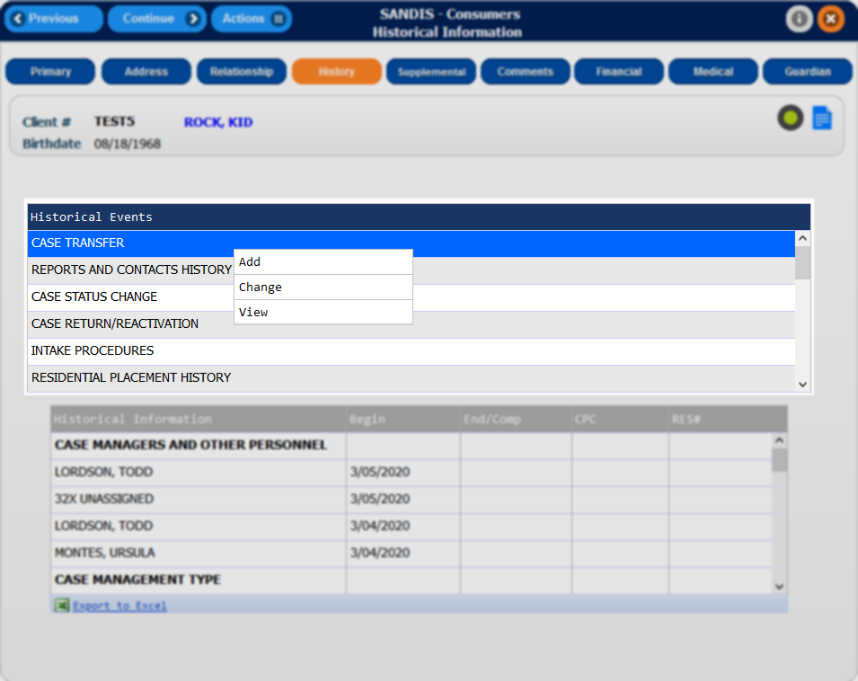
The bottom section contains Historical Information for the above categories. It displays any current records with the Begin Date, End Date, Caseload Code, and Resource # (if applicable), separated by category.  This section is only information and not editable. | 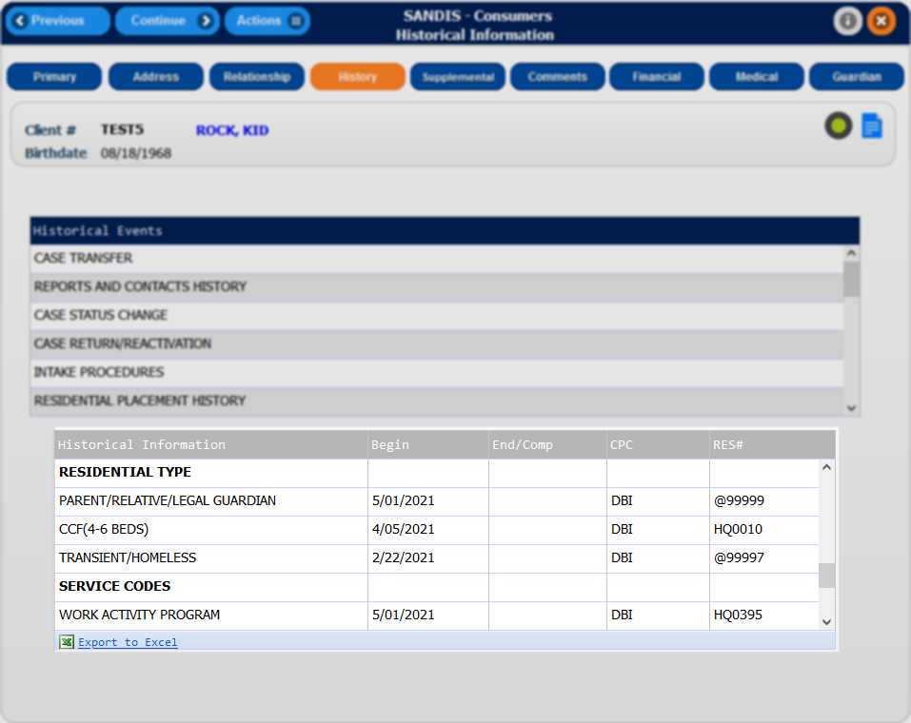
Adding a record  Right-click on a category within the Historical Events section and select Add. The page will be directed to a new screen displaying all the available options for that category. Choose the appropriate selection by right-clicking the name and select Add to bring up the Edit History Record window. | 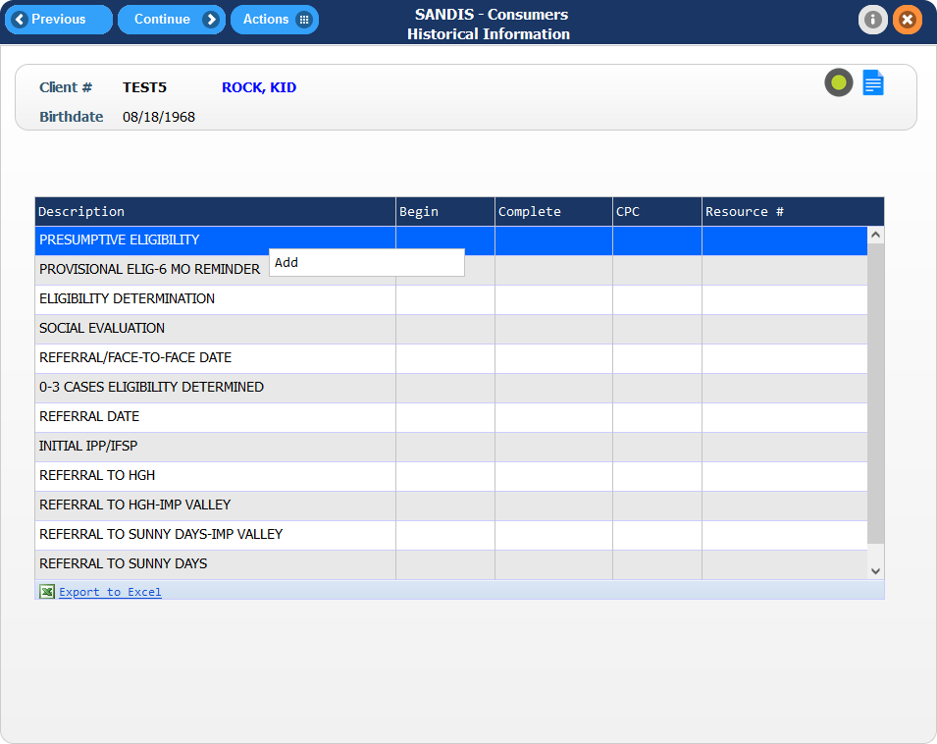
Enter the Begin Date, CPC into the open fields. Enter the Complete date and Res# as applicable.  Please note SANDIS7 will only recognize dates up to the present date in certain categories, future dates are not allowed. Please take caution when entering dates.  When complete, press to save any changes and go back to the History screen. | 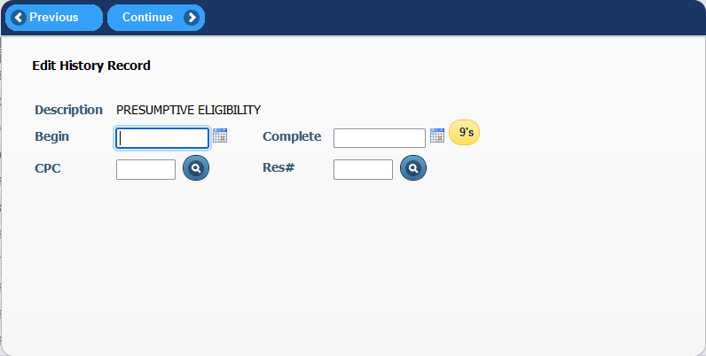
Changing/ Deleting a record  To modify a record, in the main History screen, right click a category with the record that will be changed or deleted and select Change. A screen showing all records within that category will display. Right-click the record and select either Change or Delete. Clicking Change will edit the existing record while selecting Delete will mark the record as Deleted. | 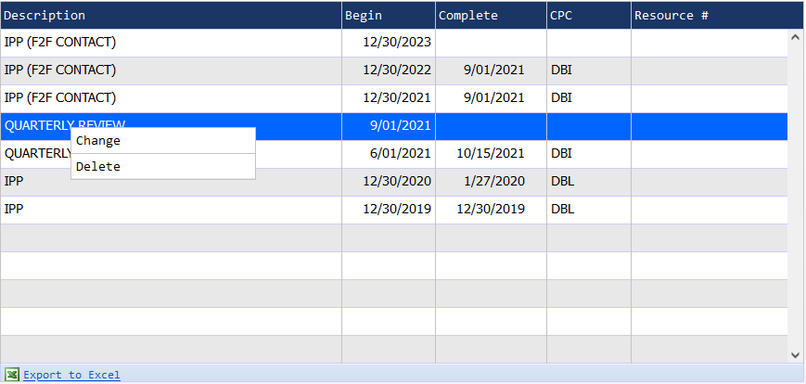
Viewing a deleted record  To view a deleted record, click on the Actions # icon in the Navigation bar and select Show Deleted Records. | 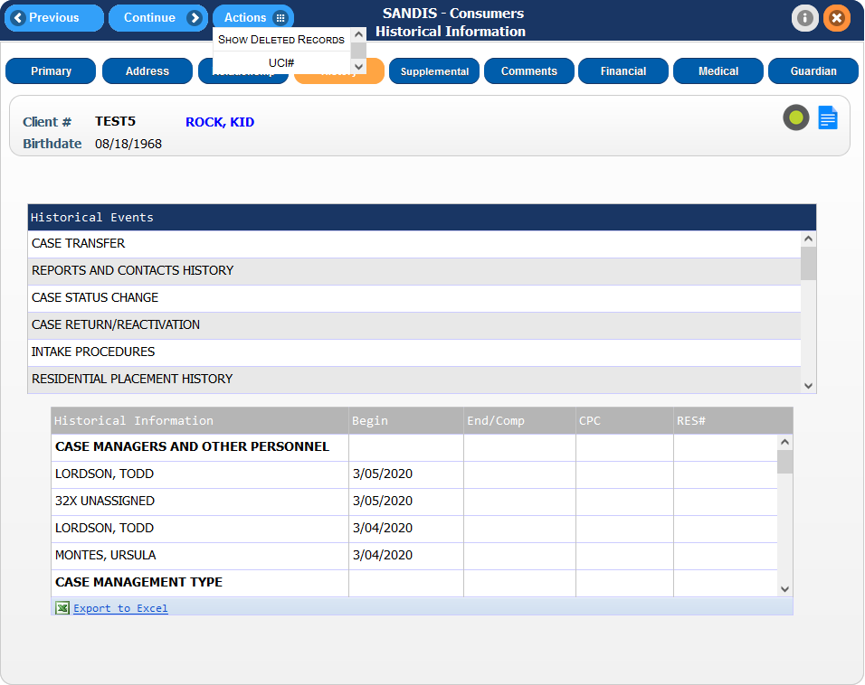
Re-activating a deleted record  In the deleted records screen, right-click on the deleted address and select Reactivate. | 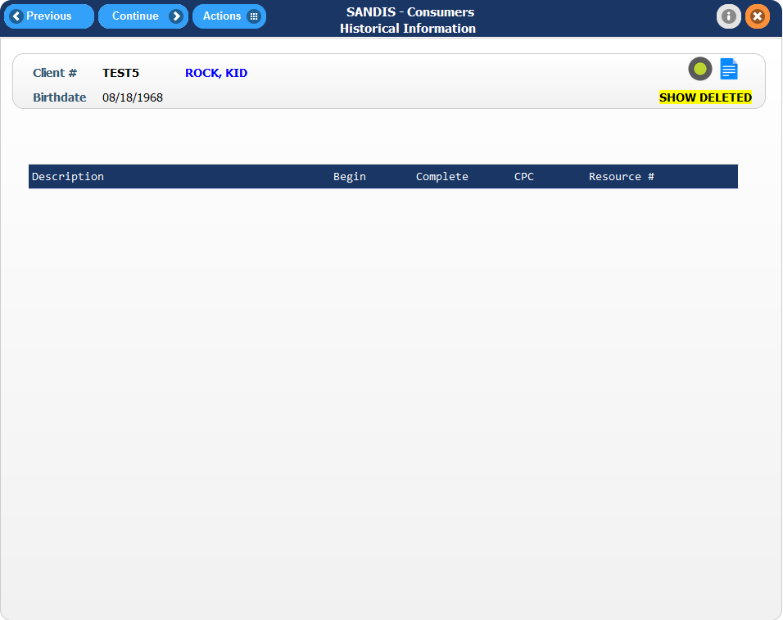
Export to Excel  The bottom section of Historical Information contains a feature to Export to Excel. Clicking on this will export all the history data for the client and prompt the user to download the data in Excel format. | 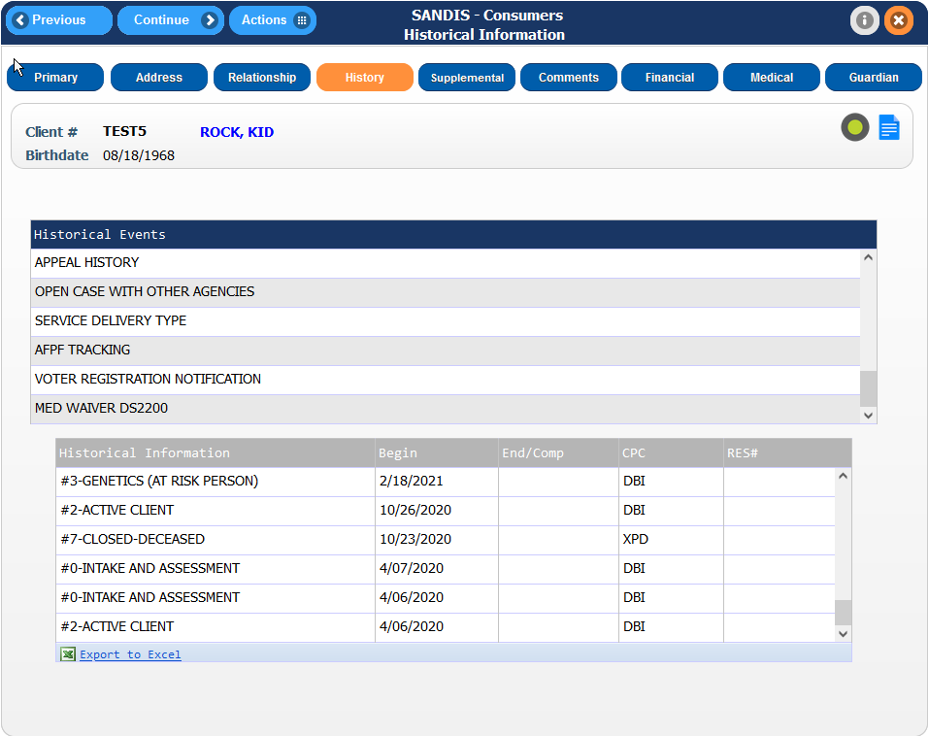
Notable Information  SANDIS7 automatically records any dates on the history screen such as CDER report dates, caseload transfers, etc. It is not necessary to manually enter information for every change although it is an option to do so. | 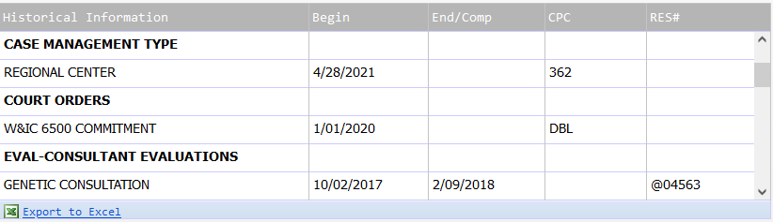

Consumer Supplemental Tab  The screen displays additional information on the client that covers special health care information, behavioral conditions and other information being tracked by various departments.  To access the Consumer Supplemental tab, click on the icon found in the Primary tab of the Consumer screen. | 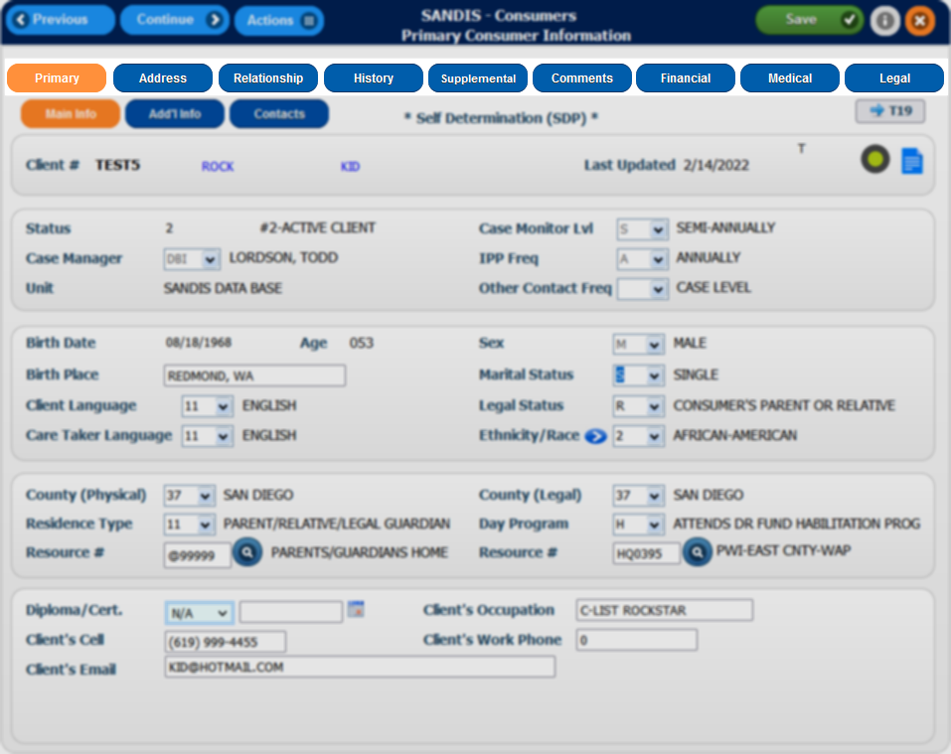
The Supplemental screen is broken down into two sections.  The top section contains the Supplemental Types categories. The bottom portion contains the Supplemental Information of those categories.  These sections also have a function to Sort, Find, and Filter information by right clicking the dark blue bar or the gray bar. | 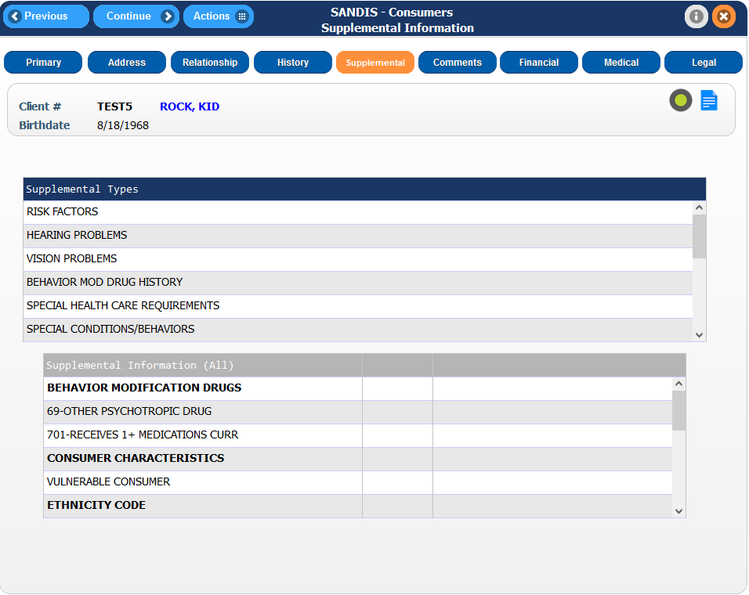
The top section contains the following Supplemental Types:  - Risk Factors  - Hearing Problems  - Vision Problems  - Behavior Mod Drug History  - Special Health Care Requirements  - Special Conditions/Behaviors  - Special Legal Conditions  - Funding Sources  - Developmental Delay | 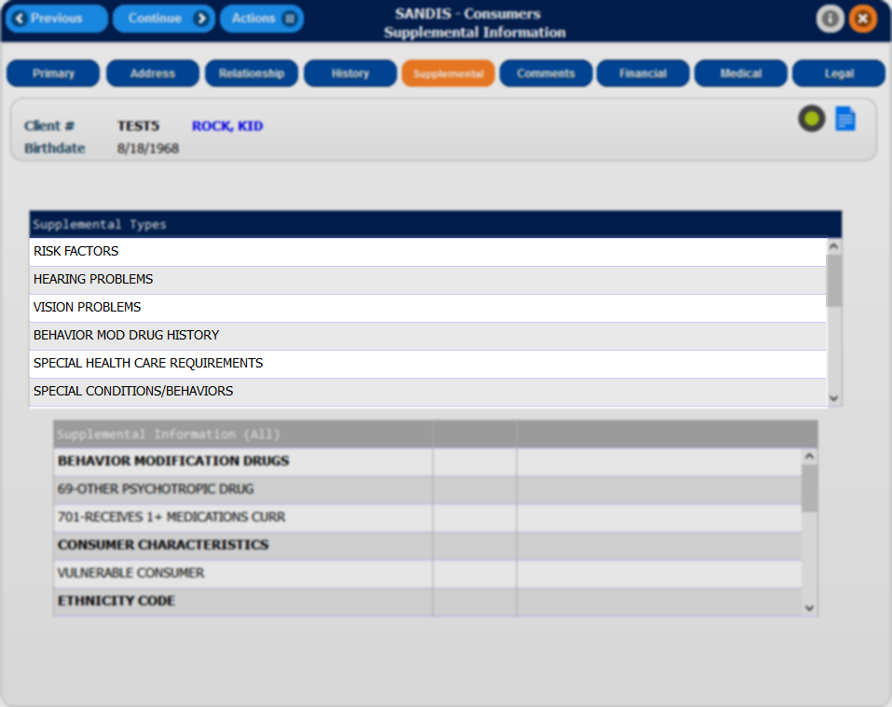
Continued...  - Healthcare Denial  - Roommate Needed  - OBRA Eligibility  - Intake Procedures  - Abnormal Involuntary Movement  - Consumer Medications  - Weighting Factor  - Medi-Cal Keeper  - Consumer Characteristics | 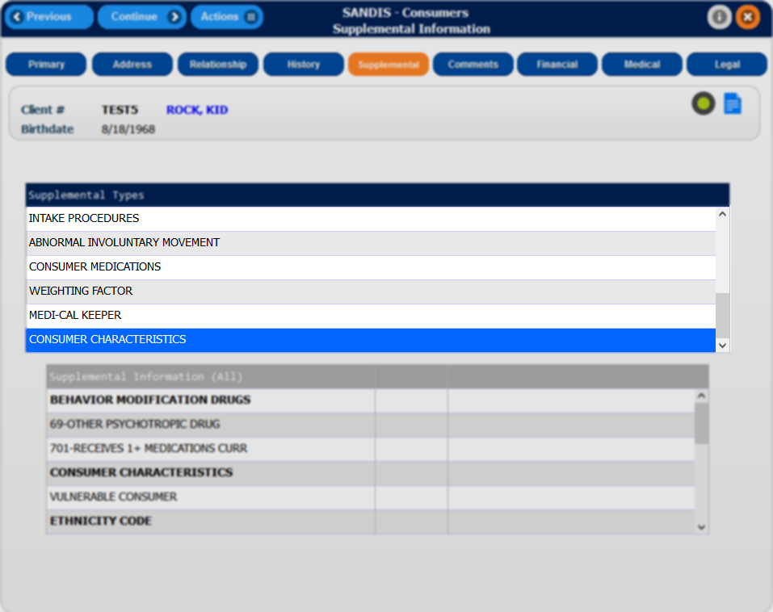
Depending on the type of profile the SANDIS account is set up for, there are options to Add, Change or View a record for each Supplemental Type category by right-clicking on the desired category. | 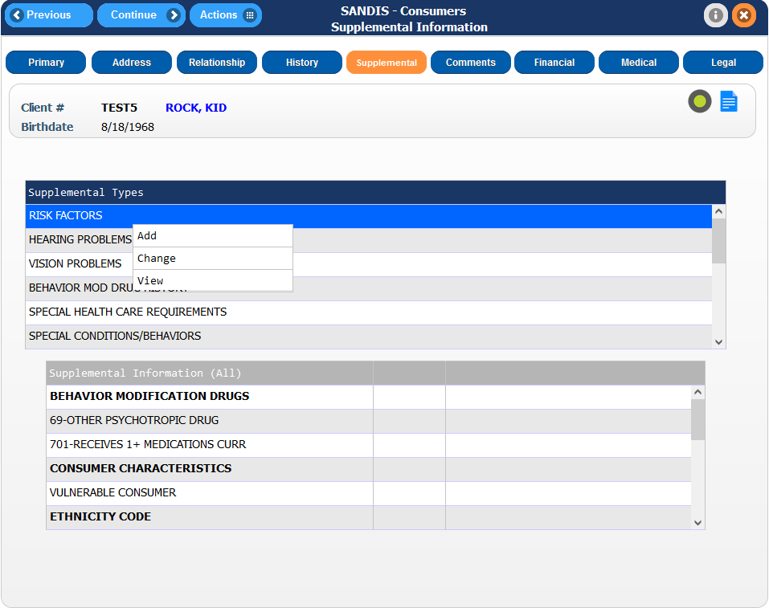
The bottom section contains any existing entries sorted by the categories listed above.  This section is only informational and cannot be edited or modified by right-clicking on it. | 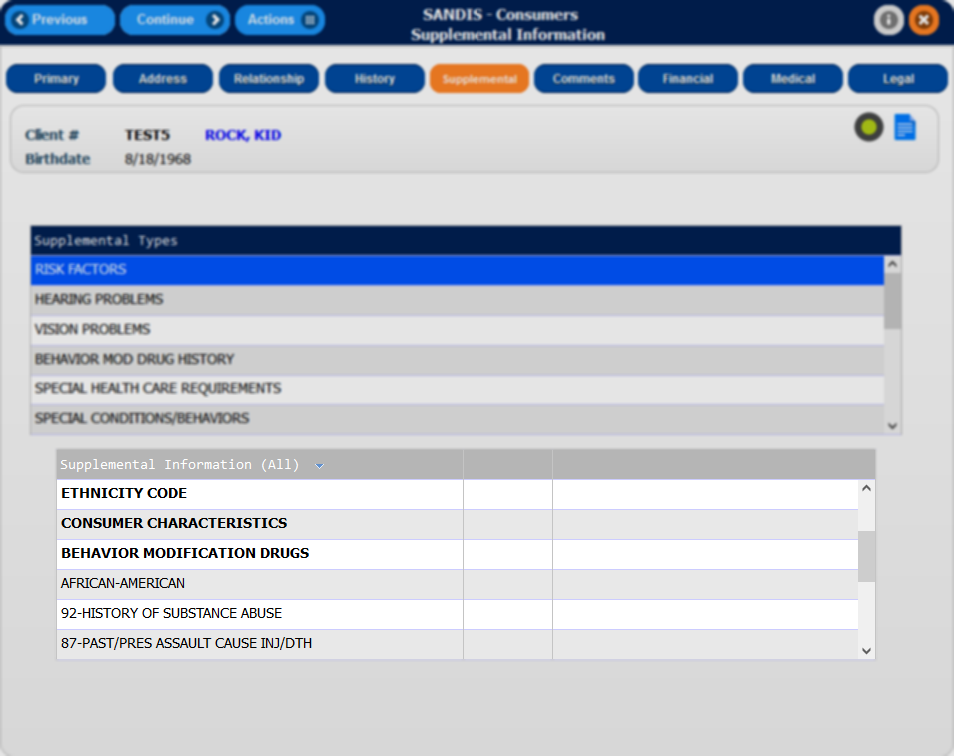
Adding a record  Right-click on a category within the Supplemental Types section and select Add. Depending on the type of entry, a pop-up will appear or the page will redirect to a new screen displaying all the available options for that category. This screen supports making multiple selections by left clicking on a selection. Once all the desired selections have been made, right-click on any of the selected lines that will be highlighted blue and select Add. | 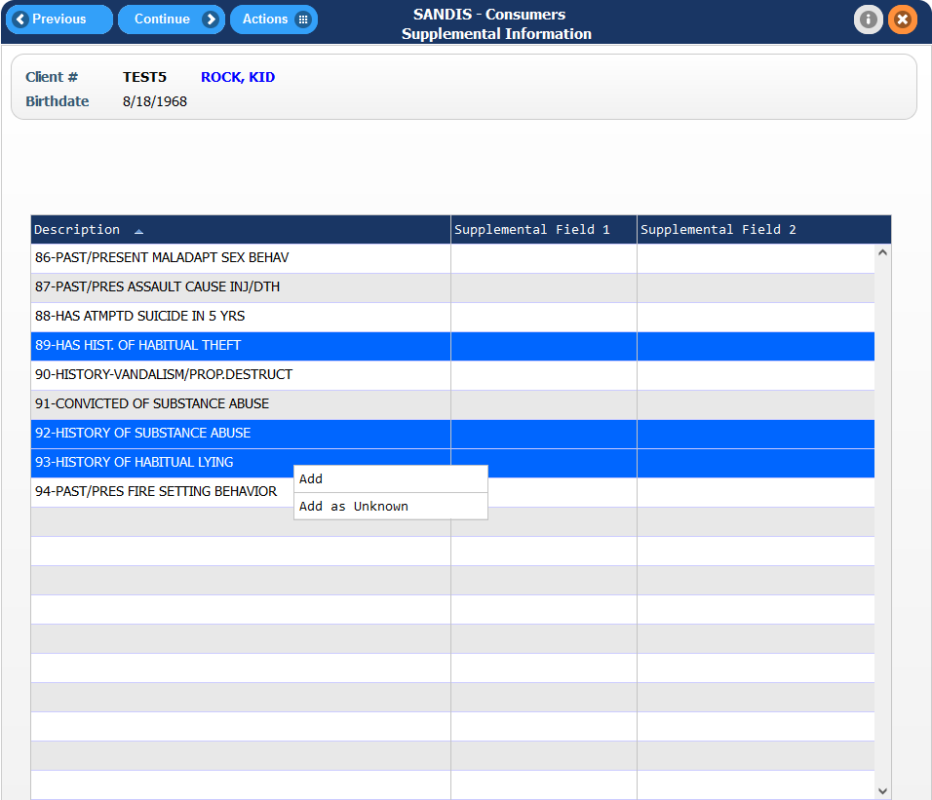
If a pop-up appears, fill in the information as necessary. Clicking on the icon to to search for a list of possible options that can be entered.  When complete, press to save any changes and go back to the History screen.  Any records that were created will now be displayed in the bottom section of the Supplemental Information screen. | 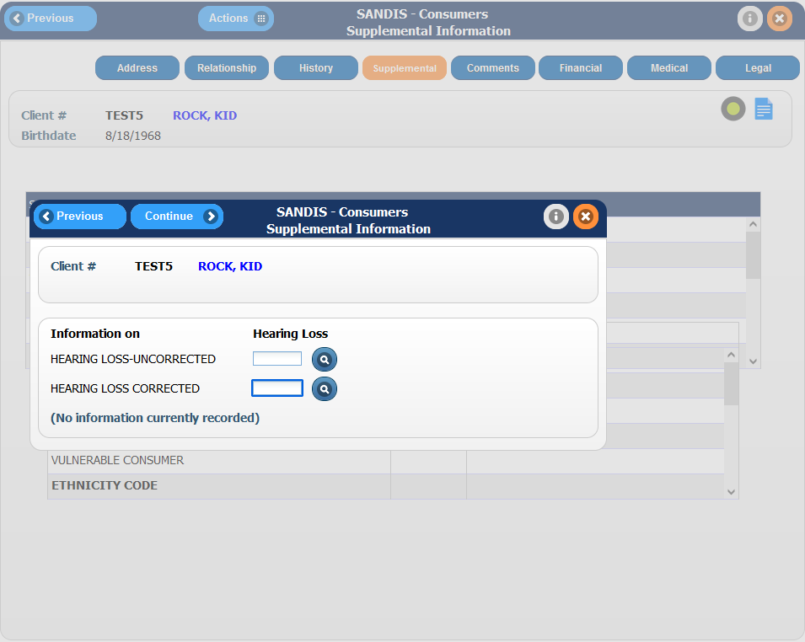
Changing/ Deleting a record  To modify a record, in the main Supplemental Information screen, right click a category with the record that is to be changed or deleted and select Change. A screen showing all records within that category will display. Right-click the record and select either Change or Delete. Change will allow the user to edit the existing record while selecting Delete will mark the record as Deleted. | 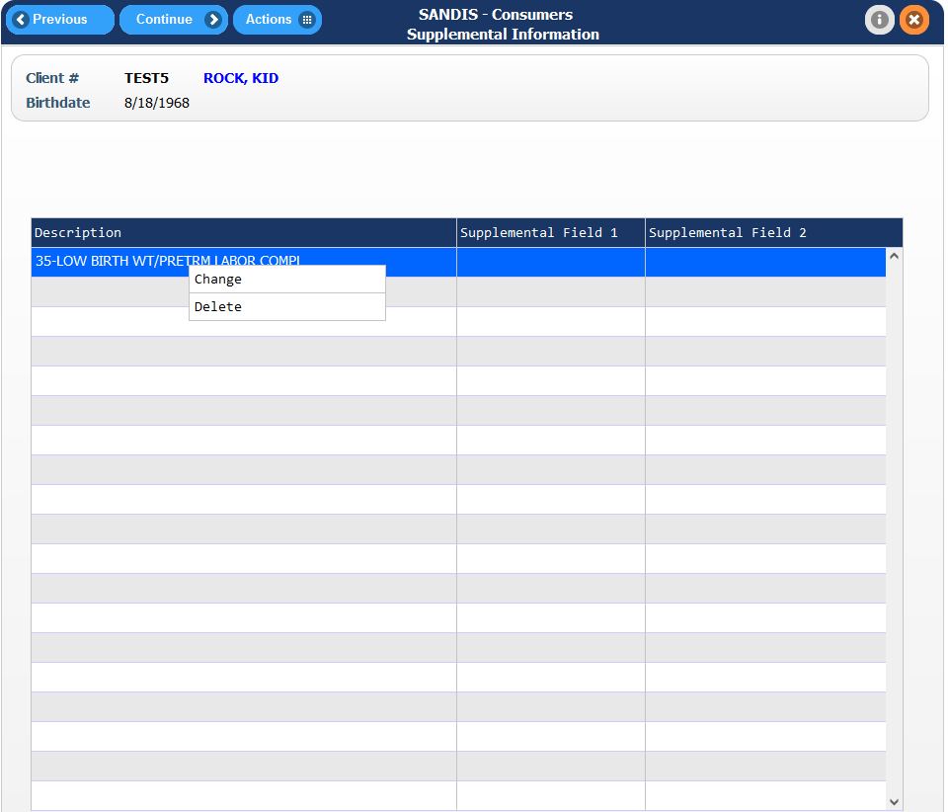
Viewing a deleted record  To view a deleted record, click on the icon in the Navigation bar and select Show Deleted Records. | 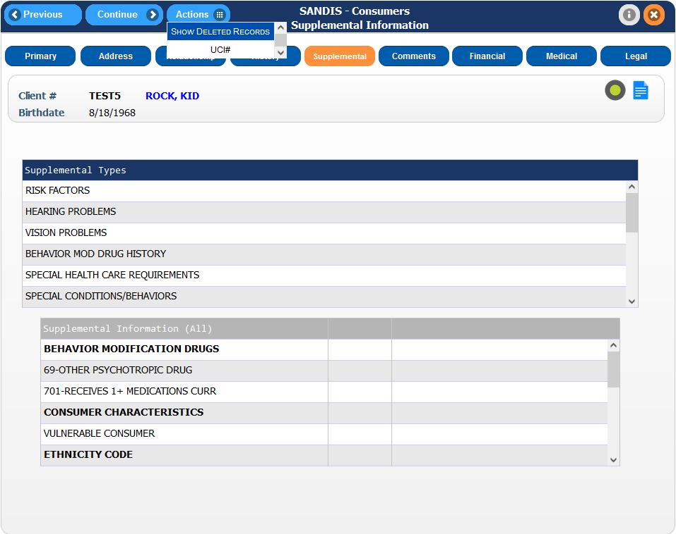
Re-activating a deleted record  In the deleted records screen, right-click on the deleted address and select Reactivate.  Please note that access to re-activate deleted records may be dependent on the user profile. | 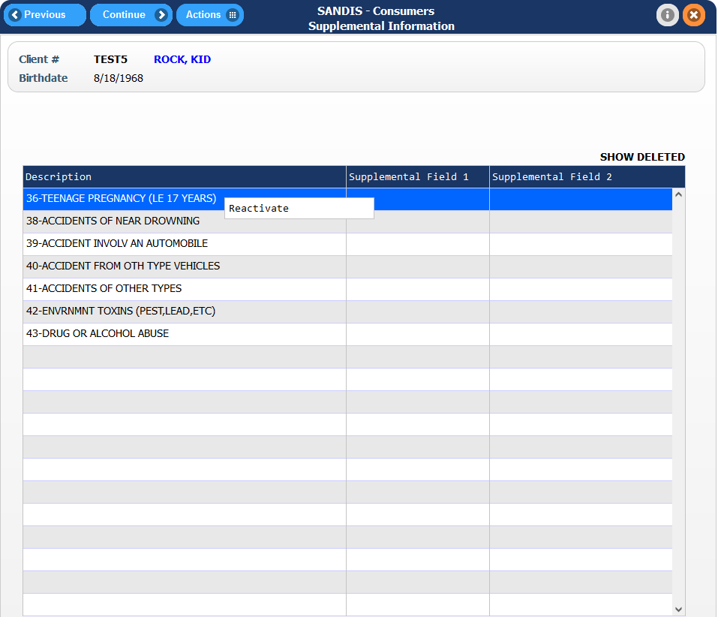

Consumer Comments tab

The Consumer Comments screen displays additional information on the client’s record not related to their medical history.

To access the Consumer Comments screen, click on the icon found in the Primary tab of the Consumer screen.

The Comments screen is broken down into two sections.  The top section contains the Comment Types categories. The bottom portion contains the Comments (all) informational section of those categories.  These sections also have a function to Sort, Find, and Filter information by right clicking the dark blue bar or the gray bar. | 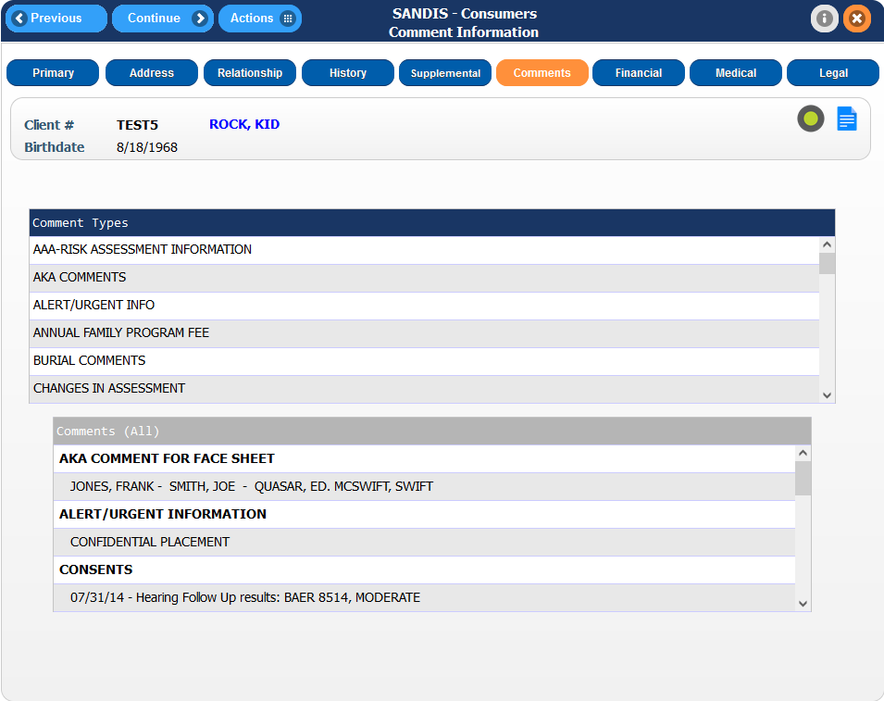
The top section contains the following Comment Types:  - AAA-Risk Assessment Information  - AKA Comments  - Alert/Urgent Info  - Annual Family Program Fee  - Burial Comments  - Changes in Assessment  - Comments Re: Follow Up | 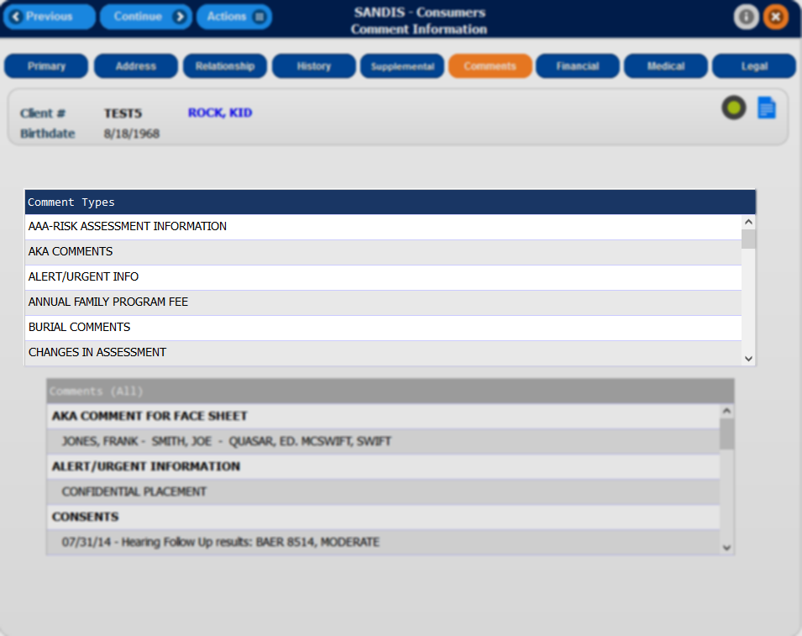
- Consents
- County Welfare Case
- Death Report Comments
- Diagnostic Comments
- Do Not Release Records To
- Email Address
- EPSDT Hours
- Face Sheet Comments
- Family Information
Continued...  - Financial Information  - General Comments  - Health Information  - High Risk Infant Exit Diagnosis  - High Risk Infant Factor  - ICD9 Code  - Identification Section Comments  - Institutional Deeming Information  - Insurance Information  - IRCT Comments  - Legal Comments  - Medicaid Waiver Disqualifiers  - Medical Insurance  - Medicare ID Card# | 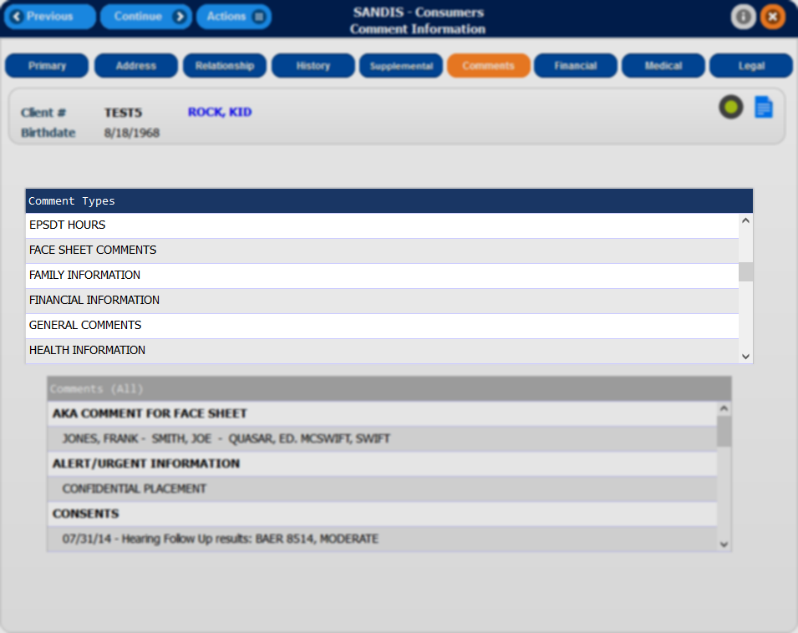
Continued...  - Part D Information  - Placement/Day Program History  - PRUCOL Comments  - Rate Information  - Redetermination Medi-Cal  - Redetermination SSI  - Referral History  - Service History  - Special Incident Follow-Up Response  - Special Incident Report Comments  - Storage (Box Location)  - Storage Comments – Therefore  - Storage Location (Doc Imaging)  - Waiver/Fed Program Comments  - 14 Digit BIC# | 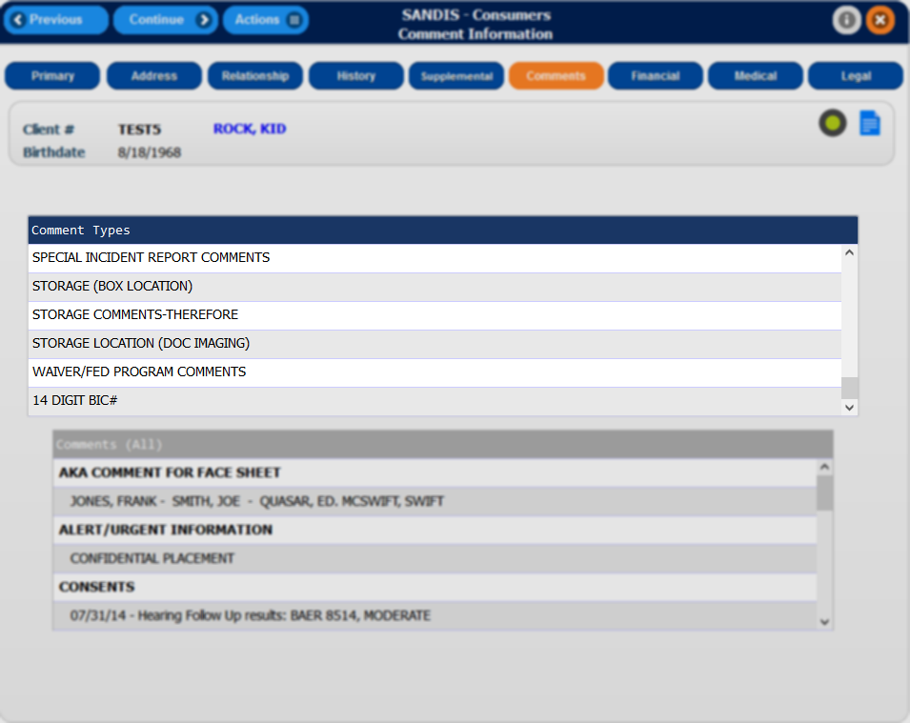
Depending on the type of profile the SANDIS account is set up for, there are options to Add, Change or View a record for each Supplemental Type category by right-clicking on the desired category.
The bottom section contains any existing entries sorted by the categories listed above.  This section is only informational and cannot be edited or modified by right-clicking on it. | 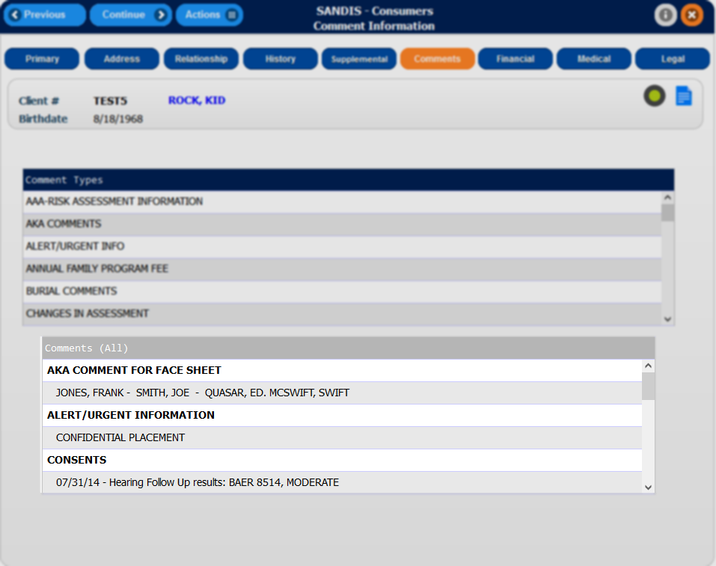
Adding a record  Right-click on a category within the Comment Types section and select Add. A new screen will appear with a section for typing notes. Once a note has been entered, press the button to save any changes and return to the Consumer Comments screen. | 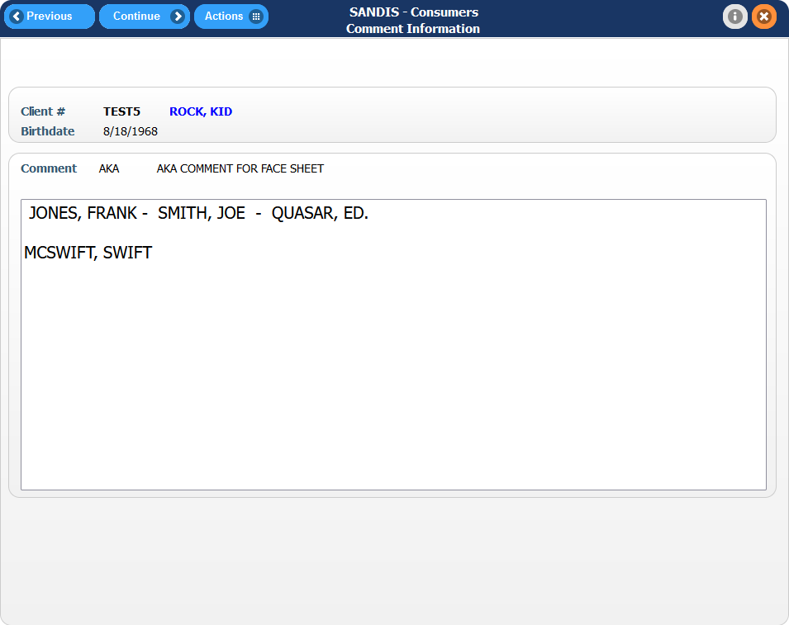
Changing/ Deleting a record

To modify a record, in the main Comment Types screen, right click a category with the record that will be changed and select Work With. A screen with the current note will be displayed and modifications can be made.

To delete a record, right-click the Comment Type in the Consumer Comments screen and select either Delete Section. This will prompt a screen to confirm the change. To confirm, press F12. After doing so, this will mark the record as Deleted.

A deleted comment cannot be restored or re-activated. Deleting a comment in this window is final.

Consumer Financial tab

To access the Consumer Financial Information screen, click on the icon found in the Primary tab of the Consumer record.
This tab displays the client’s current financial information such as:  - Current state or federal benefits  - Trust information  - Medical Insurance  - Service Delivery  - Able Accounts information  - Burial Info  This information is accessible by selecting the sub-tabs within the Financial Information screen.  All of the information on these screens are freely editable. After making any changes, press the icon to save any changes. | 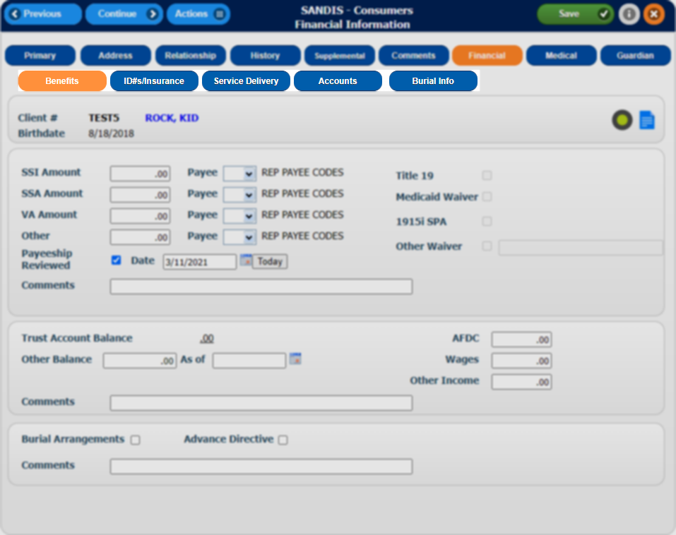
Benefits  The tab is active by default when in the Financial Information screen. The client’s SSA benefit amounts can be recorded in this screen along with the payee of those benefits.  Radio buttons to the right of the SSI information box are available to indicate whether the client is T19, Medicaid Waiver, 1915i SPA or Other Waiver eligible. The lower section will hold the client’s balance information as well as indicators for Burial Arrangements and Advance Directive.  A comment Section is available to record additional notes. | 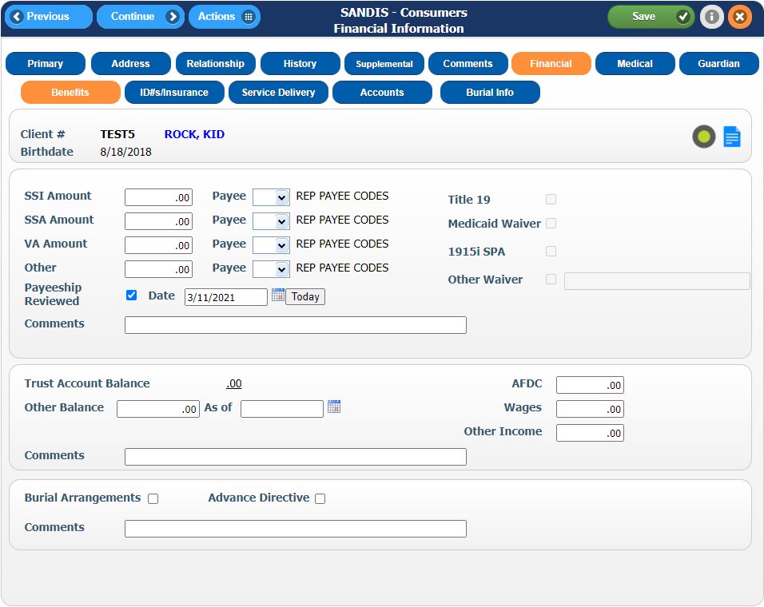
ID #’s / Insurance  Click on the tab. This screen will store the client’s account numbers for various state and federal programs such as SSA, Medi-Cal and SSA, etc.  Medi-Cal eligibility information can be recorded along with their renewal date.  Private and Public insurance information can be recorded along with effective dates.  CCS, EPSDT and IHSS can be indicated on the bottom of the page if applicable to client. | 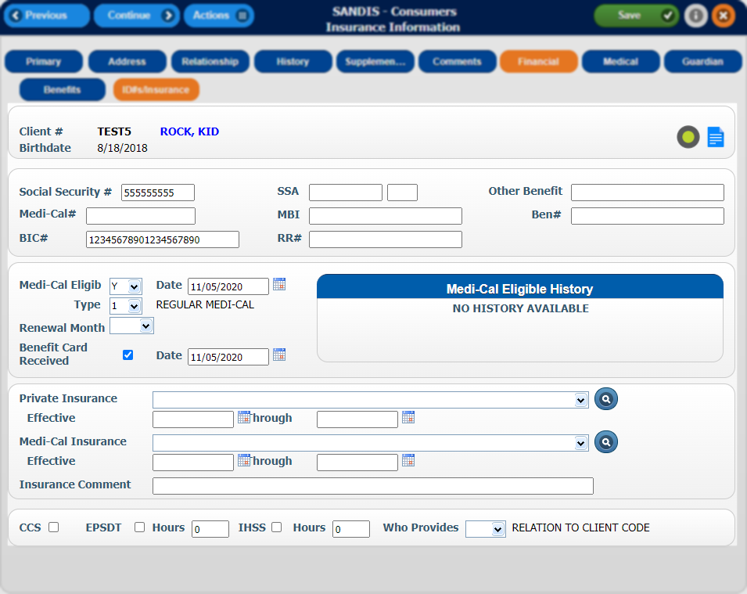
Automatic updates to record  If data is available, SANDIS will automatically display the Medi-Cal eligibility history and separate eligibility by month.  If DDS has any updates to a customer’s record, it will automatically post those updates to the client’s file on the 20th of every month. These updates include the client’s health care provider information and Medi-Cal eligibility information. | 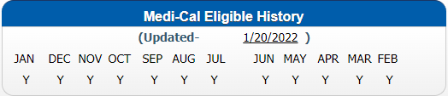  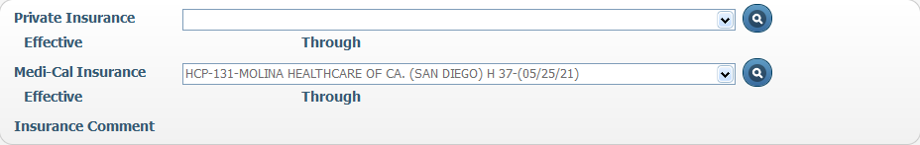
Service Delivery  Click on the tab. A screen showing the customer’s Service enrollment and delivery type will be displayed. The date of the action taken on the service (enrollment, disenrollment, etc), the reason and any other comments will be displayed. | 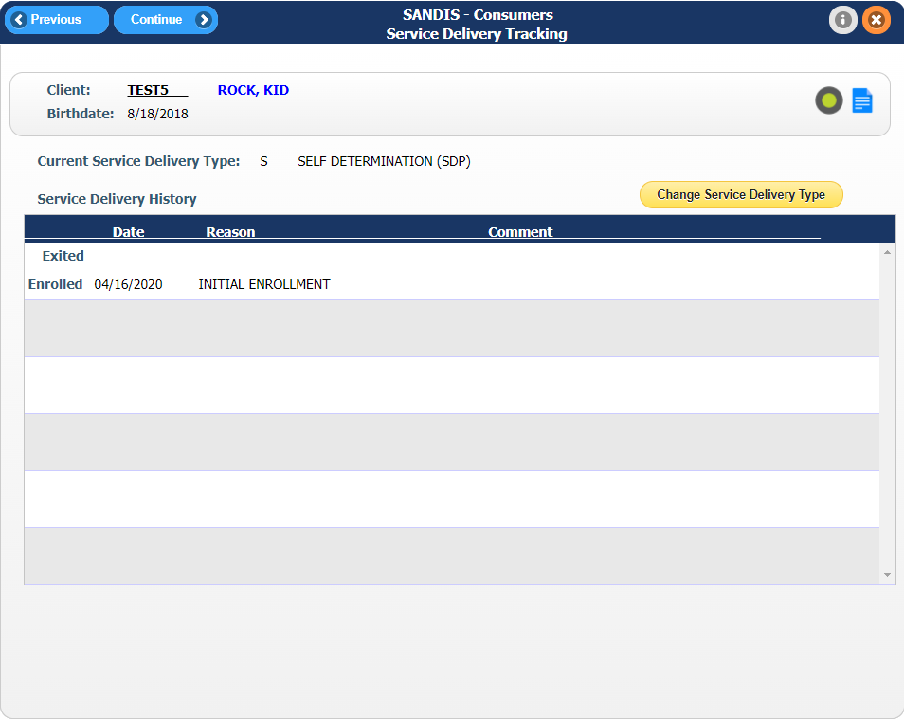
To make changes to the service delivery type, click on . An exit date for a service delivery type can be entered along with an exit reason.  If there is no active Service Delivery type, enter the start date along with the re-activation (React) reason.  Once any change has been made, press to save any changes and exit to the previous screen. | 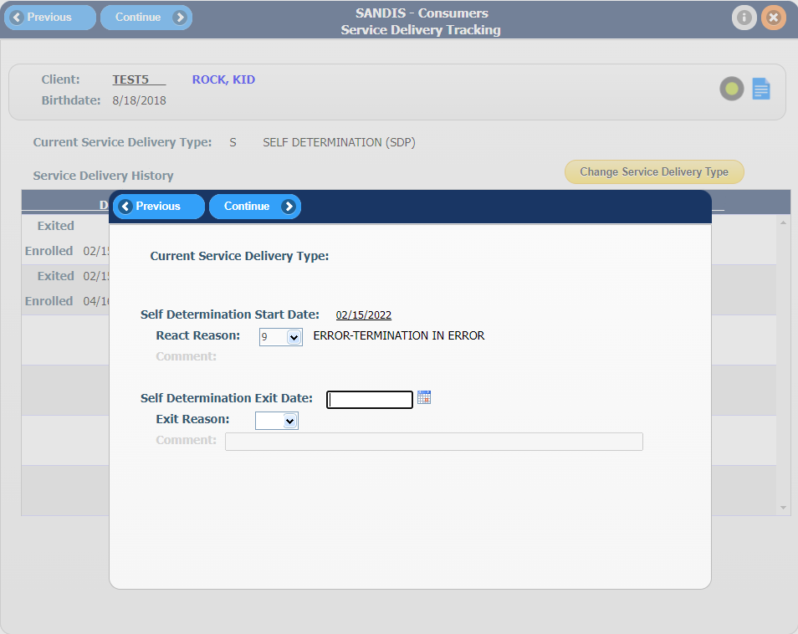
Able Accounts  Click on the tab. A screen showing the client’s Able Account information will be displayed.  The client’s account representative information can be stored in this section. Domicile State, Account # and Current Threshold indicators are present as well as an indicator if this is a Special Needs Trust account. | 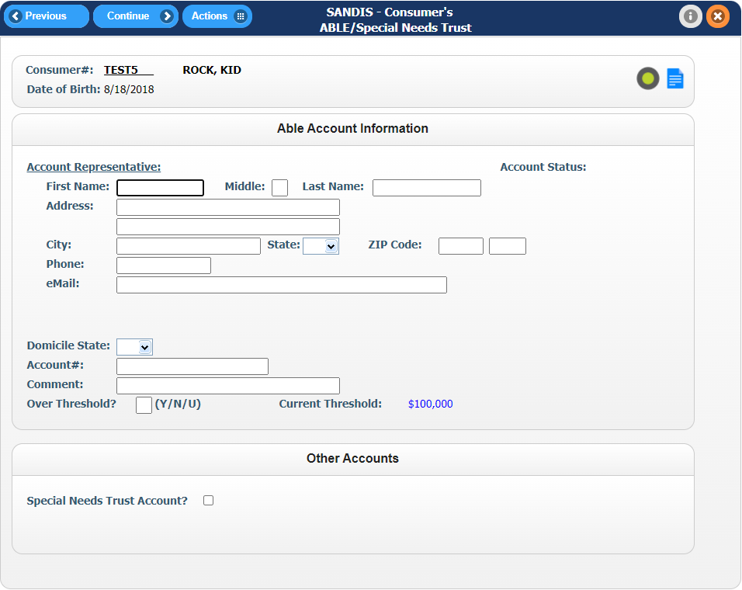
Burial Information  Click on the tab. This screen displays any Burial information present which includes a description of the service, the value of the Burial, the date, phone and location of the burial.  If there is an active record, right-click to change, view or delete the record. | 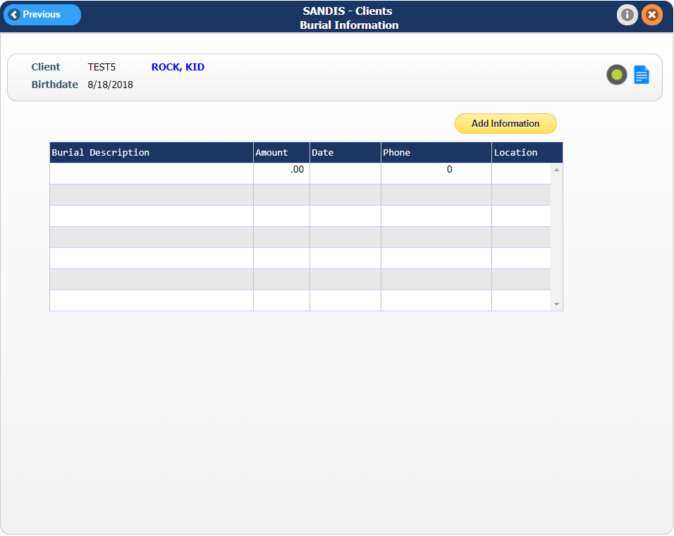
Adding new Burial Information  To create a new record for a client’s burial information, click on . A new entry will generate and a description, date, value amount and address of the new burial can be entered.  Once any change has been made, press to save and exit . | 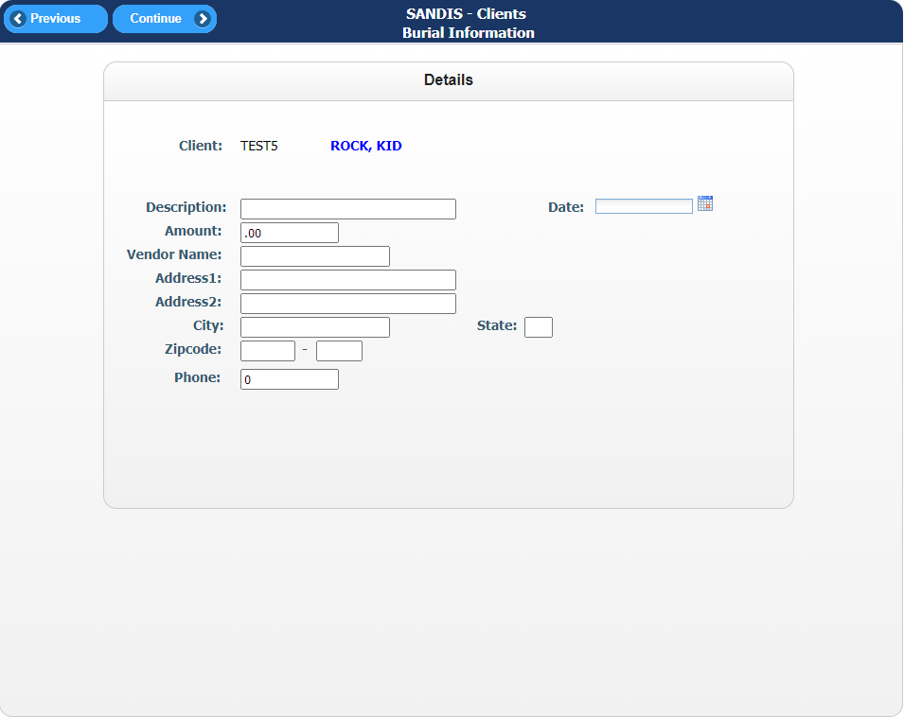

Consumer Health tab

To access the Consumer Health Information screen, click on the icon found in the Primary tab of the Consumer record.

The Health tab displays the client’s current medical information and assigned providers.  The top portion of the screen provides a section for immunizations, client allergies, current medications, TB Test date and a Communicable Disease/AIDS indicator.  The Allergies and Medications fields are editable by default and allow for free-form text entry. If any changes are made, make sure to click on the button to record any changes made. | 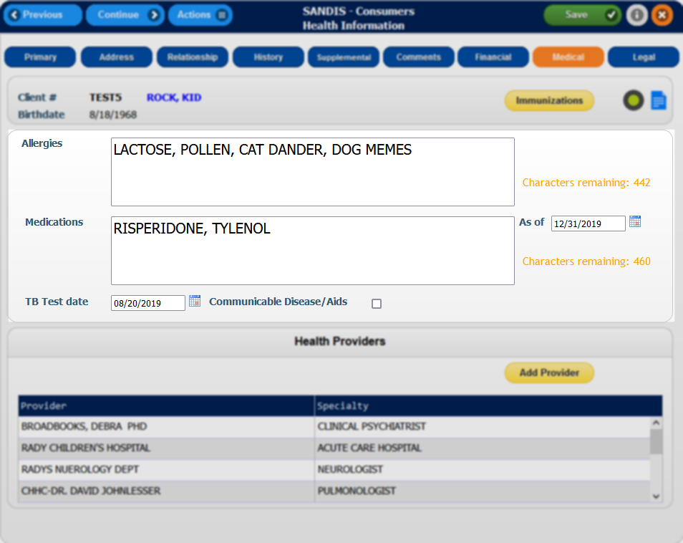
The bottom portion of the Health Information screen contains a scrollable list of Provider names assigned to the client and the provider’s specialty. For convenience, a shortcut to is located on the top corner of the Health Providers section.  It is also possible to Sort, Find and Filter by Provider names or specialties by right-clicking on the dark blue bar and selecting the desired option. | 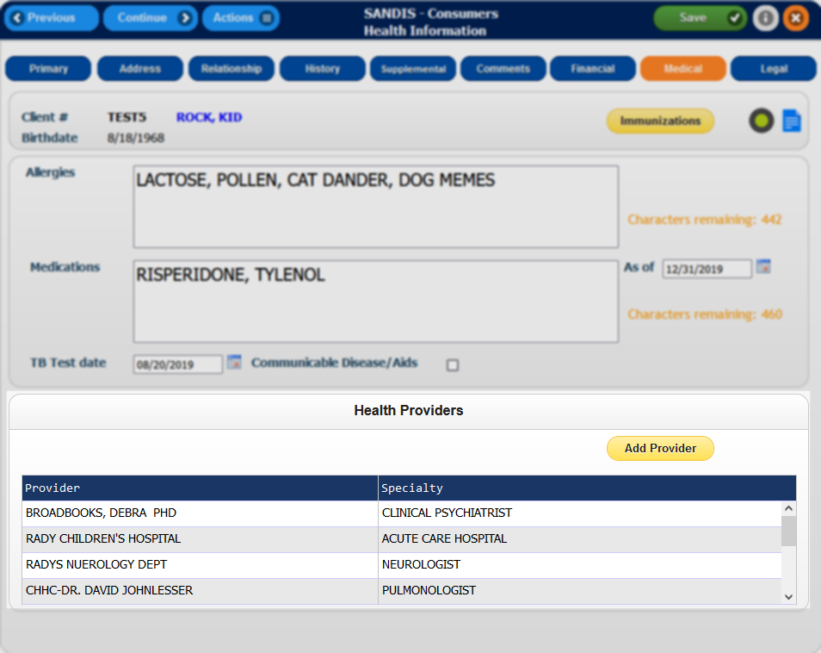
Add Provider  To add a new record for a new provider, click on the button. The page will redirect to a blank record. Fill in the empty fields as applicable then press to save any changes and exit back to the previous page. The Resource# can be manually input or a resource can be searched for by clicking the icon. | 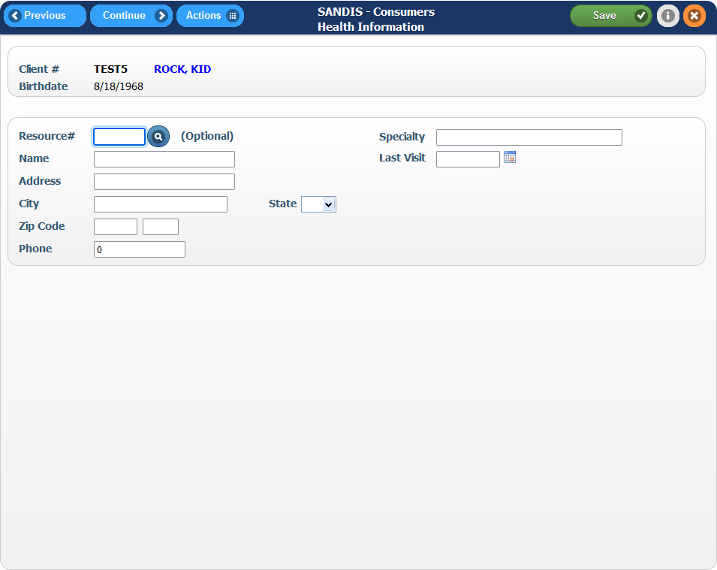
Updating a Provider record  To edit a provider, right click an existing provider record in the main Health Information screen.  Enter all the pertinent fields for the new record and press the button to save any changes or the button to save and exit to the previous screen. | 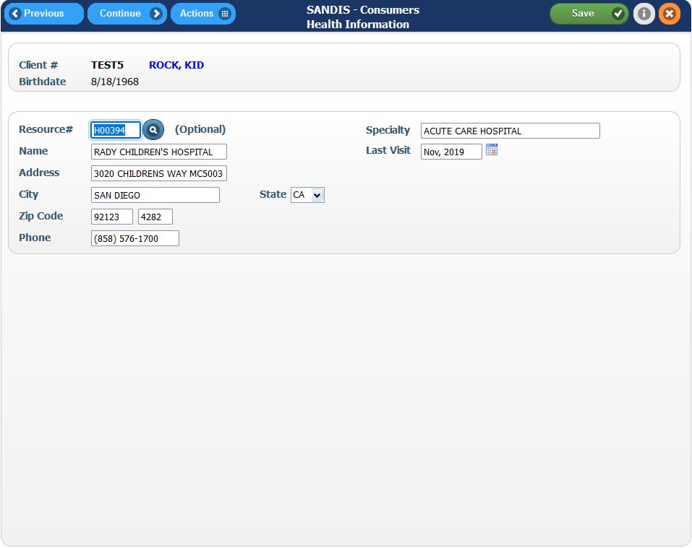
Deleting a Provider record  If there is a need to delete a provider record, right-click a record, select Delete. A second screen will prompt to confirm the deletion, press Enter to confirm the Deletion or F12 to cancel.  Please note that deleting a record in this section is permanent and cannot be restored. | 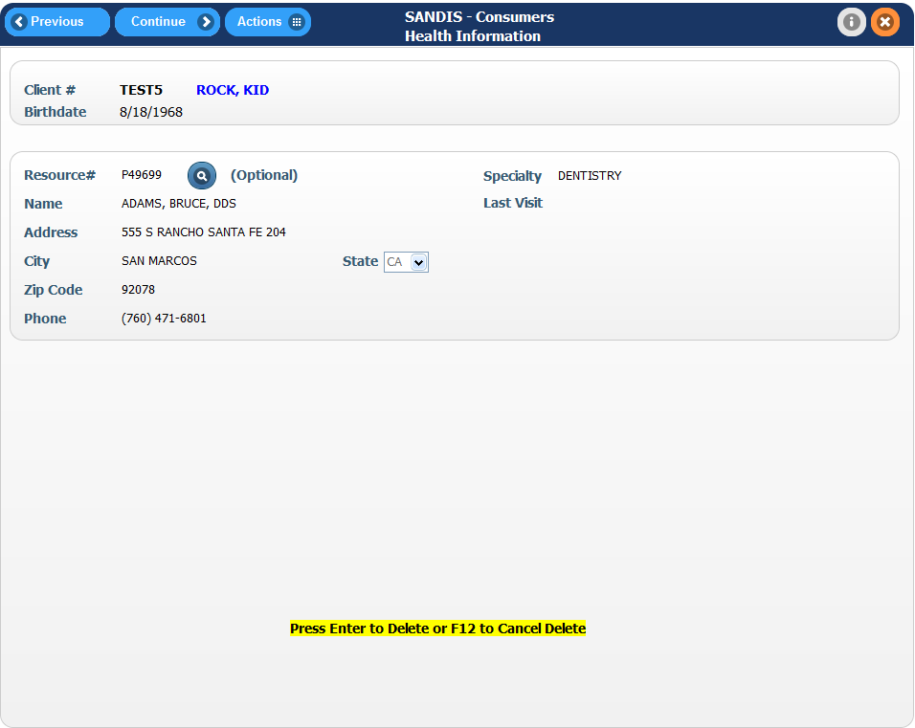
Immunizations  Clicking on the button that is located in the main Medical tab of the client’s record will redirect the screen to the client’s Immunization record screen.  In this screen, the client’s Vaccination Status, Dates Vaccinated and any comments (if applicable) will be displayed. These records can be edited, viewed or deleted. | 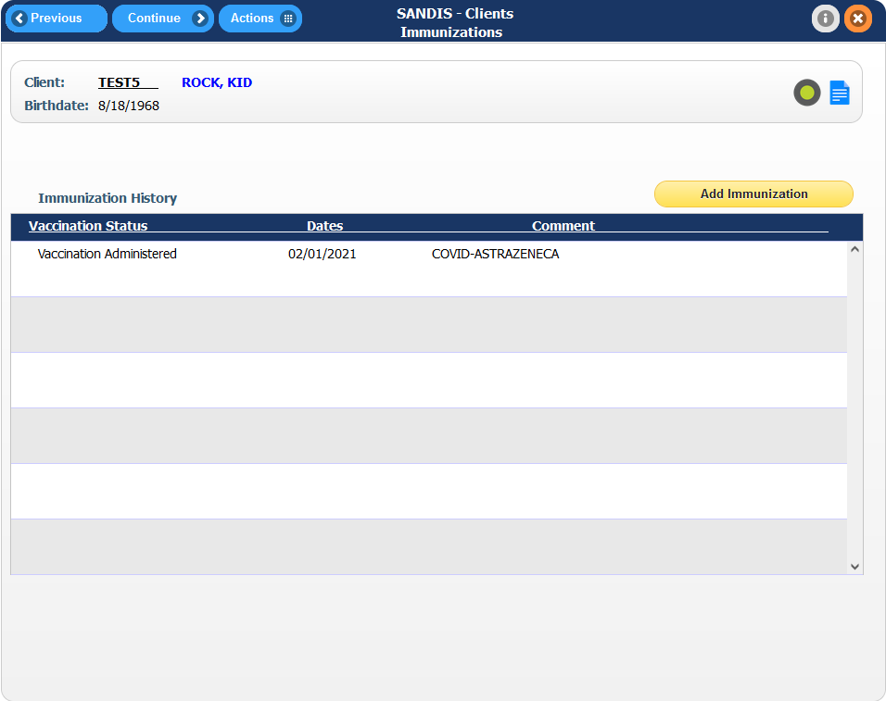
Add new Immunization record  Click on the to add a new Immunization entry to the client’s history. Fill out the sections as necessary and click to save and exit. | 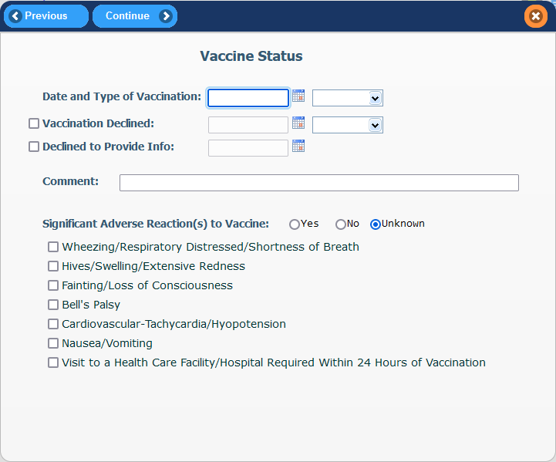
Please note that the Comments section can be displayed and used to track additional information (Boosters, etc).  e.g. A client receiving their second booster can be typed as “1st Booster.” After saving, this will be displayed in the Immunizations screen. | 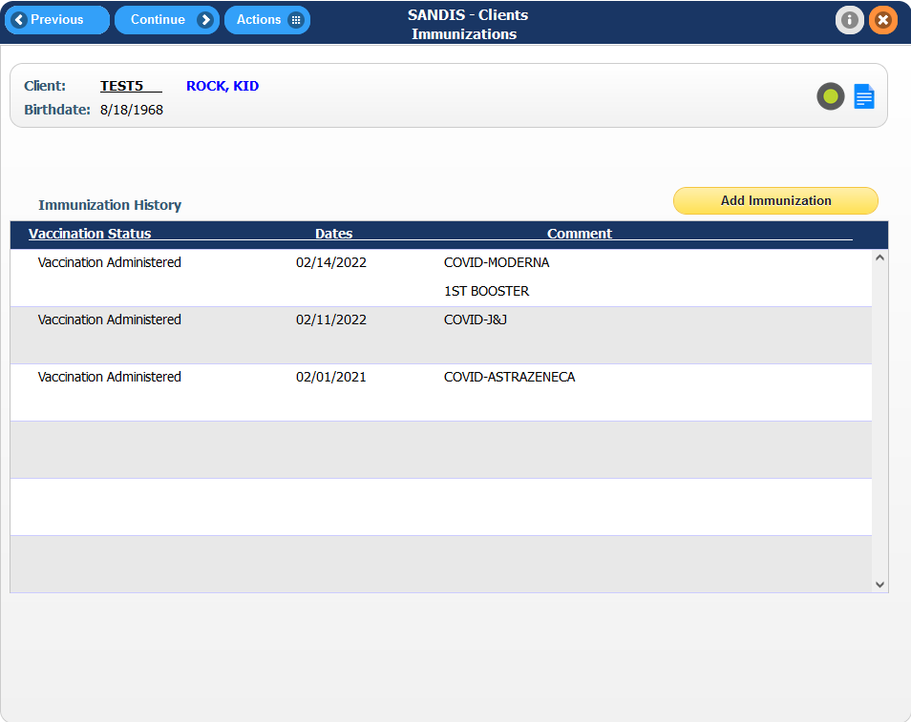
Edit or delete an existing record  To modify an existing vaccination record, right click anywhere on the record line and select Change.  After making the changes, select to save any changes and be returned back to the Immunization History screen.  To delete a record, simply right-click to bring up the menu and select Delete. Press Enter to confirm the change. | 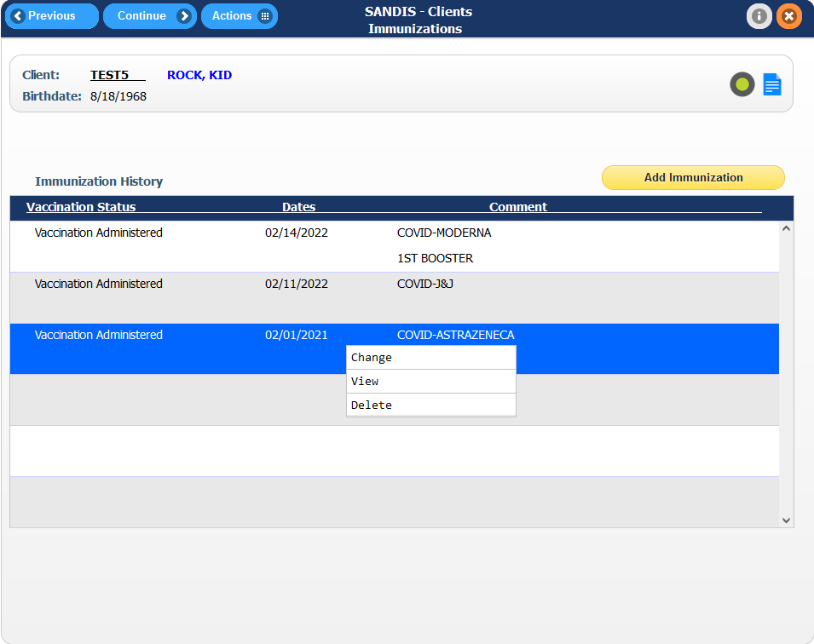
View a deleted record  To delete a record, click on the Actions # menu in the Navigation bar and select Show Deleted. | 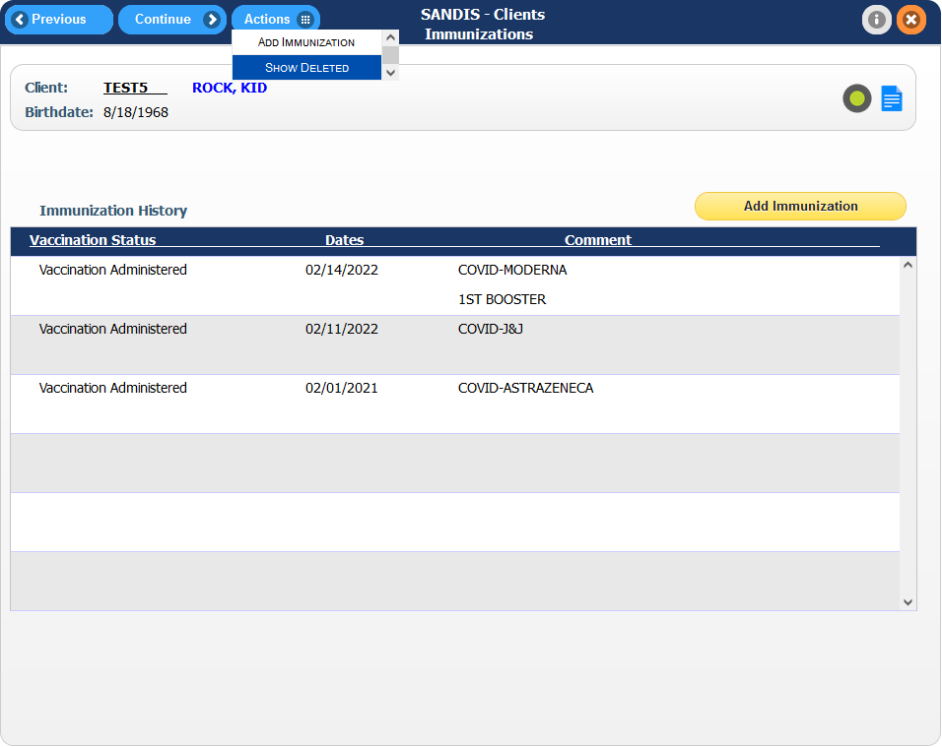
Re-activating a deleted record  In the deleted records screen, right-click on the desired Immunization record line and select Reactivate. | 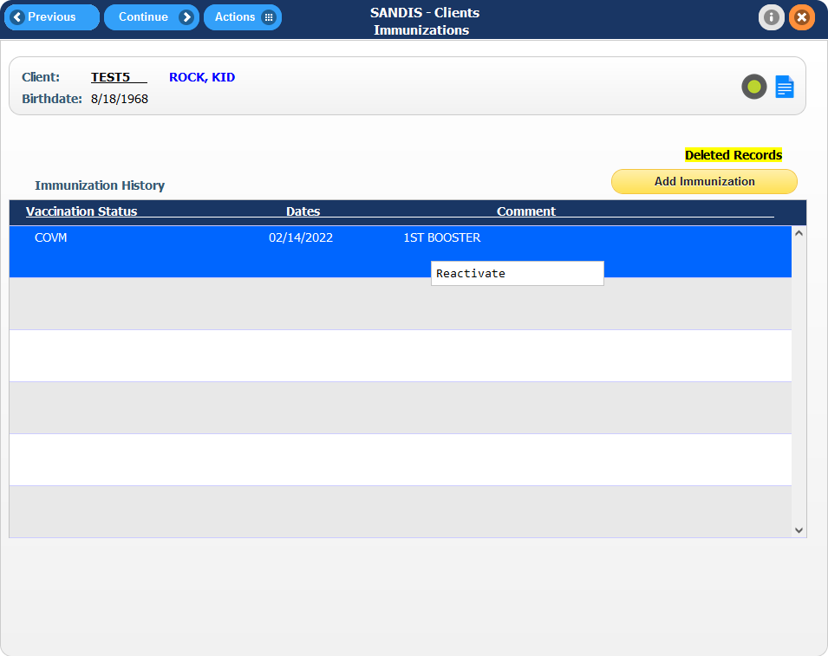
Consumer Legal tab  To access the Consumer Legal Information screen, click on the icon found in the Primary tab of the Consumer record. | 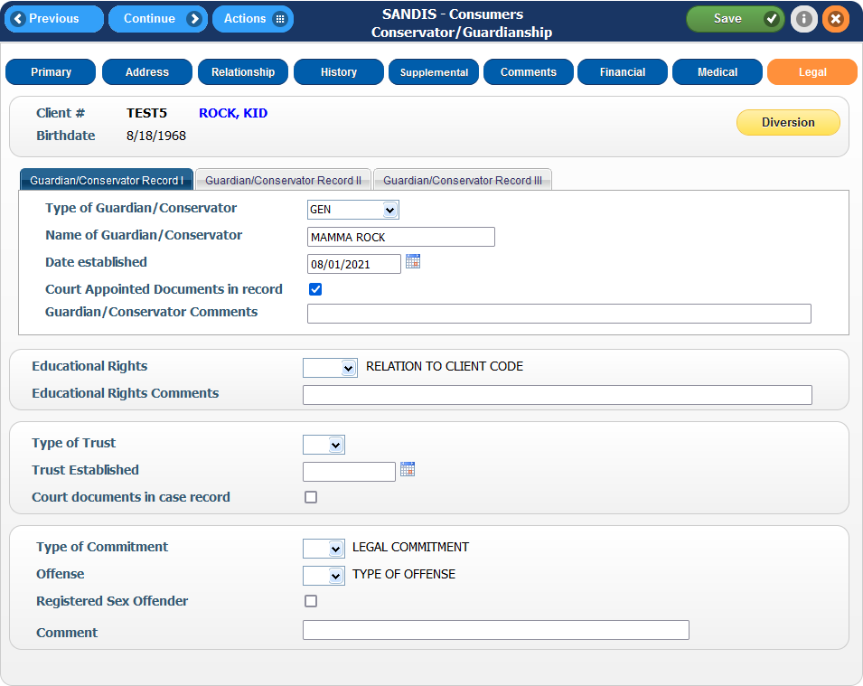
This tab displays the client’s current legal guardians or conservators (up to 3 records can be used), Educational Rights, Type of Trust used, Type of Comment and an indicator if the client is a registered sex offender. | 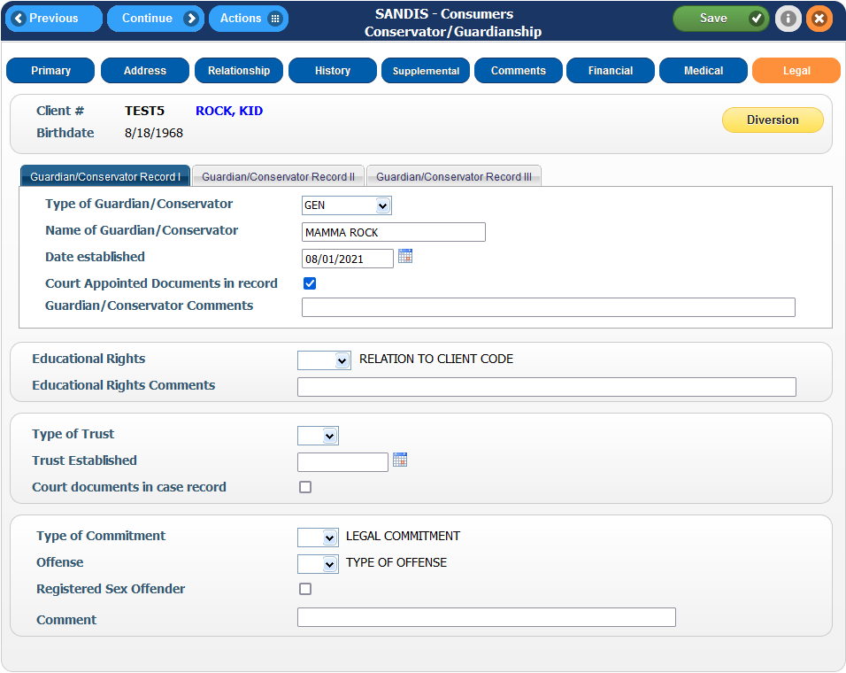
Guardian/Conservators

There are three tabs that can be used to store Guardian/Conservatorship information.

Click between records I, II and III to access each different record.

Drop downs are available to assist with entering:  - Guardian/Conservator Types  - Educational Rights  - Trust Types  - Commitment Types  - Offense Types  Changes can be made at any time by making an edit and click on the icon after the change has been made. | 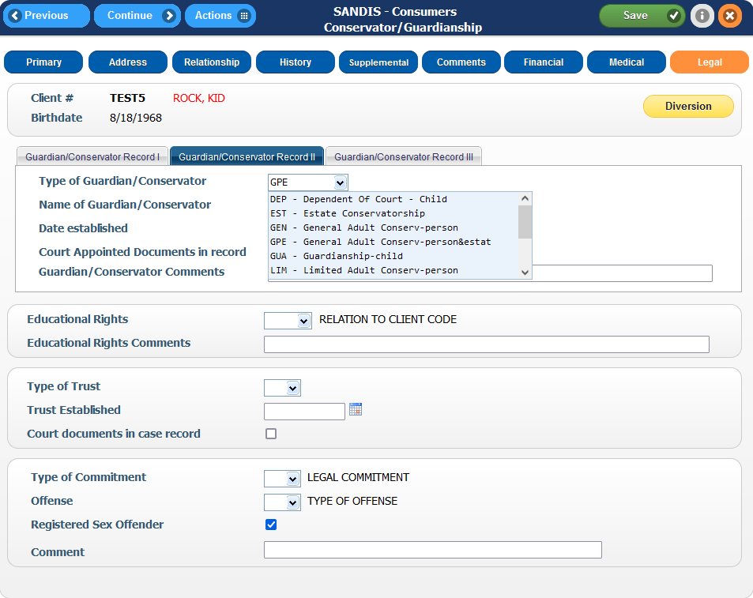
Registered Sex Offender Indicator  If a client is a registered sex offender, SANDIS will flag the record so it is easily recognizable at a glance.  Check the radio button next to Registered Sex Offender and click the icon. | 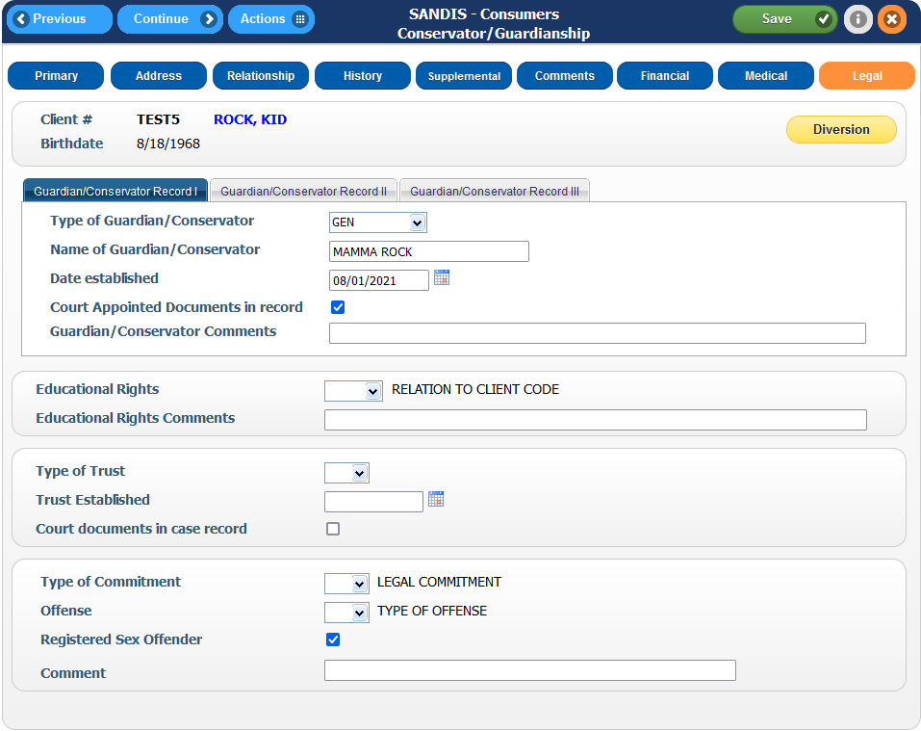
Once the change has been made, navigate to another tab. The client’s name will now be reflected in a red color font and will also be reflected in red in the Welcome Screen. | 