Inquiry Cases
The Inquiry Cases program is used to capture information regarding consumers that seek services from the Regional Center. When a record is added, the client is automatically assigned a unique inquiry number. An Inquiry record can be used to create a unique UCI# for an Individual.

To access the Inquiry Cases program, you can use the Navigation menu in your Atrium to find the Inquiry Cases section. Select the icon next to Inquiry Cases to reveal the options available to your user profile. | 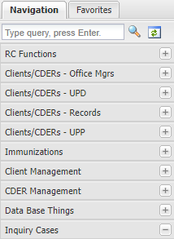
There are two options in this sub-menu.  The option allows a user to create a new Inquiry #.  The allows a user to view notes for a previously created Inquiries using the Inquiry #. | 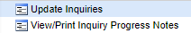

Update Inquiries  Clicking on the option will lead you to a screen as pictured on the right. There are three options from this screen:  - Create a new Inquiry  - Enter an Inquiry # to view an existing inquiry  - Search for a Consumer using last and first name | 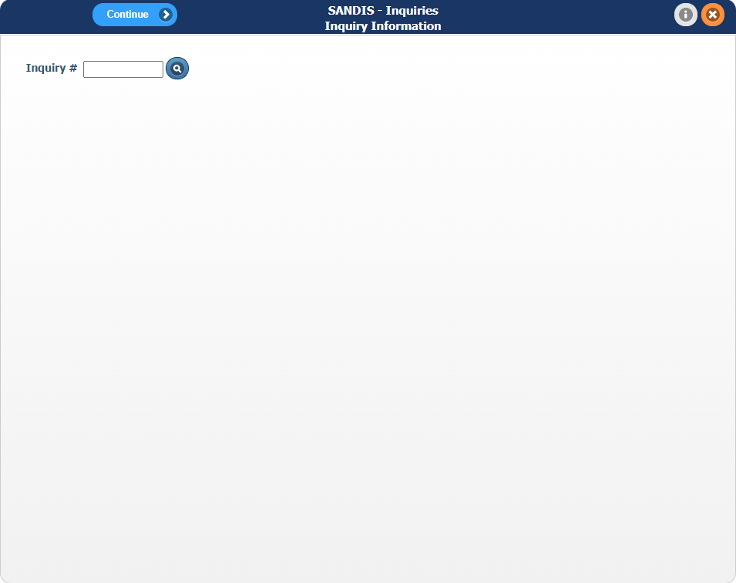
To view an existing Inquiry record, enter the Inquiry # and hit Enter on your keyboard. | 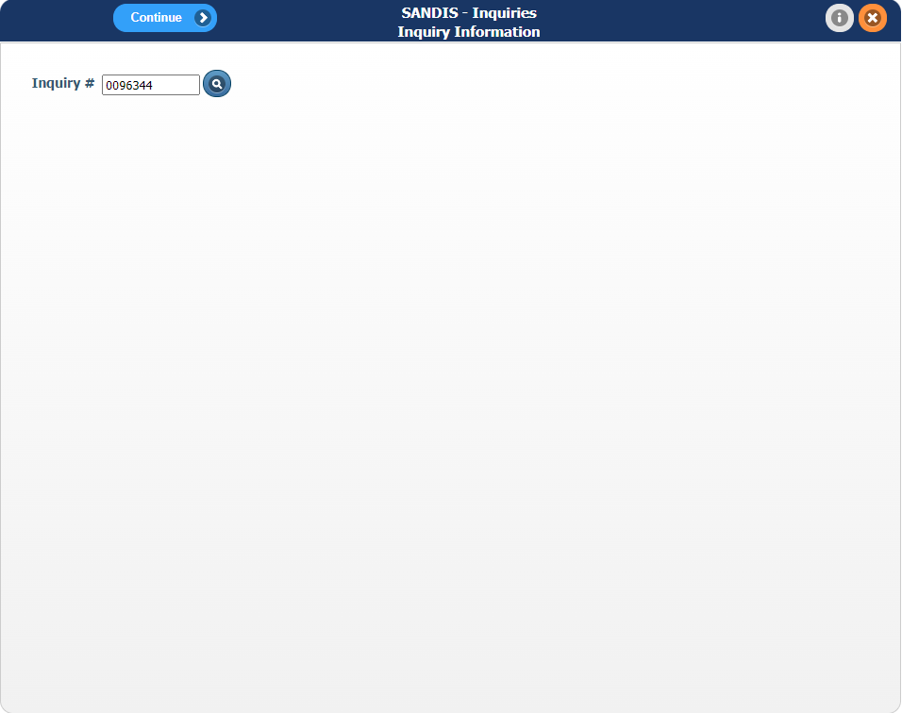
The user will then be taken to their previously saved Inquiry record for their consumer. All previously saved information will be editable and the workflow can be resumed from this point. | 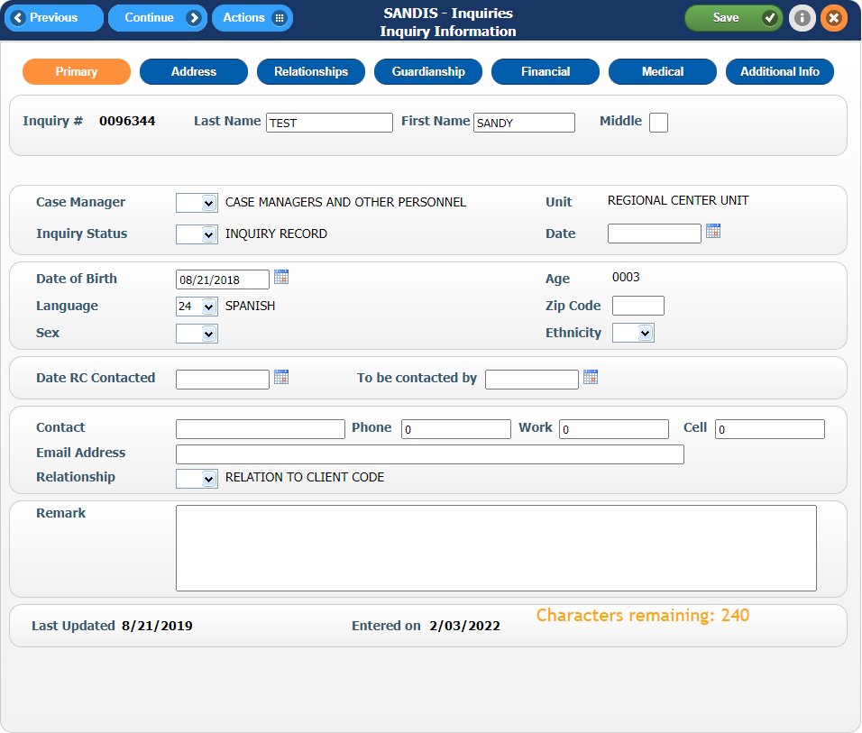

To search for an Inquiry record by first and last name of the consumer, click on the icon.
The Search by Name screen allows the user to conduct a wildcard search of any consumers with the entries that are inputted. A minimum of 1 letter in any field is required prior to conducting any search. Hit the button to continue. | 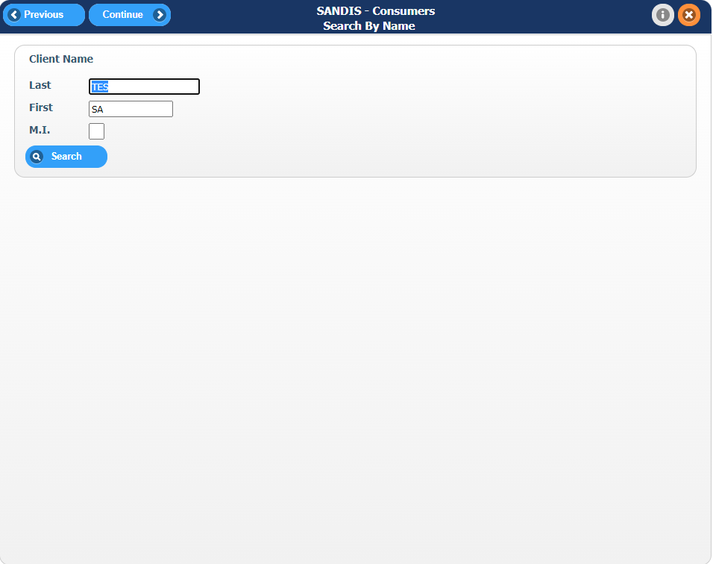
A list of all individuals matching the search criteria will appear. Double click on the correct record to continue. | 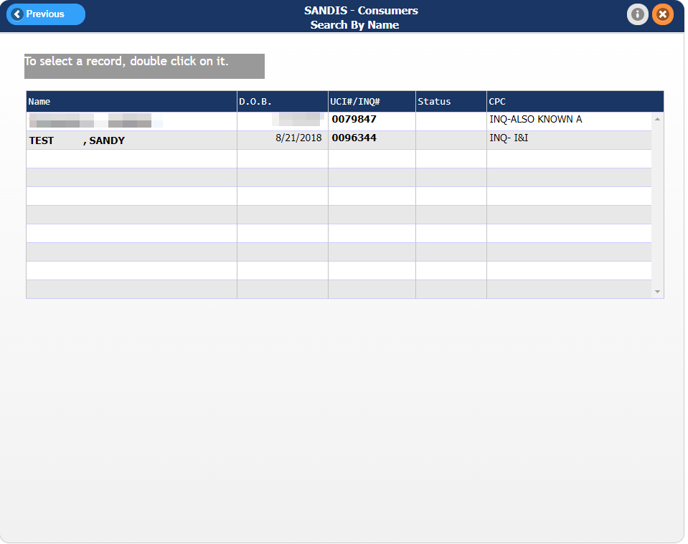

To create a new Inquiry #, keep the Inquiry field blank then click .
A new record will be generated and the Inquiry # will be displayed in the top left corner of the screen. Please note that this number is unique and can be used to search for the record from the initial Update Inquiries window. | 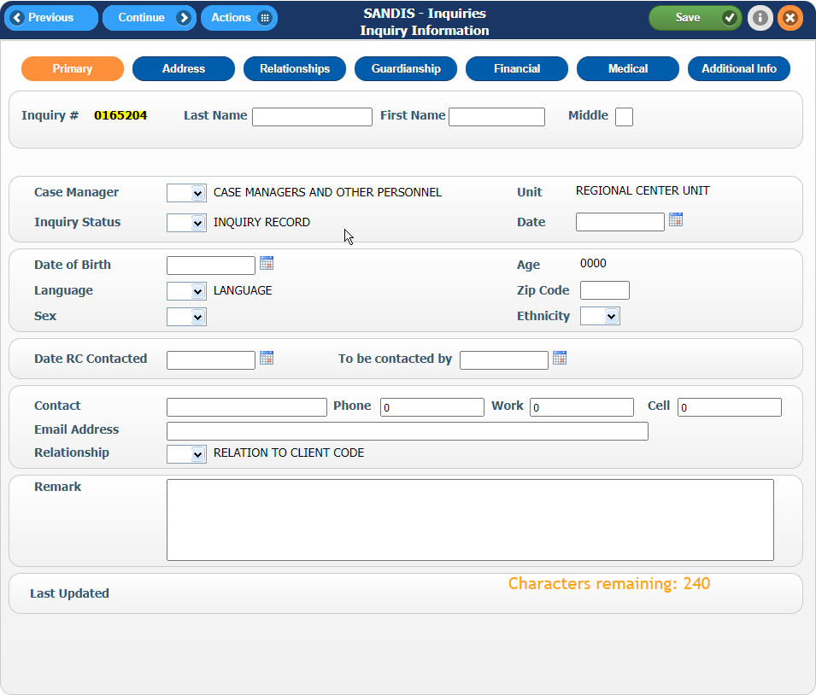
There are 7 Primary tabs to fill out the consumer information:  - Primary  - Address  - Relationships  - Guardianship  - Financial  - Medical  - Additional Info | 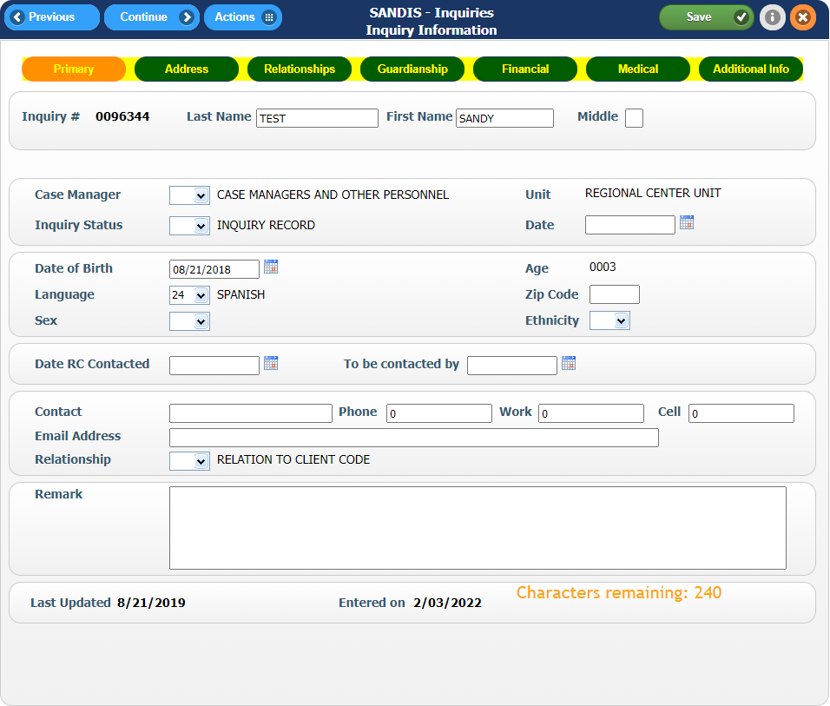
Use the button to advance through the workflow and the button to go back one tab. | 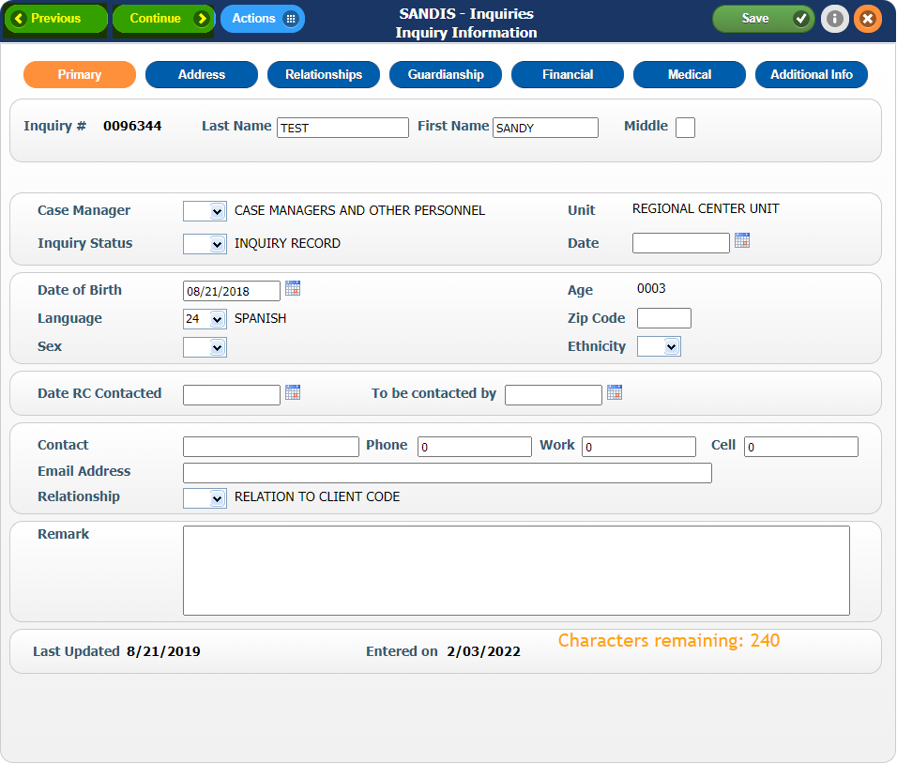
Clicking on the Actions button will bring up the following options:  - Save  - Address  - Benefit  - Create UCI  - Extra Info  - Guardianship | 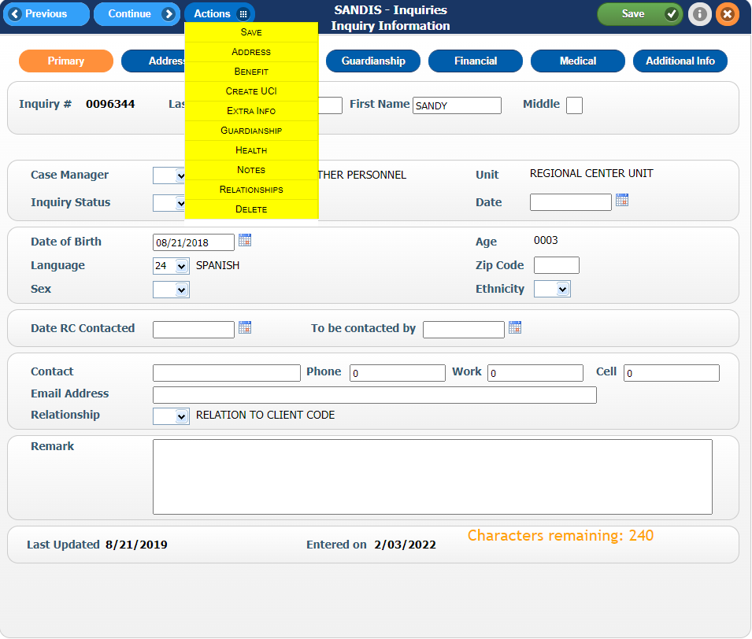
- Health  - Notes¹  - Relationships  - Delete  ^{1:} The Notes link is only accessible from the Primary screen menu and cannot be accessed from anywhere else. | 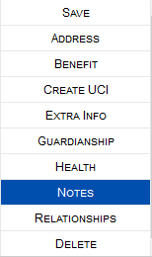
As you advance through the workflow and enter in the consumer’s information in the various tabs, the button can be used to save your work along with the button. Clicking on the next tab without pressing either of these buttons will not save your work. | 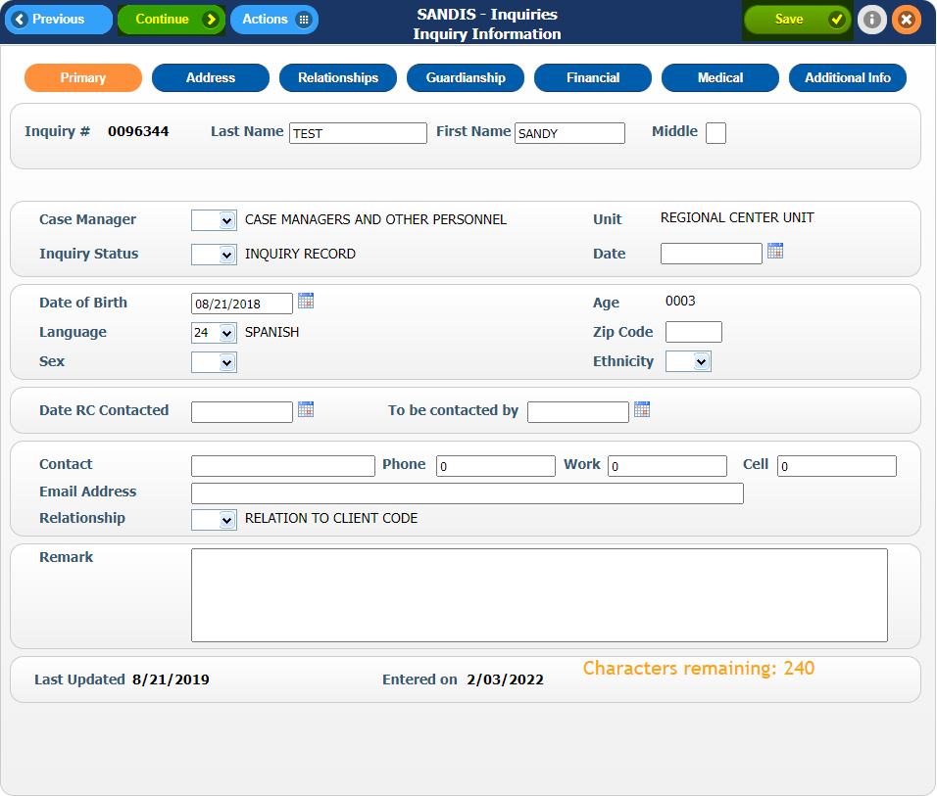
The areas highlighted in yellow show the information that is transferred to the UCI.  The areas highlighted in red are not transferred to the UCI record when the Create UCI process is initiated. | 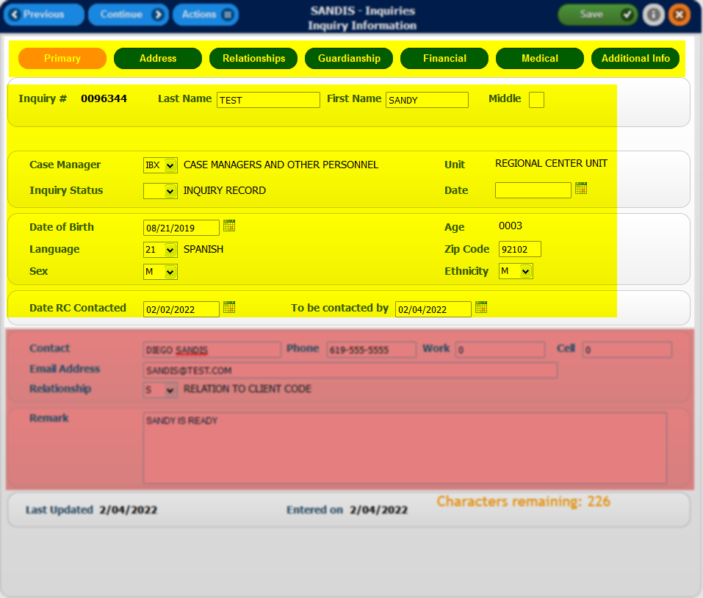
Once the Consumer is ready to be converted to a UCI #, within the Primary tab as your active screen, use the menu and click on Create UCI. | 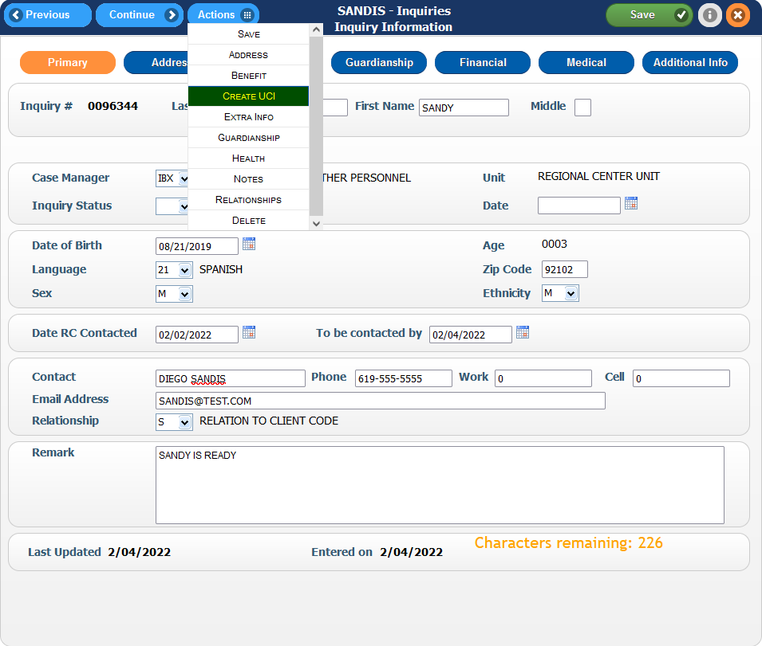

The status of the caseload will default to 0 for Intake and Assessment. All the notes entered in the Inquiry # will be copied into the newly created UCI’s Title19 module with zero units and status of Not Eligible.
Please note that once a UCI is created, the Inquiry # will be marked with a D for deletion and purged within 2 months. | 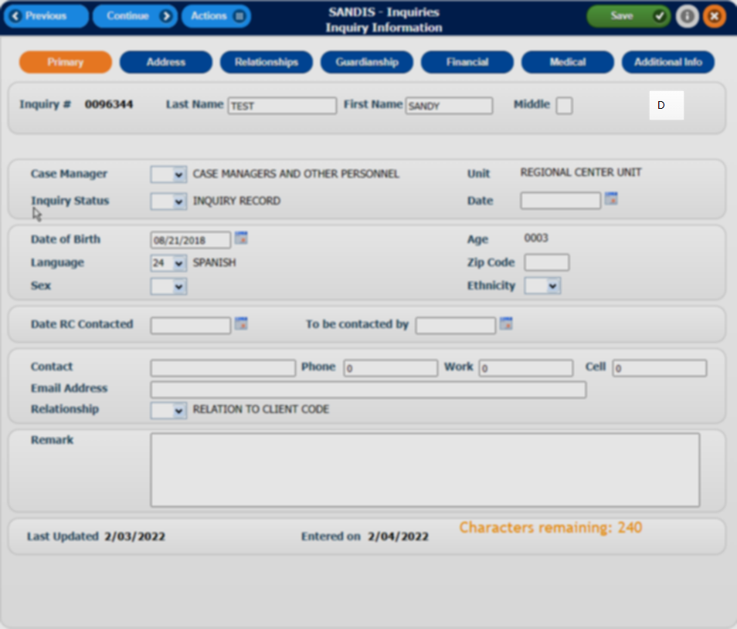

View/Print Inquiry Progress Notes  Click on , located within the Inquiry Cases group in the Navigation Menu, to enter the Print Progress Notes screen.  There are two ways to search for notes:  - Print Notes by Inq#  - Print Notes by Author | 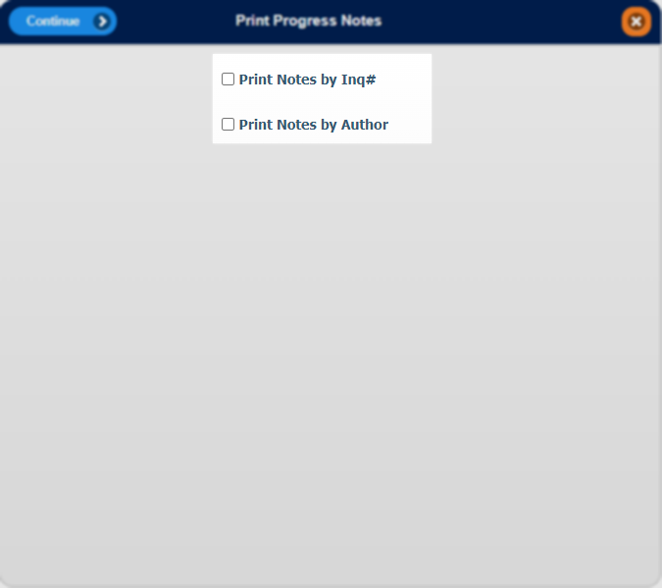
If is selected, a Query screen will appear. Delete the 7 question marks that appear in the A.XINQ# Field under Value and replace them with the unique 7-digit Inquiry #. Modify the second field, B.TNTDT to the date range that the notes were created in YYYYMMDD format. Press Enter on your keyboard or .  Example: Searching for Inquiry notes between 01/01/2022 and 02/04/2022 can be entered as 20220101 20220204 | 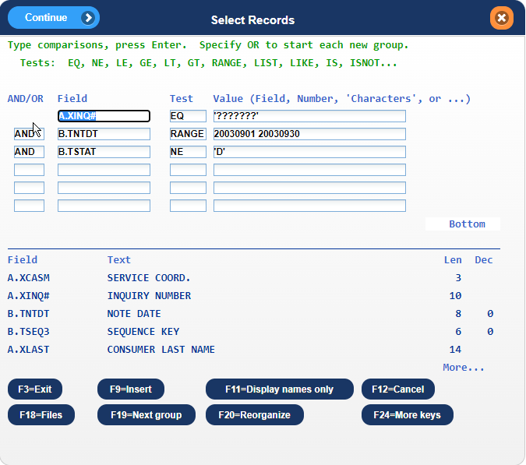
If is selected, a similar Query screen will appear. Delete the 3 question marks that appear in the Value Section under the C.TCODE Field. Modify the second field, B.TNTDT, to the date range that the notes were created in YYYYMMDD format. Press Enter on your keyboard or . | 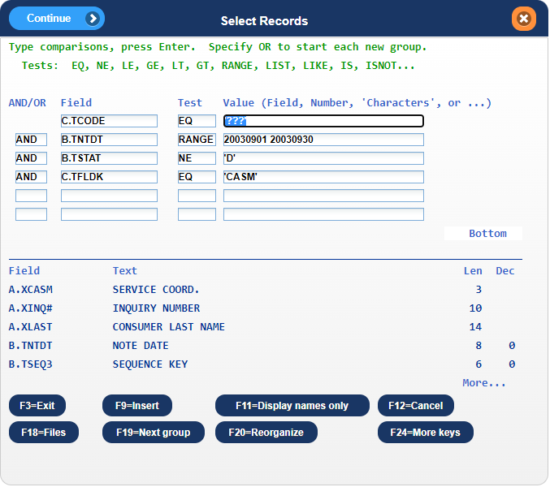
Notes that match your specified criteria in the prior will appear. You are able to press to email these notes to your inbox. | 