Trust Check
Regional Centers can assume Client Representative Payee for some of their clients. The Client Check Request feature in SANDIS7 can be used as a formal way to make requests from the trust or benefits staff in addition to keeping a running history of those requests.

From the Welcome Screen, right-click on the desired client to work with and select Chk Req from the pop-up menu that appears. | 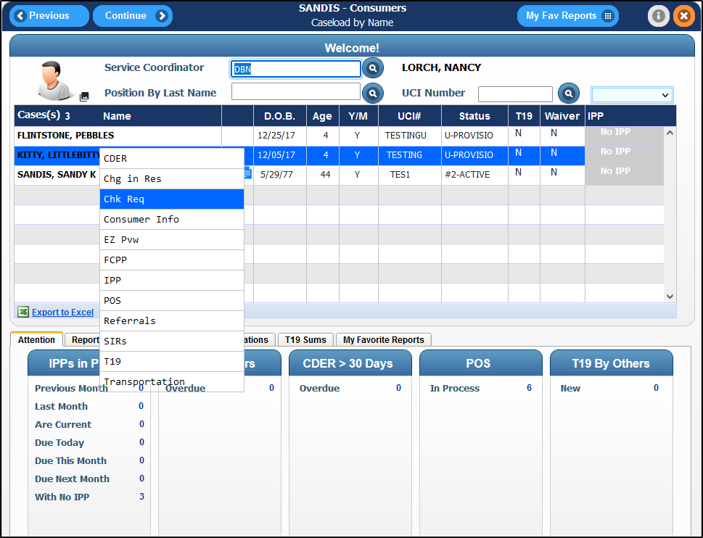
If available, a list of previous requests will be present. If there are no previous requests, the screen will be blank.  Click on the button to create a Trust Check Request. | 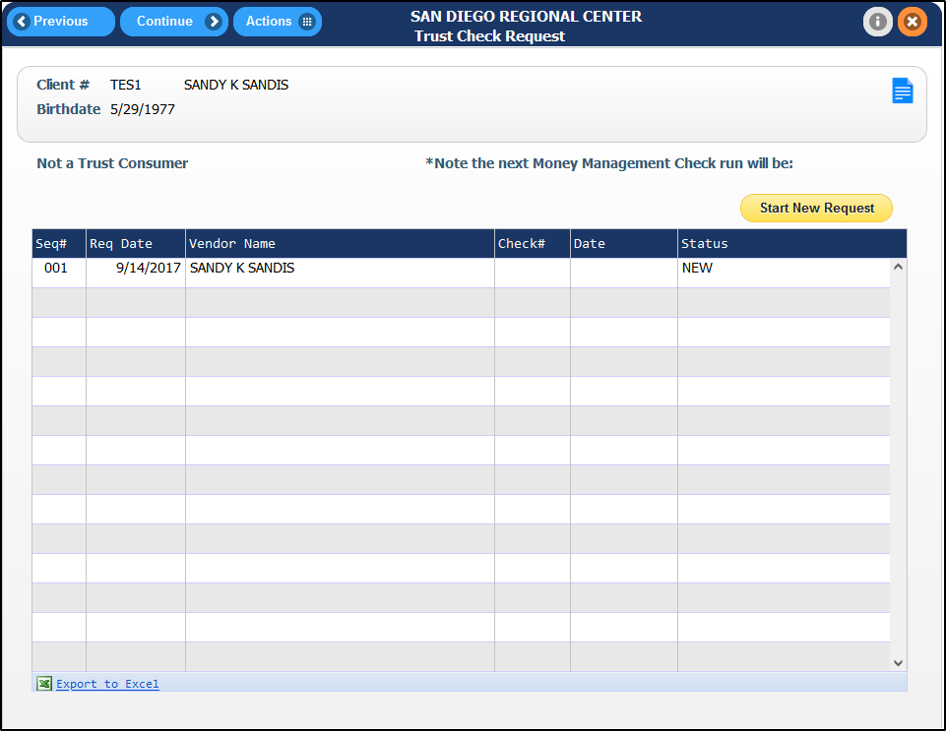

Fill the blank areas as needed.  Depending on the type of access granted to your profile, certain fields may not be able to be filled in. | 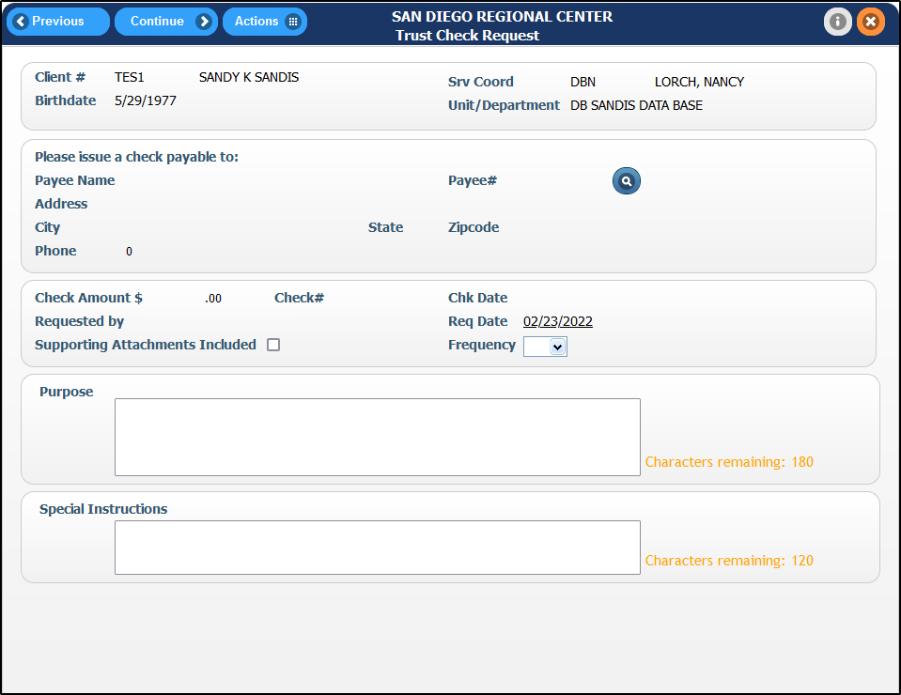
Under Payee#, there is a search feature to fill in the Payee Name, Address and Phone automatically prefill based on existing records. Click on the icon to be directed to the Trust Checks Vendor Search screen. | 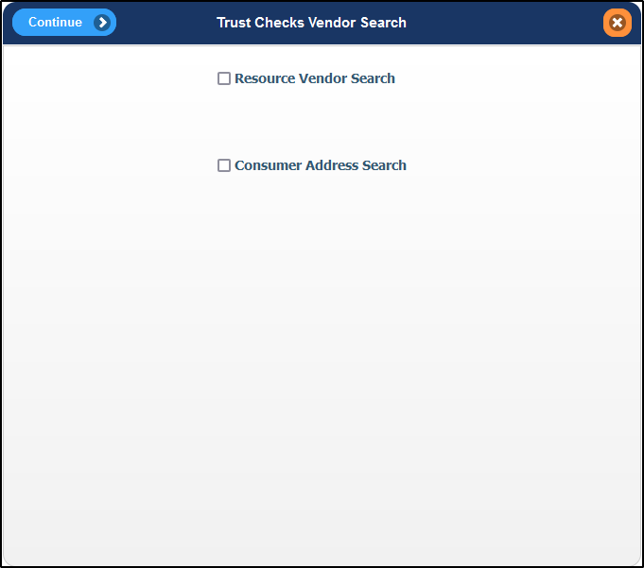
Resource Vendor Search will provide a directory of vendors in SANDIS7. Type in the desired resource name, click on  to filter between all resources and active resources only.  Once the resource name is entered, press or Enter on the keyboard. | 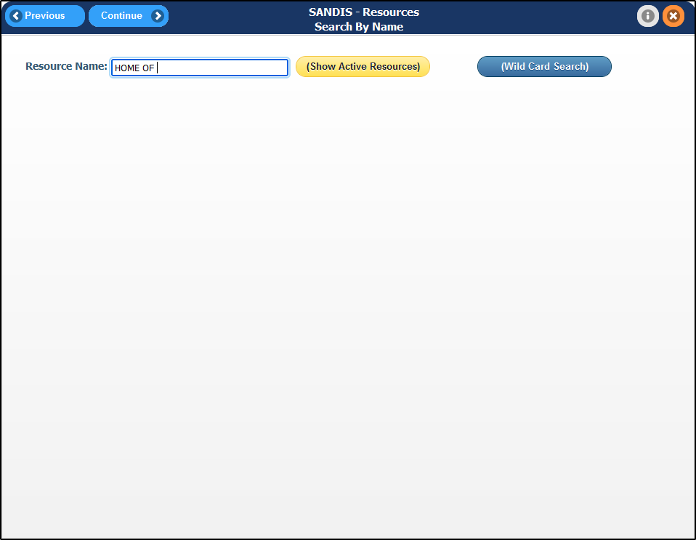

A list of results will appear. Right-click the desired record and choose Select to have the resource’s information loaded into the Trust Check Request fields. | 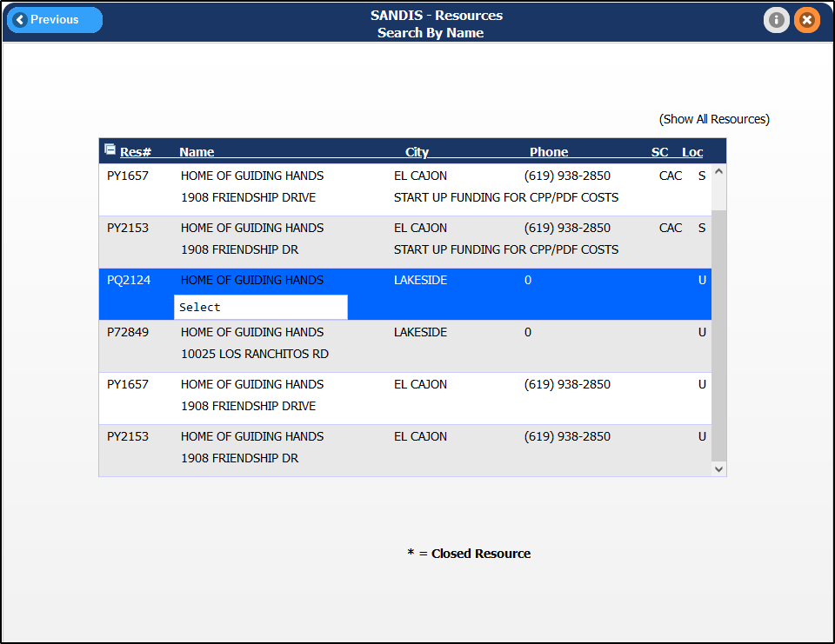
If searching by Consumer, a list of addresses recorded on the Client’s UCI record will be displayed. Right-click the selected address and choose Select.  If an address is not displayed on this screen, it will be required to add it to the client’s record. | 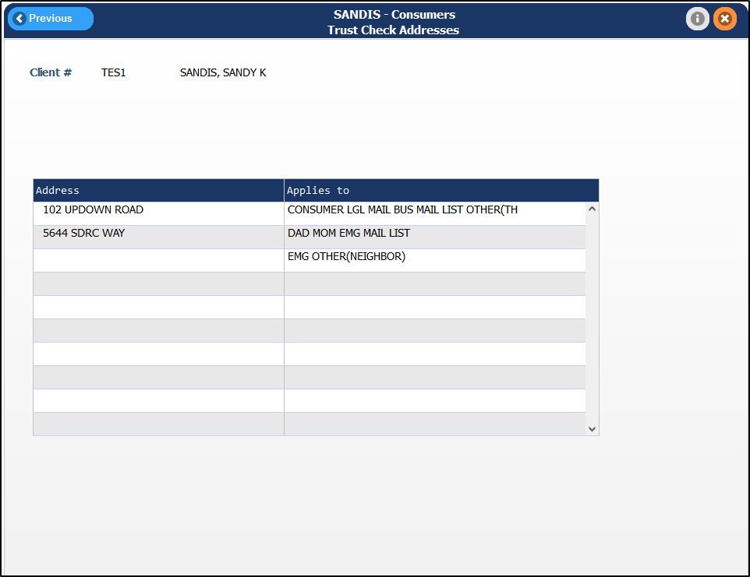
Ensure that the correct information was transferred over and ensure that the Frequency field is set to the correct issue frequency. The Purpose field must be completed and the Special Instruction field is available to provide instructions to fiscal staff, if necessary. | 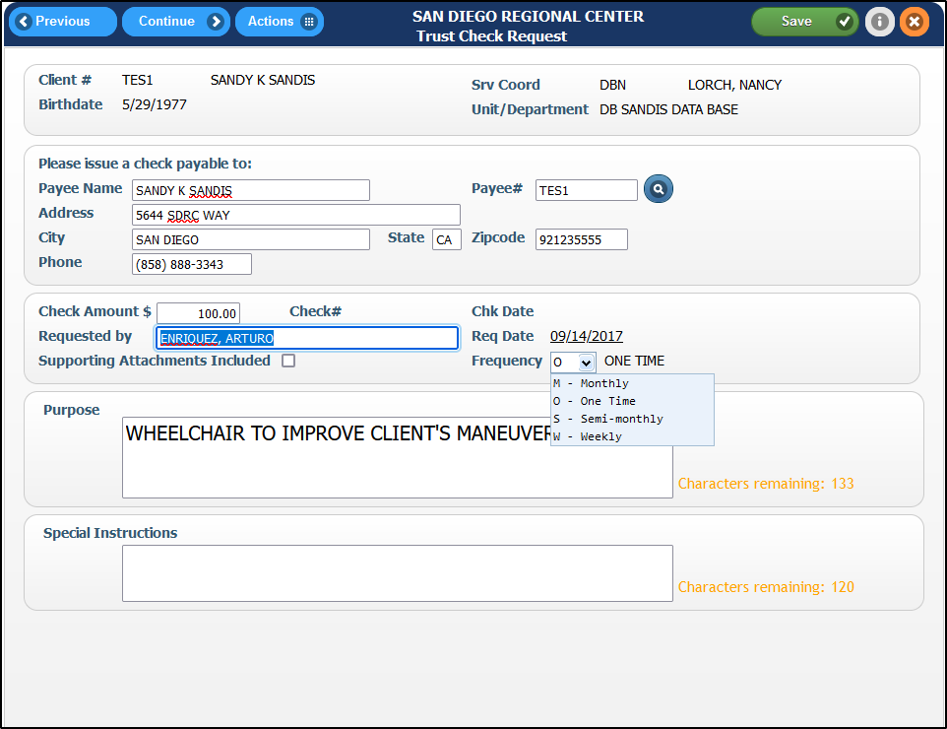

To save completed work without exiting, press . Once all fields are completed and the check request is ready to be submitted, press to be taken back to the Trust Check Request history screen for your UCI. | 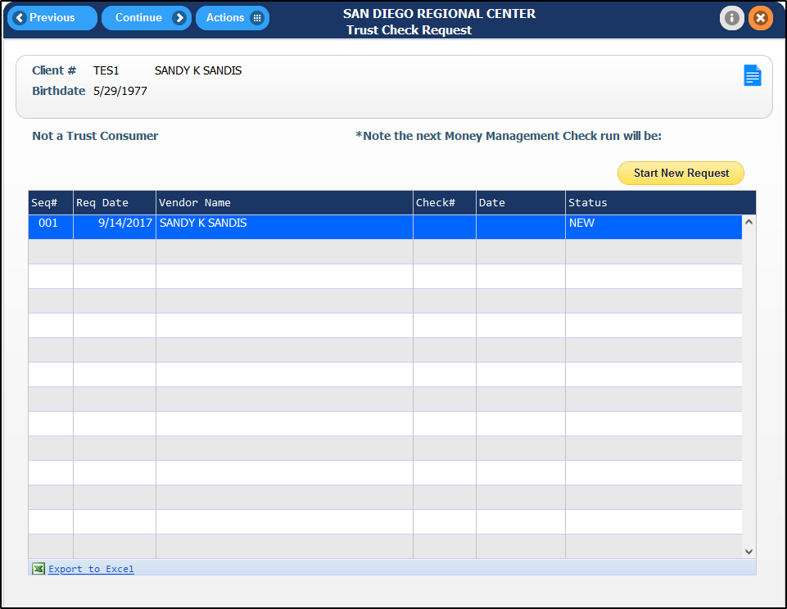
Right-click the newly created check request and select Submit. An email to your supervisor will be created and you will see the status of the request change to Submitted. | 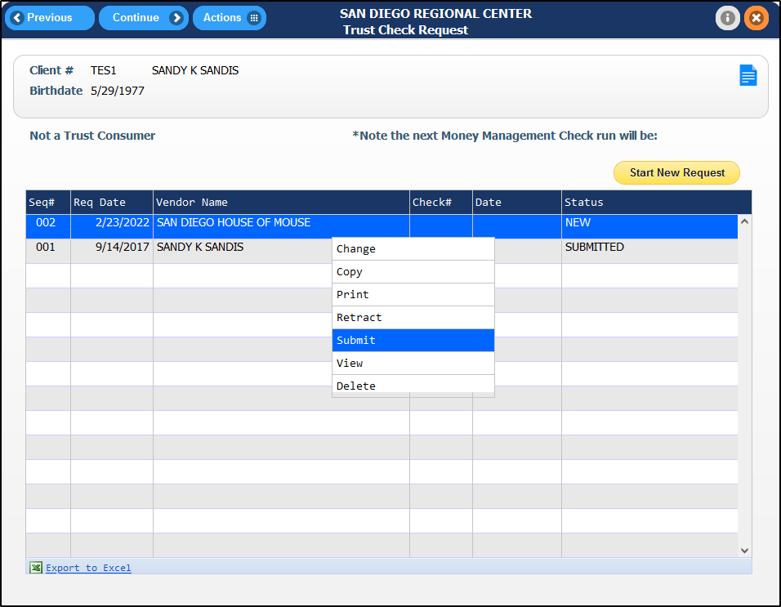
If more changes are needed, you are able to select Retract to revert the status to New.  Please note that only records with status New can be edited. If a change is needed, retract the request and set it back to New Status. | 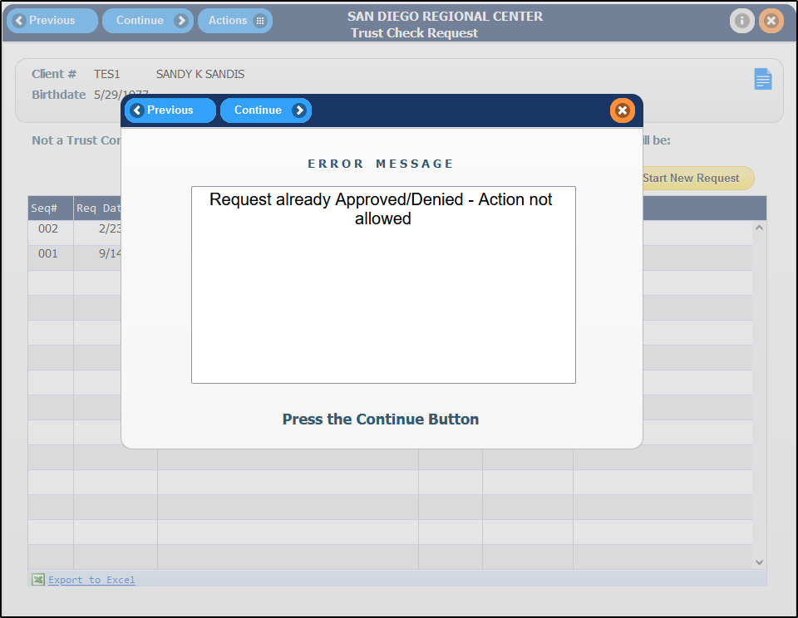

A previous request can be copied if necessary. In the Trust Check Request’s screen, right-click a record and choose Copy. This will copy the record’s Payee name, address, phone along with the check amount and purpose/special instructions fields into the new request. | 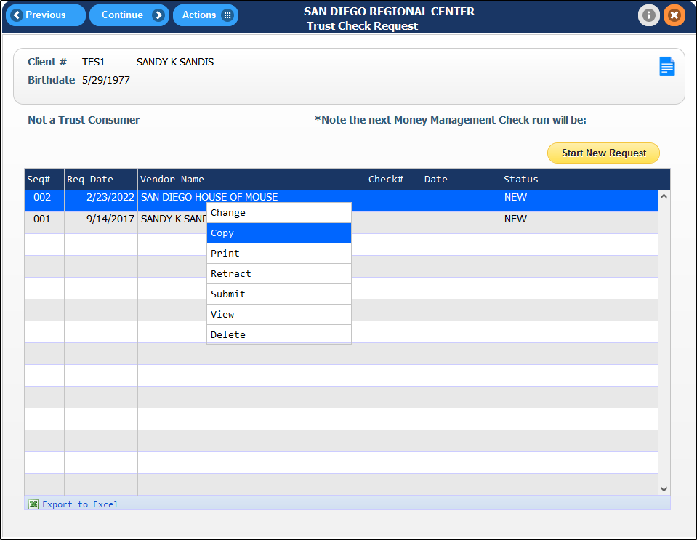
A record can be viewed in View Only mode by right-clicking the record and selecting View. Note that the fields will not be editable.  It is recommended to view requests in this method until they are ready to be worked on. | 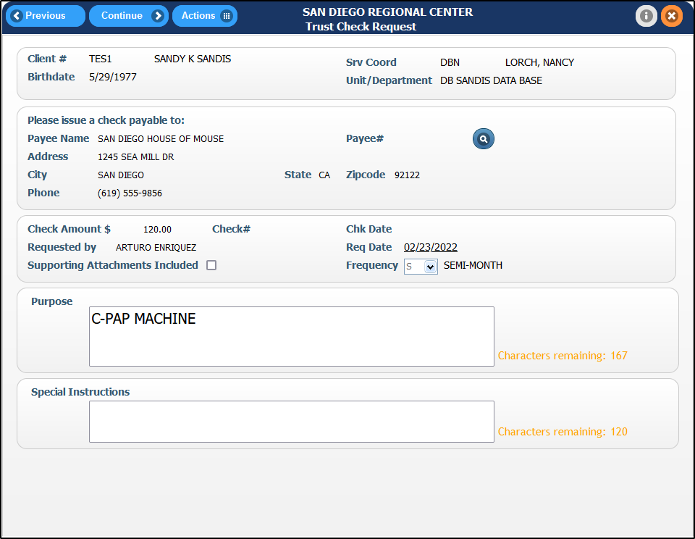
To delete a New request, simply right-click the record and select Delete.  To view all deleted requests, select the icon and choose Show Deleted. A deleted request can be brought back by right-clicking the record and selecting Reactivate. | 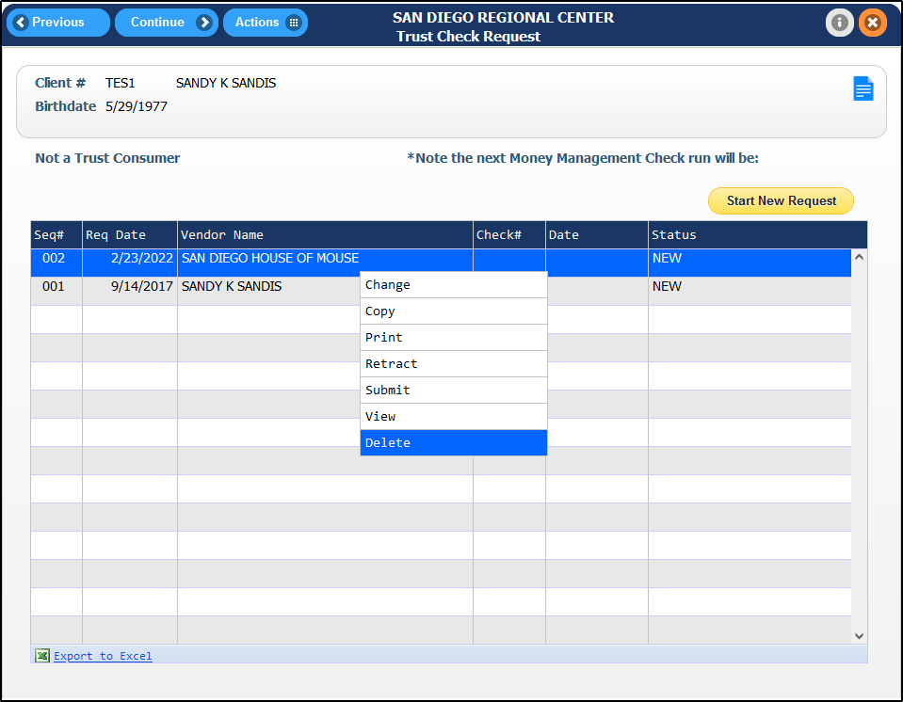

To Print a copy of your request, right-click the record and select Print. | 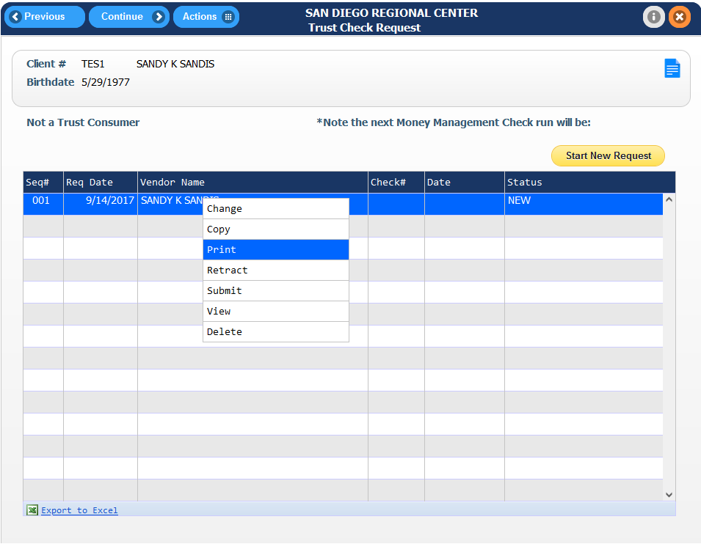
The request will be displayed, ensure it is accurate prior to continuing.  There are navigation buttons displayed on the bottom right corner of the screen.  When ready, press the or the button. | 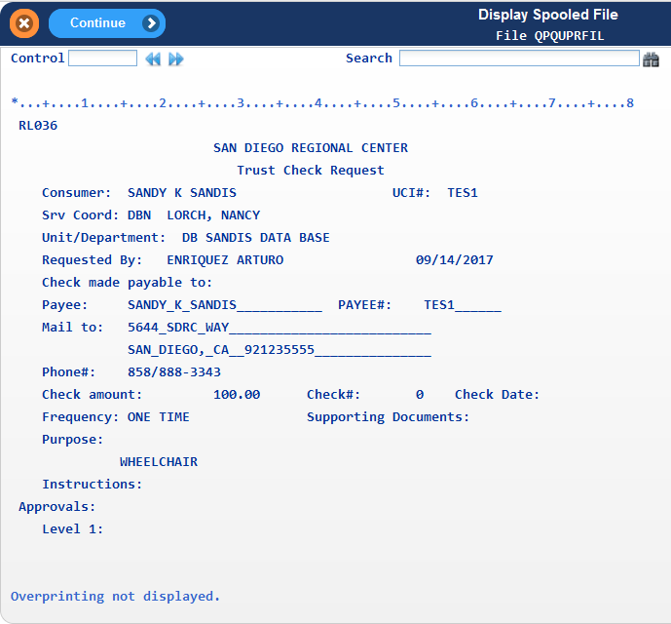
A pop-up will display to print or email the report. Press the button next to the desired option. | 