Transportation Service Request (TSR)
Transportation services are provided so persons with a developmental disability may participate in programs and/or other activities identified in the IPP. The SANDIS Transportation module provides options to generate Transportation Service Requests (TSRs). The user can create a new request for either Bus Pass, Mobility Training, Voucher, or Contract Transportation Services using SANDIS. Once the request has been created, the user can Change or Stop an existing service.
For the Regional Center's Transportation Coordinator, the SANDIS program can assist with tracking the variety of sources used to provide transportation for clients as well as the services used while being transported.
To access the Transportation Service Request (TSR) program, right-click a client from the Welcome Screen. Then select . | 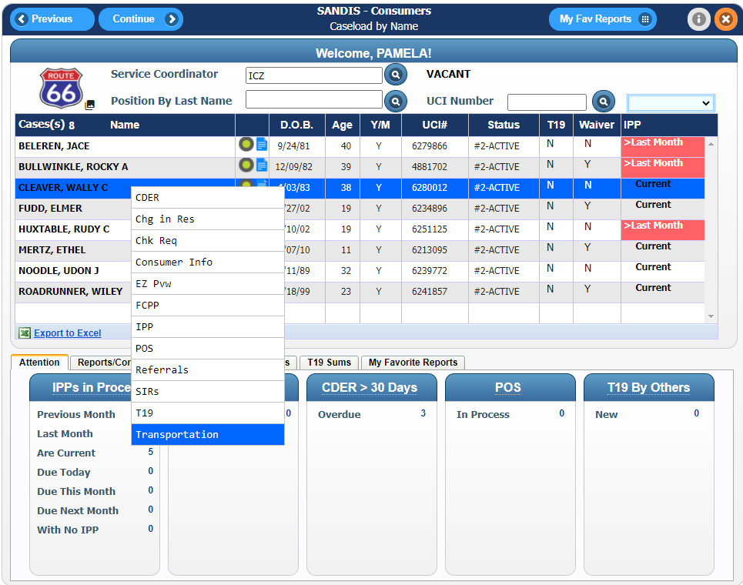
The TSR History Screen shows all the TSRs that have been entered. It shows the date they were created, the starting address (from), the destination address (to), the action and the status. If the status is NEW TRAN, it has not yet been processed by the Transportation Coordinator. If there is an asterisk (*) in front of the status, this indicates that the service is no longer provided. | 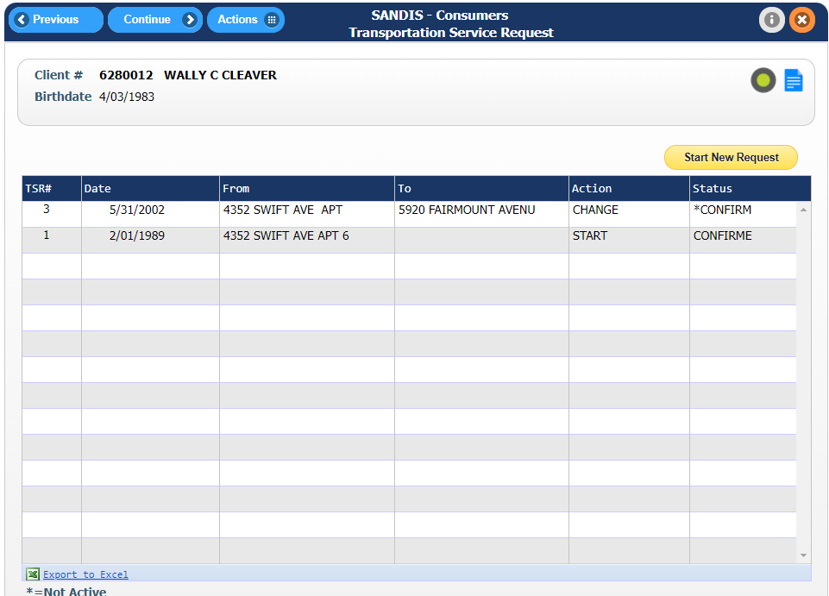

Starting A New Request

To add a Bus Pass, Mobility Training, Voucher, or Contract Service, select .
Enter the resource number of the drop-off location, if applicable. To search for the vendor, click . Then click . | 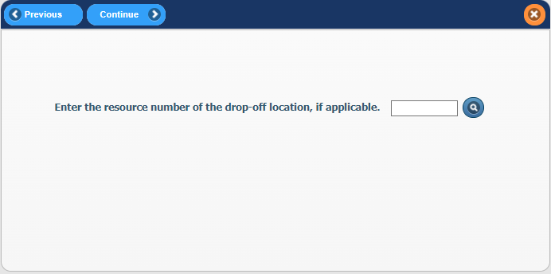
Confirm the address and resource information in the tab. If the Resource information is not correct, update the fields as needed. Then click . | 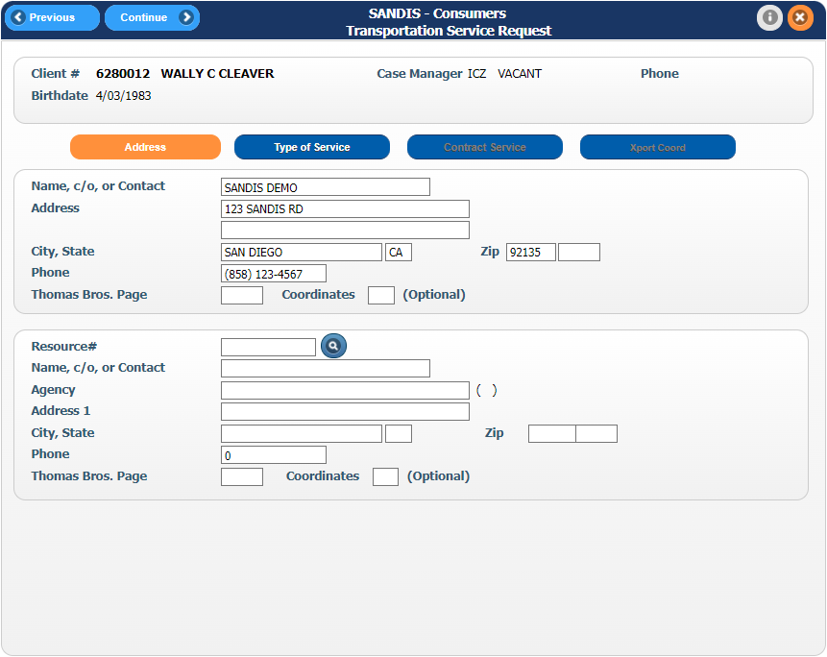

Bus Pass  In the tab, select the dropdown menu under Type to select the type of Bus Pass required. Use the scroll bar to the right to see Bus Pass options to select. If it’s a time-limited bus pass and when the service will end is known, type the end date in the Continue Until field. If the service request is on-going, leave the field blank.  Note that if the Bus Pass request is also a mobility training for the client, the user must enter these as two separate TSR's. | 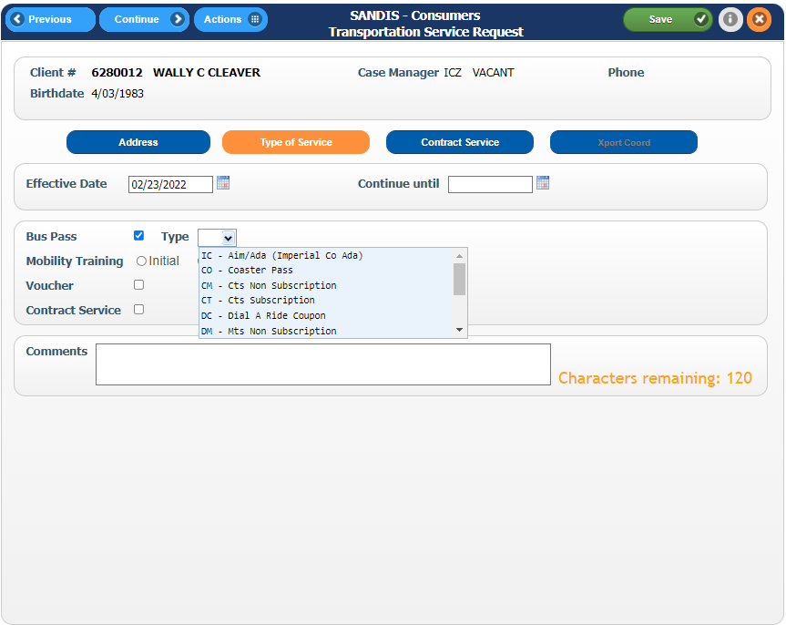
Mobility Training TSR  For Mobility Training, indicate whether it is Initial or Retraining. Note that if a Bus Pass request is needed with the Mobility Training, this will require two separate TSR's.  Leave Continue Until blank for Mobility Training. Click to go to the next screen. | 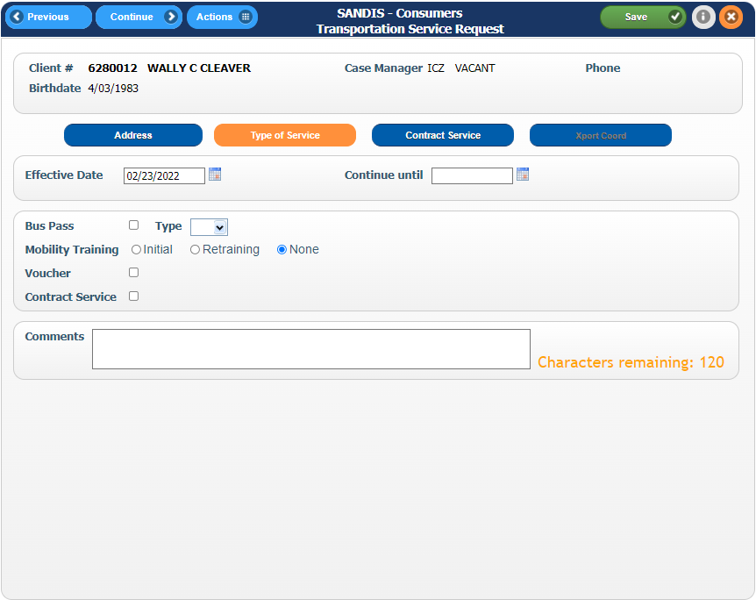
Mailing labels for bus passes are generated from the SANDIS Consumer Address file. A warning screen will appear as a reminder to go into the client's SANDIS file and put an X under Bus Pass for the address where the bus pass should be mailed.  Note: If the icon is selected on this screen, this will take the user back to the TSR History menu and the information is deleted. | 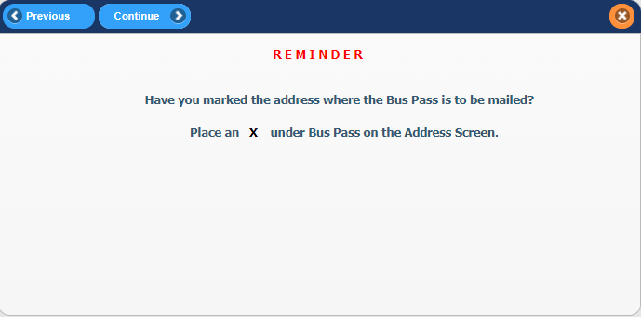
If the is selected, the tab will display. On this screen, complete the information in each of the fields displayed. Fill in the fields on the Contract Service Request Screen:  - Schedule  - Trips  - Days of the week  - Start/End Time  - Aide Required on route  - Must be received by Adult  - Wheelchair  - Can transfer from wheelchair?  - Comment  Note that Start Time and End Time are military style 24-hour clocks, such as 15:00 for 3 p.m.  Days of the week may be entered as either letters or abbreviations, i.e. "M-F", "Mon, Wed, Fri", or "Monday." Click to go to the next screen. | 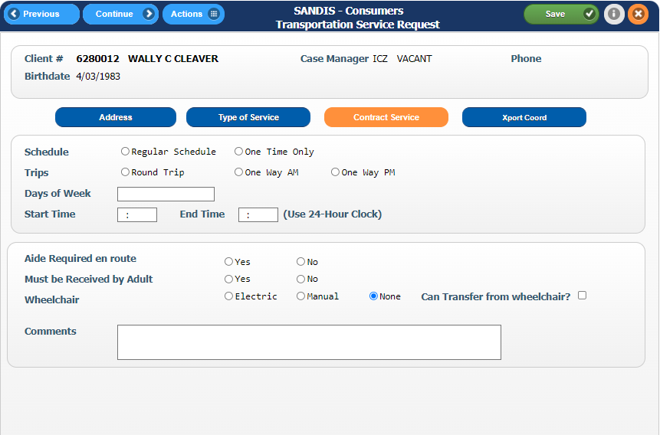
The tab is used by the Transportation Coordinator only. This screen can determine the name of the vendor assigned to the request.  Click to save the information and return to the Transportation Service History Screen. | 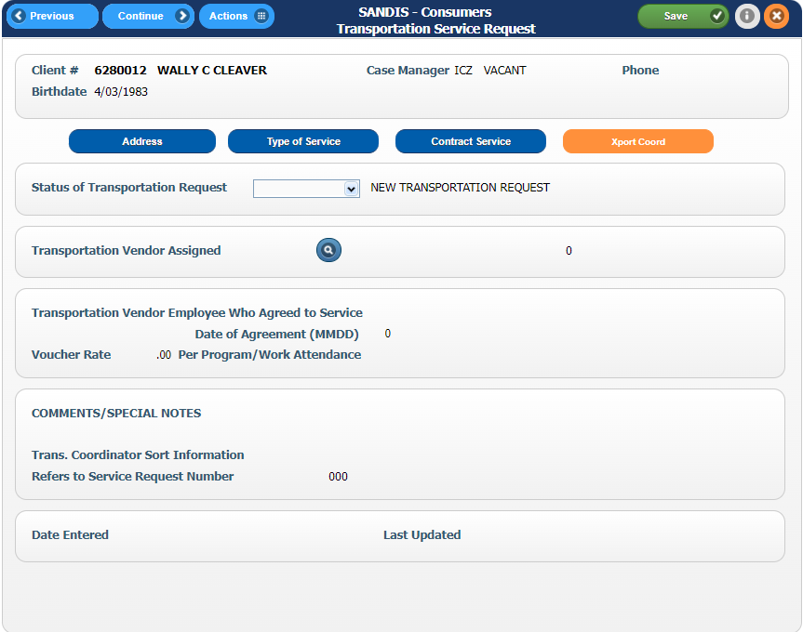

The new TSR will display in the TSR History Screen. Right-clicking the TSR will display multiple right-click options. | 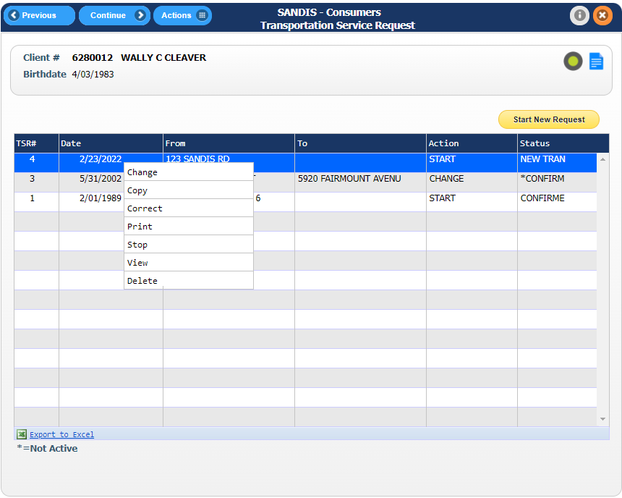
1. Change - Creates a NEW TSR to indicate there was a “change” to the original request. Changes may include information about an existing request, such as address, appointment time, contact person, etc.  2. Copy - Used to generate or start a new TSR, or can be used to copy a previous TSR. If a client has multiple destinations during the same day, or different pick up times on different days, each unique leg of the trip requires a separate service request.  3. Correct - Corrects information in an existing request. Note that Correct can only be used if the Transportation Coordinator has not acted on the request and the status is NEW TRAN.  3. Print - Prints out the information in the TSR.  4. Stop - Stops an existing service. A change from contract transportation to a bus pass is also treated this way.  6. View - Views a particular request without allowing any changes.  7. Delete - Deletes a new TSR service request entirely from the service history, such as if the client no longer needs the service. Note that Delete can only be used prior to processing by the Transportation Coordinator. If the Transportation Coordinator has already acted on the request, use Stop. Select stop to work with TSR's for another client, click the Previous button and enter the UCI#. If finished, click the Exit button to return to the Welcome Screen. | 